**TITLE PAGE**

|  |  |
| --- | --- |
| **Title** | **Observability in Distributed Systems** |
| **Author** | **ABDULLAH MUHANNAD P V** **HM0015138** |
| **Date** | **07/11/2025** |

**Table of Content**

1. Overview
2. The Challenges of Distributed Systems
3. How Observability Solves These Problems
4. Real-World Observability Success Stories
5. Getting Started with Observability
6. **Module 1: Introduction to Observability**
   1. Does Observability Cover Monitoring?
   2. What Can Be Monitored?
   3. What Can Be Observed?
   4. What are the Tools Available?
7. **Module 2: Prometheus – Setting Up Monitoring**
   1. Metrics, Monitoring and Prometheus | Basics of Prometheus
   2. Metrics vs Monitoring
   3. Prometheus & Prometheus Architecture
   4. Prometheus Installation & Configurations
   5. Prometheus UI , Grafana UI , Alertmanager UI
8. **Module 3: PromQL and Metrics Analysis**
   1. Metrics in Prometheus:
   2. What is PromQL?
   3. Exporters and its function on prometheus
   4. Combining Series & Built In Functions in PromQL
   5. Custom metrics
9. **Module 4: Instrumentation and Custom Metrics**
   1. Instrumentation
   2. Instrumentation in Prometheus:
   3. Exporters vs Instrumentation
   4. Use Cases for Instrumentation Metrics
   5. Architecture Of This Efk Project
   6. Test the Application End point
10. **Module 5: Logging with the EFK Stack**
    1. Logging principles in distributed systems and Kubernetes
    2. Deploying the EFK Stack (Elasticsearch, Fluentbit, Kibana)
    3. Configuring Fluentbit for log collection
    4. Visualizing logs in Kibana
    5. Cluster cleanup procedures
11. **Module 6: Distributed Tracing with Jaeger**
    1. Introduction to Distributed Tracing and Jaeger
    2. Jaeger architecture and components
    3. Installing Jaeger with Helm on Kubernetes
    4. Instrumenting services with OpenTelemetry
    5. Viewing and analysing traces via the Jaeger UI
    6. Cleaning up tracing components post-use

**Observability in Distributed Systems**

**Overview**

Modern distributed systems, microservices architectures, and cloud-native applications introduce complexity in monitoring, debugging, and maintaining system health. Traditional logging and monitoring approaches are insufficient to provide real-time insights into system behaviour, performance bottlenecks, and failure root causes.

**Problem Definition**

As systems scale, it becomes increasingly difficult to:

* **Track requests** across multiple services, containers, and servers.
* **Detect anomalies** in real time before they impact users.
* **Diagnose failures** quickly due to lack of correlated telemetry data (logs, metrics, traces).
* **Understand system dependencies** and performance bottlenecks.
* **Ensure compliance** with SLAs (Service-Level Agreements) and SLOs (Service-Level Objectives).

**Key Challenges**

* **Lack of end-to-end visibility**:

Disconnected logs, metrics, and traces make troubleshooting slow and inefficient.

* **High cardinality data**:

Dynamic cloud environments generate vast amounts of telemetry data, making storage and analysis costly.

* **Noise and alert fatigue**:

Poorly configured monitoring leads to irrelevant alerts, reducing incident response effectiveness.

* **Tool fragmentation**:

Multiple observability tools (logging, APM, metrics) create silos instead of a unified view.

* **Performance overhead**:

Excessive instrumentation can degrade system performance.

**Desired Outcomes**

An effective observability solution should:

* Provide **real-time insights** into system health and performance.
* **Correlate logs, metrics, and traces** for faster root cause analysis.
* **Reduce mean time to detect (MTTD) and mean time to resolve (MTTR)** incidents.
* **Scale efficiently** with dynamic cloud-native environments.
* **Minimize operational overhead** with intelligent alerting and anomaly detection.

**Success Metrics**

* Reduction in production incidents due to proactive detection.
* Faster debugging through distributed tracing and structured logs.
* Improved system reliability and user experience.
* Lower operational costs by optimizing telemetry data storage and processing.

**The Challenges of Distributed Systems**

Before we explore solutions, let’s outline the key problems:

**Problem 1: Lack of End-to-End Visibility**

* Requests travel across multiple services, containers, and servers.
* Traditional logging doesn’t show **how failures propagate**.

**Problem 2: Slow Debugging & Incident Resolution**

* Without proper traces, engineers waste hours correlating logs to find root causes.
* Mean Time to Resolution (MTTR) increases, hurting user experience.

**Problem 3: Noisy Alerts & False Positives**

* Poorly configured monitoring leads to alert fatigue, making real issues harder to detect.

**Problem 4: Performance Bottlenecks Are Hard to Detect**

* Latency issues may only appear under **specific conditions** (e.g., high traffic).

**Problem 5: Scaling Observability Without Breaking Costs**

* Storing and analysing **high-cardinality data** (e.g., traces, metrics) can be expensive.

**How Observability Solves These Problems**

**Solution 1: Distributed Tracing for End-to-End Visibility**

* **What it does:**

Tracks a request’s journey across services (e.g., using Open Telemetry, Jaeger).

* **How it helps:**
  + Identifies **slow or failing services** in a transaction.
  + Visualizes dependencies between microservices.
  + Example: A payment failure can be traced to a **specific database timeout**.

**Solution 2: Structured Logging + Correlation IDs**

* **What it does:**

Logs include a **unique request ID**, linking related events.

* **How it helps:**
  + Engineers can **filter logs by transaction** instead of digging through unrelated entries.
  + Example: A failed API call’s logs can be grouped for faster debugging.

**Solution 3: Metrics & AI-Driven Anomaly Detection**

* **What it does:**

Tracks system health (CPU, memory, latency) and applies **machine learning for anomaly detection**.

* **How it helps:**
  + Reduces **false alerts** by learning normal behavior.
  + Detects **gradual degradation** (e.g., memory leaks) before outages occur.

**Solution 4: Intelligent Alerting & SLO Monitoring**

* **What it does:**

Alerts only when **Service-Level Objectives (SLOs)** are violated.

* **How it helps:**
  + Prevents **alert storms**—only notifies on critical failures.
  + Example: Instead of alerting on every HTTP 500, it triggers only if **error rates exceed 1%**.

**Solution 5: Cost-Efficient Observability Pipelines**

* **What it does:**

Uses **sampling, filtering, and compression** to reduce data costs.

* **How it helps:**
  + Stores high-value data (e.g., errors, critical traces) while **dropping redundant logs**.
  + Example: Only 10% of traces are stored, but **all errors are retained**.

**Real-World Observability Success Stories**

**Case Study: Major E-Commerce Platform**

* **Problem:** Frequent checkout failures, but logs were scattered across 20+ services.
* **Solution:** Implemented **distributed tracing + structured logging**.
* **Result:** Debugging time dropped from **4 hours to 15 minutes**.

**Case Study: FinTech Company**

* **Problem:** False alerts caused engineers to ignore real incidents.
* **Solution:** Switched to **SLO-based alerting with AI anomaly detection**.
* **Result:** **Alert fatigue reduced by 70%**, and MTTR improved by 50%.

**Getting Started with Observability**

**Step 1: Instrument Your System**

Use **OpenTelemetry** for traces, **Prometheus** for metrics, and **ELK/Loki** for logs.

**Step 2: Implement Correlation IDs**

Ensure every log, trace, and metric includes a **request ID**.

**Step 3: Set Up Smart Alerts**

Define **SLOs** (e.g., "99.9% uptime") and alert only when breached.

**Step 4: Optimize Data Storage**

Use **sampling** for traces, **retention policies** for logs.

**Step 5: Continuously Improve**

Review **dashboards**, adjust **thresholds**, and refine anomaly detection.

**MODULES**

1. Introduction to Observability
2. Prometheus - Setting Up Monitoring
3. Metrics and PromQL in Prometheus
4. Instrumentation and Custom Metrics
5. Logging with EFK Stack
6. Distributed Tracing with Jaeger

**Module -1**

**Introduction to Observability**

* **Concepts Covered:**
  + Introduction to Observability, Monitoring, Logging, and Tracing.
  + The difference between Monitoring and Observability.
  + Tools available for Monitoring and Observability.
  + Comparison between monitoring and observing in Bare-Metal Servers vs. Kubernetes.
* **Key Learning:**
  + Understand the fundamental concepts of observability.
  + Learn why monitoring and observability are crucial in modern IT environments.

**Definition:**  
The capability to infer a system's internal state from the data it emits — **logs**, **metrics**, and **traces**. These are the fundamentals of observability . in this blog we are focus the fundamental pillars of observability explanation and its practicals are included. Fundamental pillars are

* **logs**
* **metrics**
* **traces**

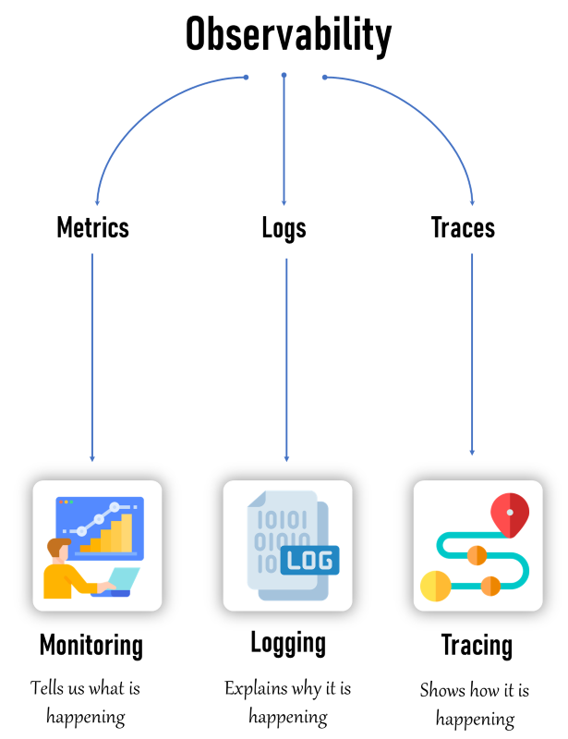

**Why Monitoring?**

**Monitoring** allows us to continuously observe system activity and confirm that everything is functioning as expected.

**Goal:**

To uphold the stability, efficiency, and safety of IT systems. By identifying anomalies or irregularities at an early stage, monitoring helps prevent major outages or data breaches.

**Key uses of monitoring include:**

* **Early Issue Detection:** Spot potential problems before they escalate.
* **Performance Assessment:** Evaluate how systems and applications are performing over time.
* **Ensuring Uptime:** Verify that services remain accessible and reliable for users.

**Why Observability?**

**Observability** enables us to gain insight into the underlying reasons behind our system's behavior.

It provides a comprehensive view — like having a diagnostic toolkit and a clear roadmap — to explore and troubleshoot complex issues.

We rely on observability to:

* **Identify Root Causes:** Pinpoint the origin of problems within the system.
* **Analyse System Behaviour:** Understand how components interact and respond under various conditions.
* **Enhance System Design:** Continuously refine and optimize performance, reliability, and resilience

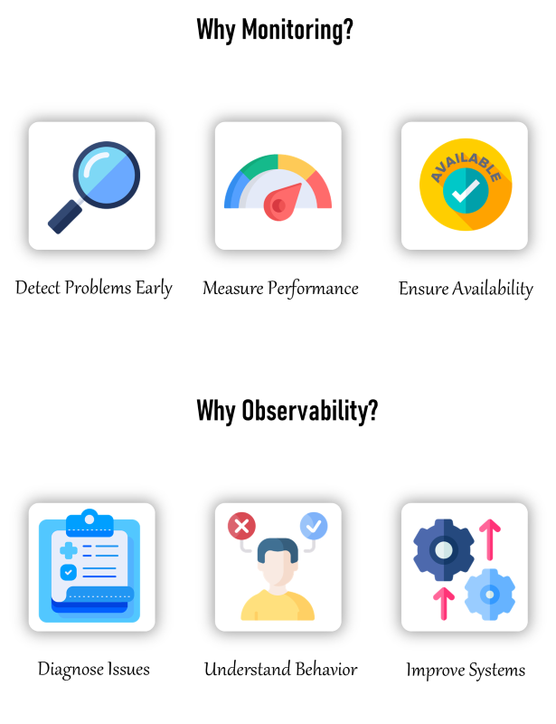

**What is the Exact Difference Between Monitoring and Observability?**

 Monitoring is the *when and what* of a system error, and observability is the *why and how*

| **Category** | **Monitoring** | **Observability** |  |
| --- | --- | --- | --- |
| **Primary Goal** | Verifies that systems are operating correctly | Explains why the system is behaving a certain way |  |
| **Type of Data** | Gathers system metrics like CPU load, memory consumption, and error counts | Aggregates logs, metrics, and traces for a holistic understanding |  |
| **Alerting Mechanism** | Triggers alerts when predefined thresholds are exceeded | Analyses patterns and anomalies to uncover root causes |  |
| **Use Case Example** | Notifies when CPU usage on a server exceeds 90% | Traces a slow user request across services to locate the performance issue |  |
| **Insight Provided** | Spots early signs of failure or degradation | Offers deep visibility for troubleshooting and behavioral analysis |  |

**Does Observability Cover Monitoring?**

**Yes! Monitoring is a part of Observability.**

While **monitoring** is concerned with tracking specific metrics and generating alerts based on set thresholds, **observability** encompasses a broader approach.

Observability goes beyond metrics — it offers a full picture of system behaviour by **collecting and analysing logs, metrics, and traces**, allowing for deeper insights and effective root cause analysis.

**What Can Be Monitored?**

* **Infrastructure:** Tracks system-level metrics such as CPU load, memory consumption, disk input/output operations, and network activity.
* **Applications:** Monitors key performance indicators like response latency, error frequency, and data processing rates.
* **Databases:** Observes query efficiency, usage of connection pools, and transaction throughput.
* **Network:** Measures network health through latency monitoring, packet loss detection, and bandwidth analysis.
* **Security:** Logs and detects unauthorized access attempts, vulnerability scans, and firewall activity.

**What Can Be Observed?**

* Logs: Detailed records of events and transactions within the system.
* Metrics: Quantitative data points like CPU load, memory consumption, and request counts.
* Traces: Data that shows the flow of requests through various services and components

**What are the Tools Available?**

* **Monitoring Tools**: Prometheus, Grafana, Nagios, Zabbix, PRTG.
* **Observability Tools**: ELK Stack (Elasticsearch, Logstash, Kibana), EFK Stack (Elasticsearch, FluentBit, Kibana) Splunk, Jaeger, Zipkin, New Relic, Dynatrace, Datadog.

**Module-2**

**Prometheus - Setting Up Monitoring**

* **Concepts Covered:**
  + Introduction to Prometheus and its architecture.
  + Setup and configuration of Prometheus in an EKS cluster.
  + Installation of kube-prometheus-stack with Helm and integrating it with Grafana.
  + Basic queries and setup for monitoring with Prometheus and Grafana.
* **Key Learning:**
  + Get hands-on experience with Prometheus and Grafana.
  + Learn to install and configure Prometheus on Kubernetes.

1. **Metrics vs Monitoring**

**Metrics** are quantifiable data points that reflect what's occurring in a system. Think of them like the number of daily steps you take, your heart rate, or the outside temperature—each one gives you a snapshot of a specific condition.

**Monitoring** involves observing these metrics continuously over time to recognize patterns, detect anomalies, and understand what “normal” looks like. It’s similar to tracking your step count to stay on top of your fitness goals or checking your heart rate to ensure it stays within a healthy range.

1. **Prometheus**

* **Prometheus** is an open-source toolkit designed for **monitoring systems and generating alerts**, initially developed by SoundCloud.
* It’s widely recognized for its **flexible data model**, **expressive query language (PromQL)**, and its ability to trigger alerts based on time-series metrics.
* Prometheus can be deployed in a variety of environments, including **bare-metal servers** and **container orchestration platforms like Kubernetes**.

1. **Prometheus Architecture**

**Prometheus features a modular and scalable architecture**, built for flexibility and adaptability.  
It includes a set of **core components**, each playing a distinct role in the overall monitoring workflow.

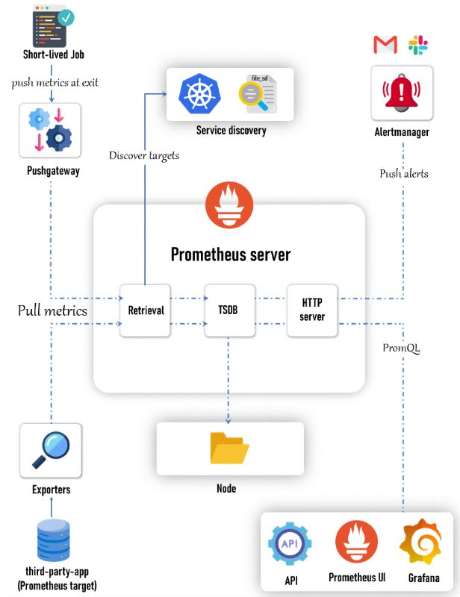

### **1)Prometheus Server**

The **Prometheus server** serves as the **central component** of the monitoring system. It is tasked with collecting metrics from defined targets, storing them in a **time-series database (TSDB)**, and exposing that data through an **HTTP API** for querying and analysis.

**Core Components:**

* **Retrieval Module:** Handles the collection of metrics from target endpoints. Targets can be specified manually or discovered automatically via dynamic service discovery mechanisms.
* **TSDB (Time Series Database):** Stores the collected metrics efficiently, optimized for handling large volumes of time-series data.
* **HTTP Server:** Offers an interface for querying metrics using **PromQL**, accessing metadata, and integrating with other parts of the Prometheus ecosystem.
* **Storage Engine:** Persists data locally on disk (HDD/SSD) in a format specifically built for time-series storage and fast retrieval.

**2)Service Discovery**

**Service discovery** enables Prometheus to automatically detect and maintain the list of targets (such as services or applications) it needs to monitor.This functionality is especially vital in **dynamic environments like Kubernetes**, where services can frequently appear or disappear.

**Key Components:**

* **Kubernetes Integration:** In Kubernetes-based setups, Prometheus leverages the Kubernetes API to automatically discover **pods, services, and nodes**, ensuring it always monitors the current state of the environment.
* **File-Based Service Discovery:** For static or more controlled environments, Prometheus can load target configurations from files, offering flexibility where automatic discovery isn't applicable.

### **3) Pushgateway**

The **Pushgateway** serves as a bridge for collecting metrics from ephemeral jobs or applications that Prometheus can’t scrape directly. These short-lived processes **push** their metrics to the Pushgateway, which then **exposes** them so Prometheus can **pull** the data.

**Use Case:**  
Ideal for batch jobs or transient tasks with a brief lifespan—ensuring their metrics are captured even though they don’t persist long enough for direct scraping.

### **4) Alertmanager**

The **Alertmanager** handles alerts produced by Prometheus. It deduplicates and groups them, then routes notifications to the right channels—whether that’s PagerDuty, email, Slack, or others.

### **5) Exporters**

Exporters are lightweight programs that gather metrics from external systems and present them in a format Prometheus can scrape. They’re crucial for monitoring services that don’t offer native Prometheus support.

**Common Examples:**

* **Node Exporter:** Collects hardware and OS-level metrics.
* **MySQL Exporter:** Exposes database performance statistics.
* **Application-Specific Exporters:** Tailored exporters for various software stacks.

### **6) Prometheus Web UI**

The Prometheus web interface lets users navigate the gathered metrics, execute on-the-fly PromQL queries, and view the results right inside Prometheus.

### **7)Grafana**

Grafana serves as a robust dashboard and visualization platform that connects with Prometheus to deliver detailed, customizable displays of metric data.

### **8)API Clients**

API clients use Prometheus’s HTTP API to retrieve data, execute metric queries, and connect Prometheus with external systems or bespoke applications.

**Prometheus Installation & Configurations**

Step by step procedure

Prerequisites

* Download and Install AWS Cli
* Setup and configure AWS CLI using the aws configure command.
* Install and configure eksctl
* Install and configure kubectl .

Am using **git bash** for implement all the steps am doing screenshot show below you can follow the same

* Create an **eks cluster** named as **observability**
* Apply the command

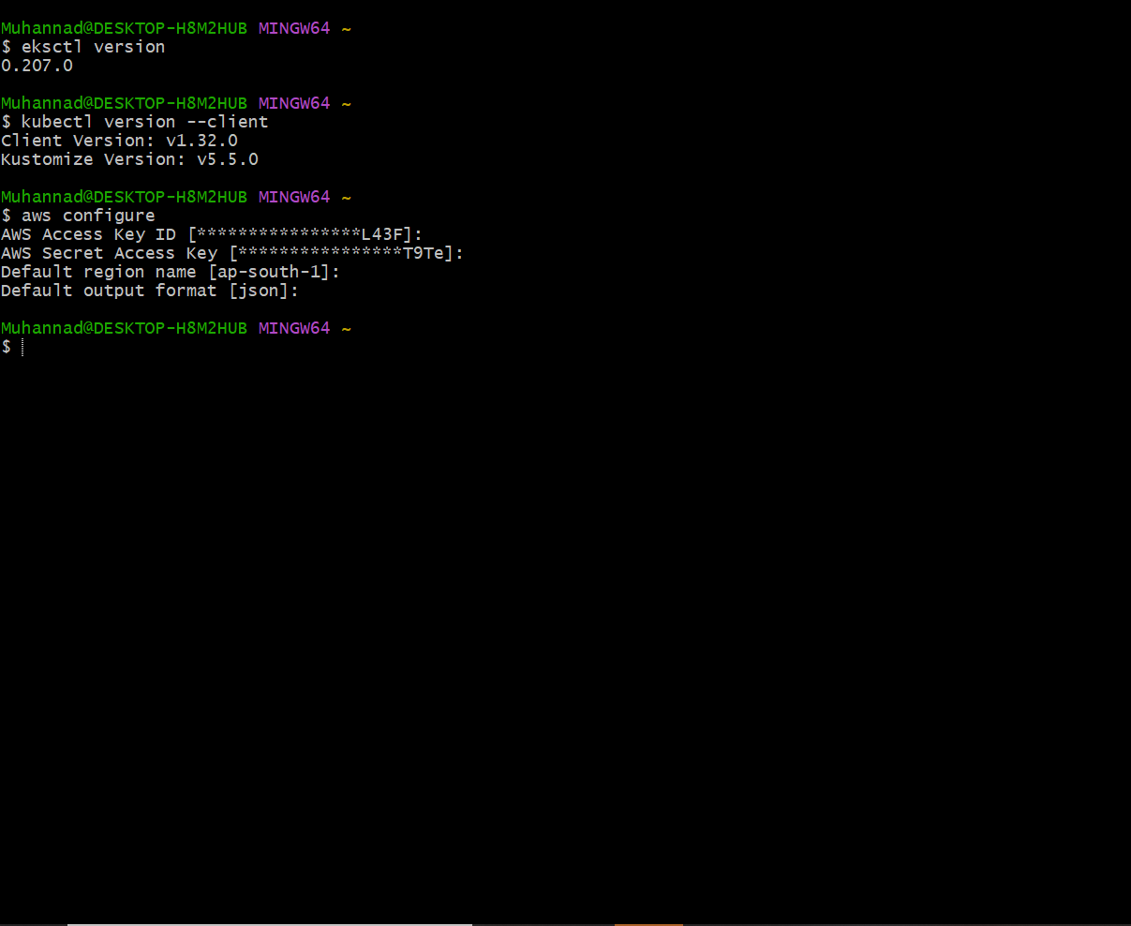

**Step1 : Pre request is completed apply command for create the cluster**

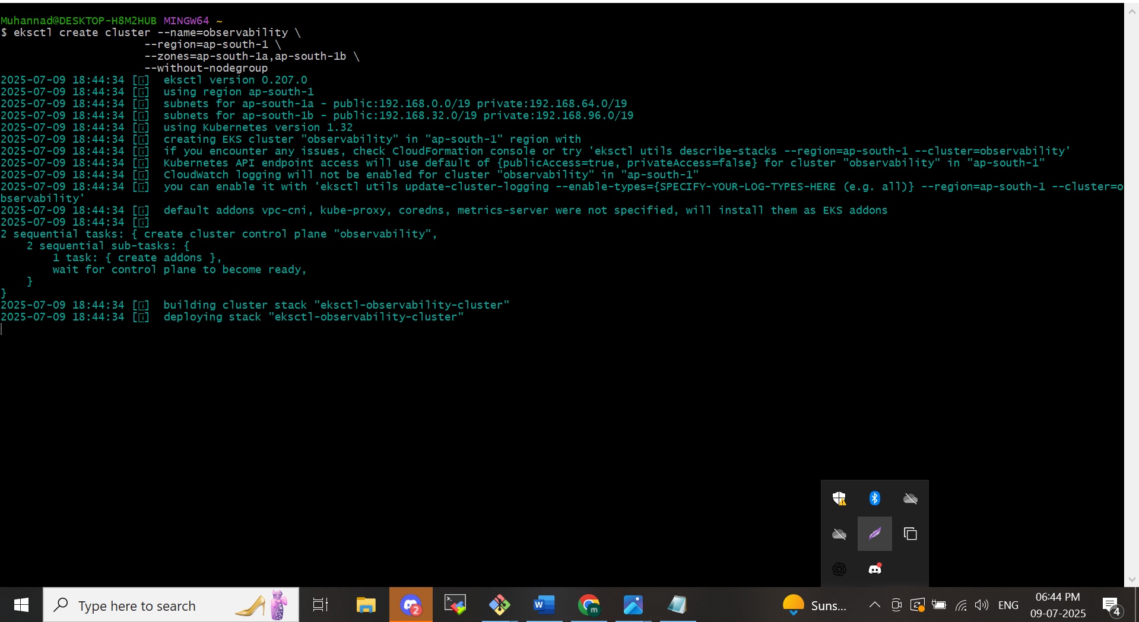

* **Create iam oidc provider**

The importance of oidc provider to communicate any aws services with eks cluster we use oidc provider.

*eksctl utils associate-iam-oidc-provider *

*--region ap-south-1 *

*--cluster observability *

*--approve*

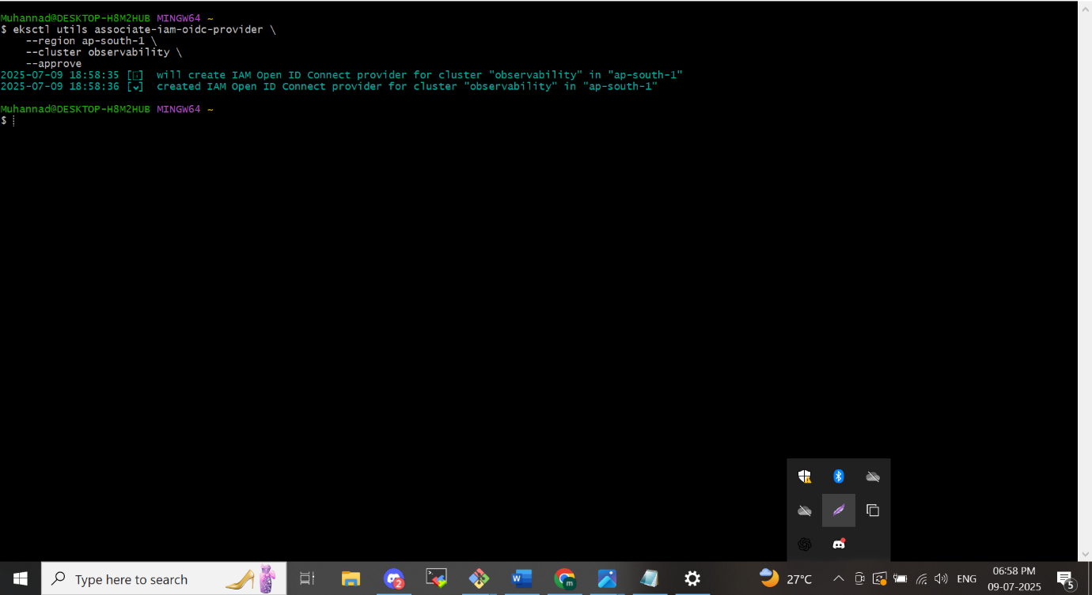

* **Create node group**

*eksctl create nodegroup --cluster=observability *

*--region=ap-south-1 *

*--name=observability-ng-private *

*--node-type=t3.medium *

*--nodes-min=2 *

*--nodes-max=3 *

*--node-volume-size=20 *

*--managed *

*--asg-access *

*--external-dns-access *

*--full-ecr-access *

*--appmesh-access *

*--alb-ingress-access *

*--node-private-networking*

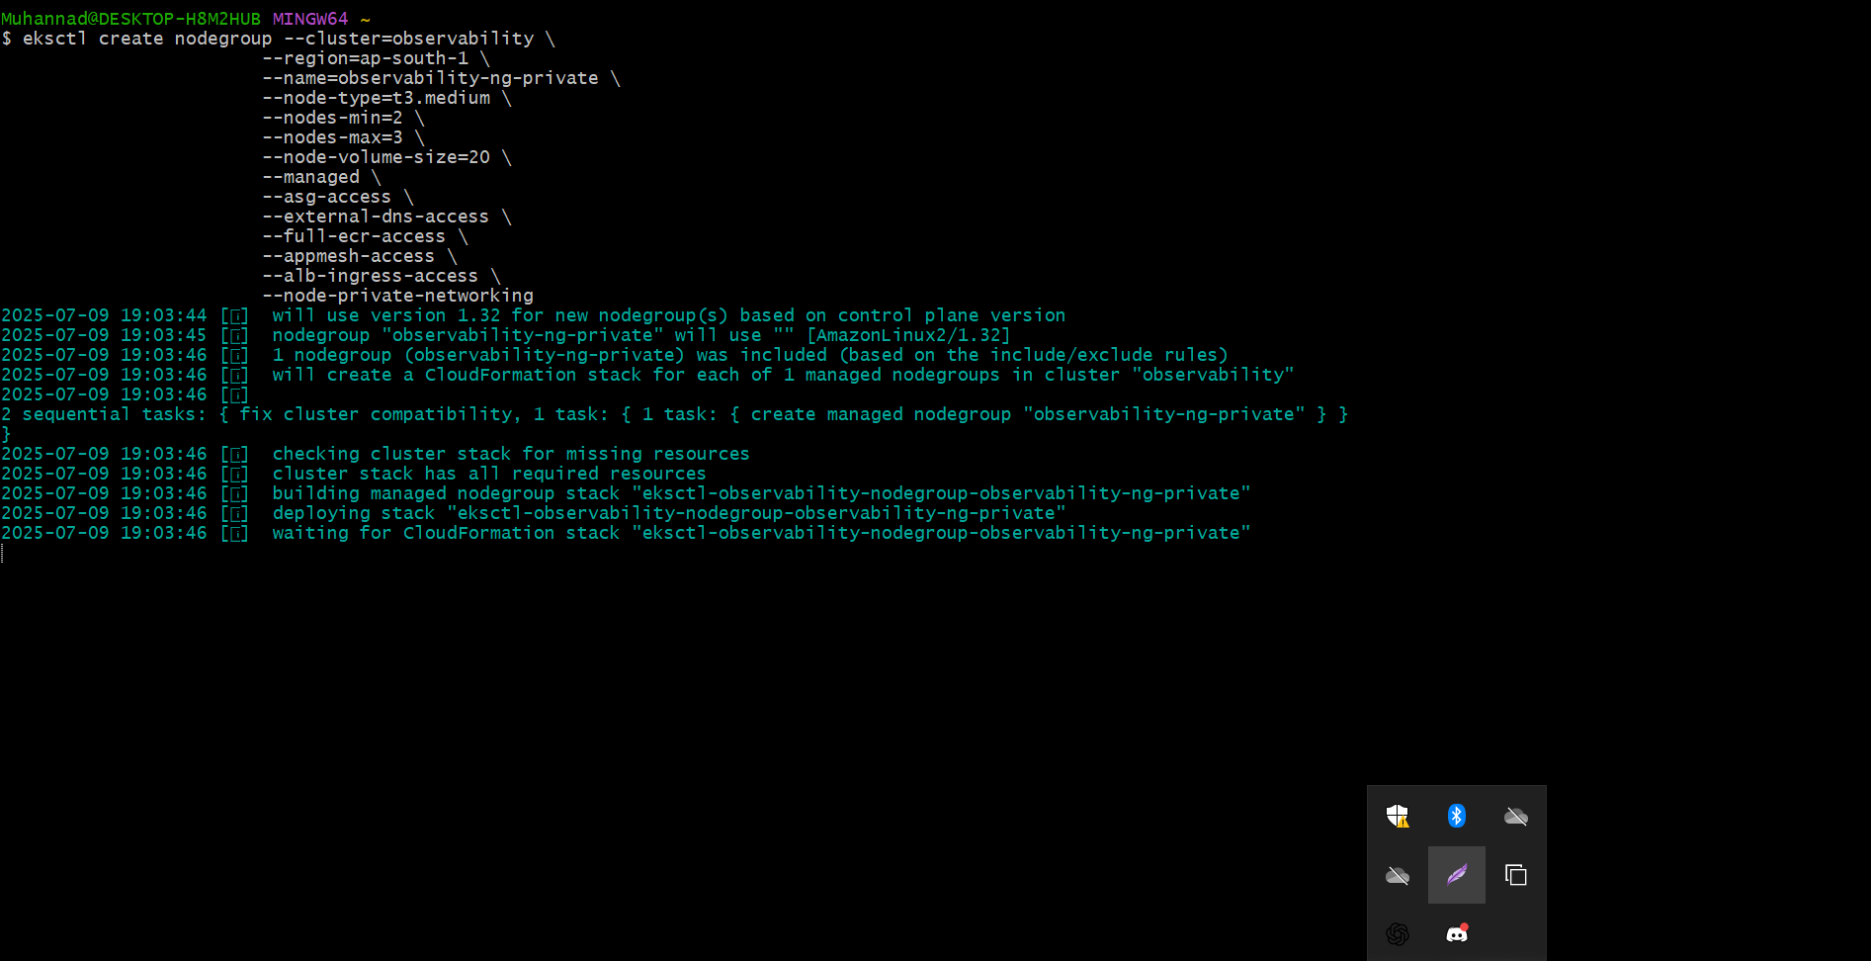

*aws eks update-kubeconfig --name observability* – Make on the same context

**Step 2 : Install kube-prometheus-stack**

I am using Helm to create the kube-prometheus-stack. First, install Helm, then run the command below

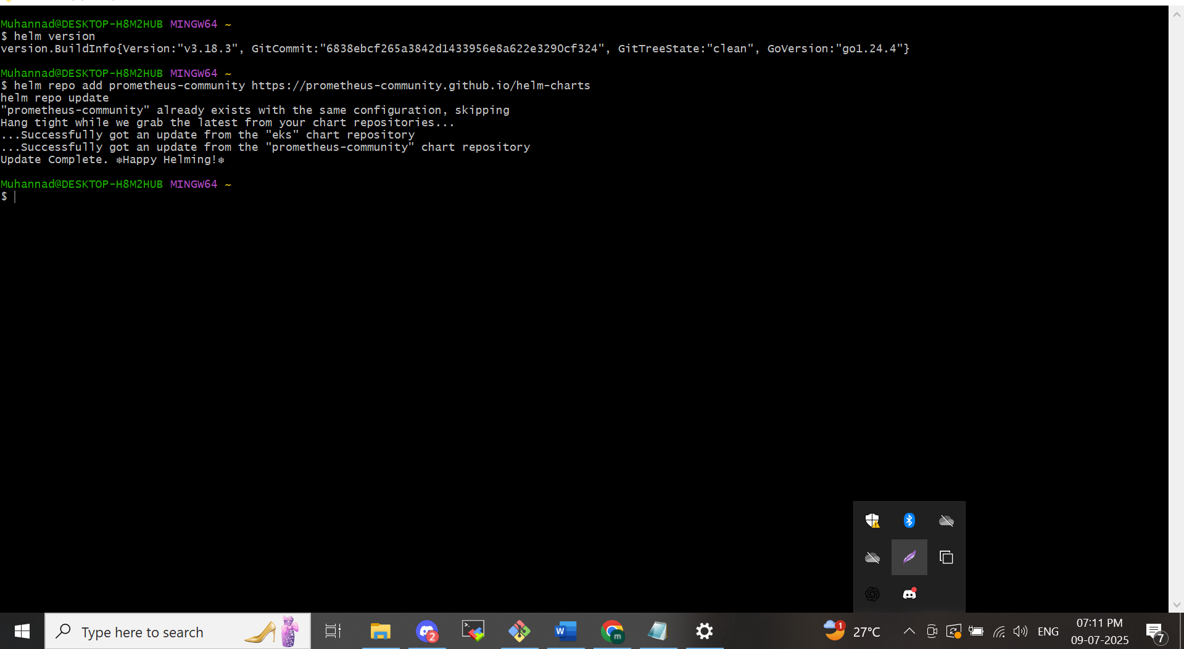

**Step 3: Deploy the chart into a new namespace "monitoring"**

Clone the repo below and switch to the following file .You can fork or clone the file below

<https://github.com/muhannadpv786/observability-zero-to-hero.git>

*kubectl create ns monitoring*

*cd day-2*

*helm install monitoring prometheus-community/kube-prometheus-stack *

*-n monitoring *

*-f ./custom_kube_prometheus_stack.yml*

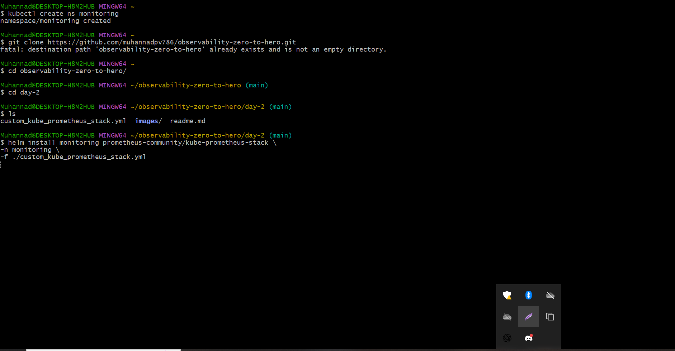

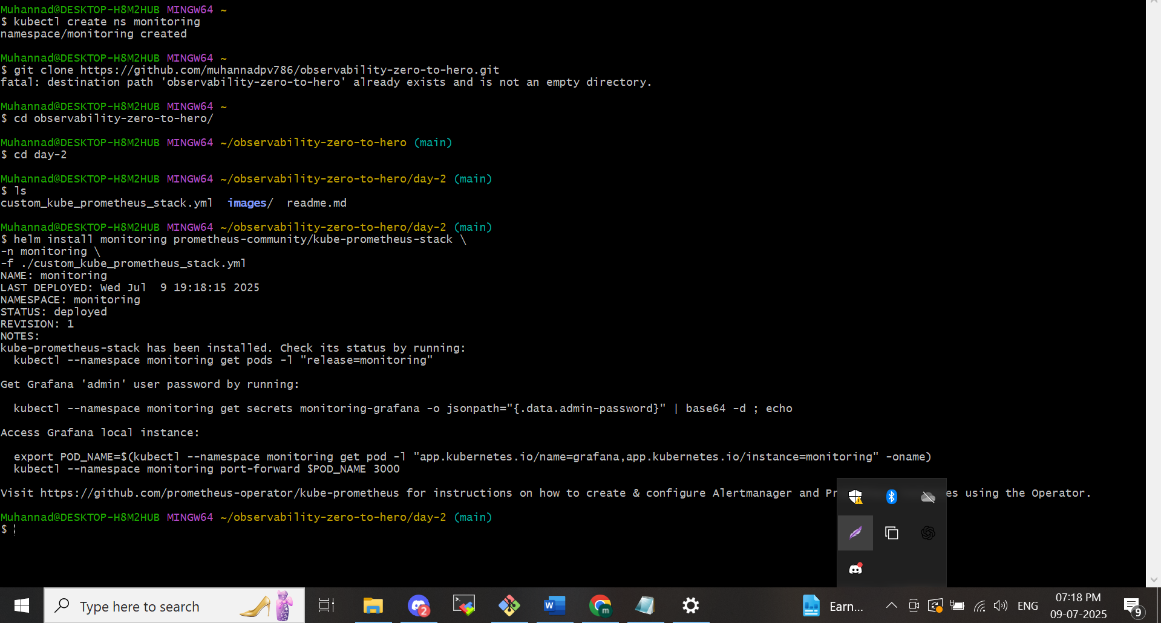

**Step 4: Verify the Installation**

*kubectl get all -n monitoring*

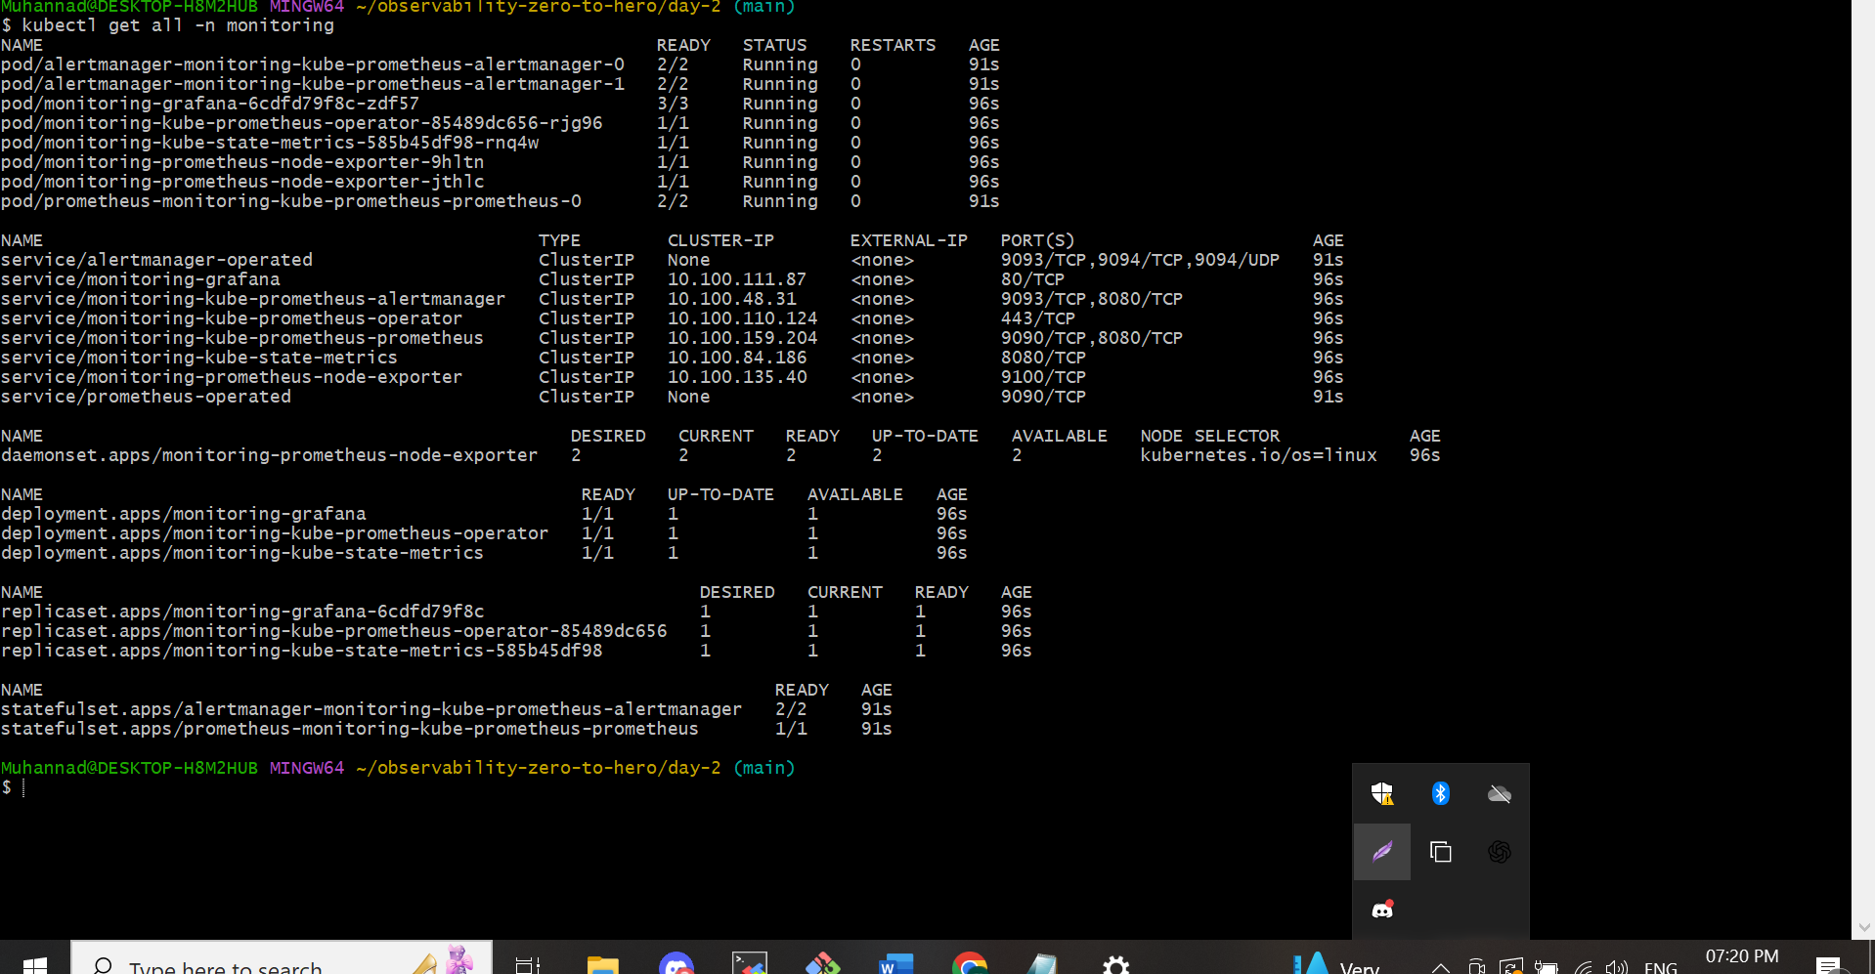

**NB:-**The pods are running in eks cluster I am trying to expose it in local host by using **port-forward method**

Actually ,what happening is we created the eks cluster in private subnet am created all from my local machine so the communication in between my local machine and the aws by configure awscli all the details are stored in my local machine in the aws cli folder as below

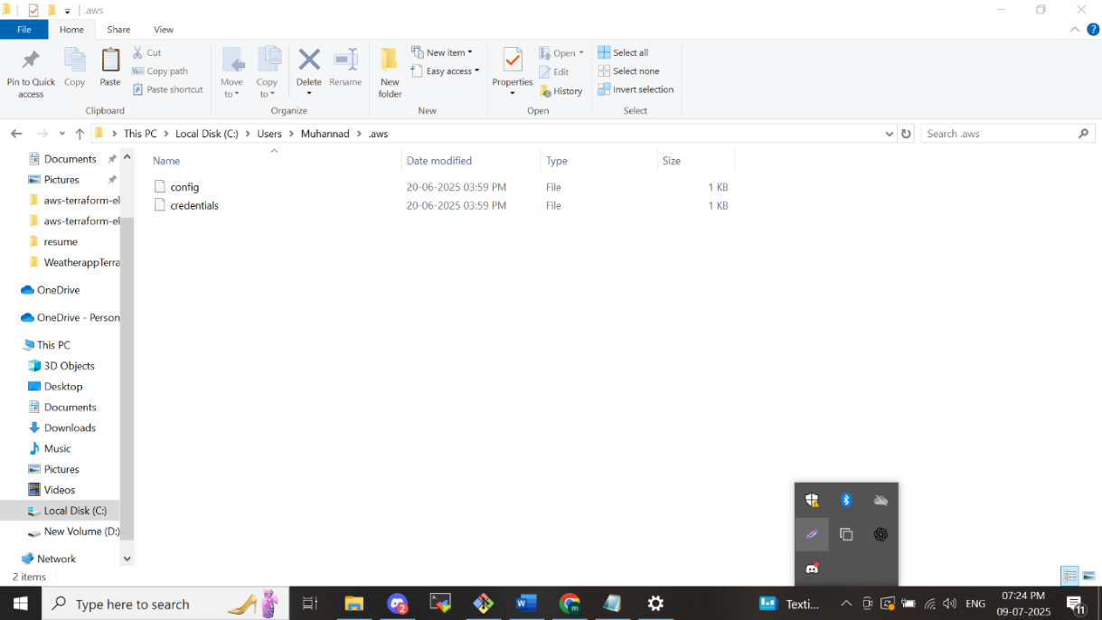

This will make to allow the communication between awscloud and local machine . Now am going to port forward the pods in the name space monitoring its contains **Prometheus UI,** **Grafana UI, Alertmanager UI**:

**stack.yml** so the alert manager feature will enabled you can refer the file in that repo. The customized feature we add by enable the file in the repo named as **custom_kube_prometheus**

The port forward commands are showing below for each services:

* **Prometheus UI**:

*kubectl port-forward service/Prometheus-operated -n monitoring 9090:9090*

**NOTE:** If you are using an EC2 Instance or Cloud VM, you need to pass --address 0.0.0.0 to the above command. Then you can access the UI on instance-ip:port

* **Grafana UI**: password is prom-operator

*kubectl port-forward service/monitoring-grafana -n monitoring 8080:80*

* **Alert manager UI**:

*kubectl port-forward service/alert manager-operated -n monitoring 9093:9093*

There its expose once we gave the command it communicate with kube-api the kubeapi will gave the instruction for the expose it to localhost.in eks aws service the master will fully be controlled by aws and the master node cannot be seen by user in our eks architecture the pods are running in private subnet in the vpc the master is in public subnet that picture in your mind once you are implementing this.

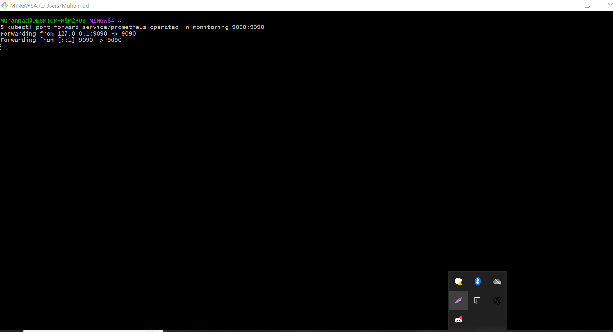

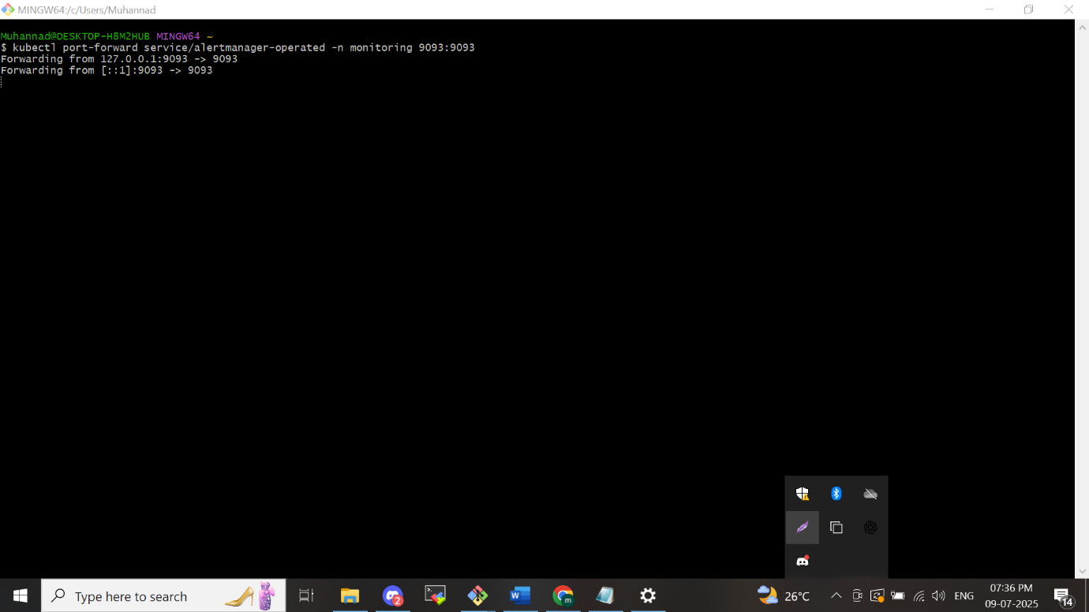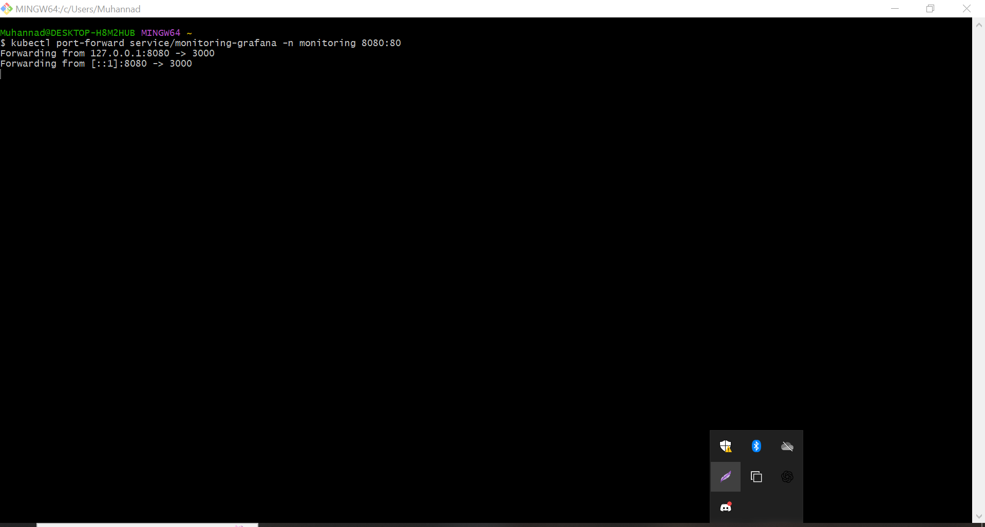

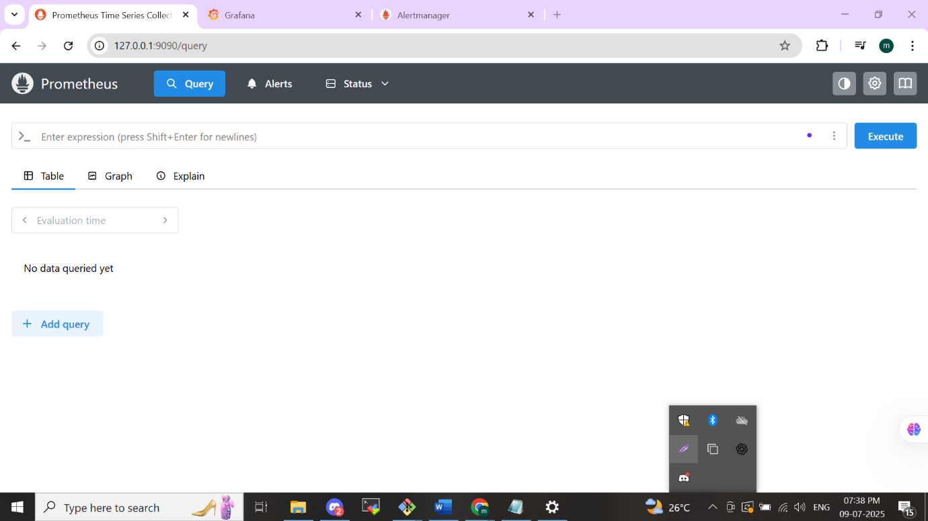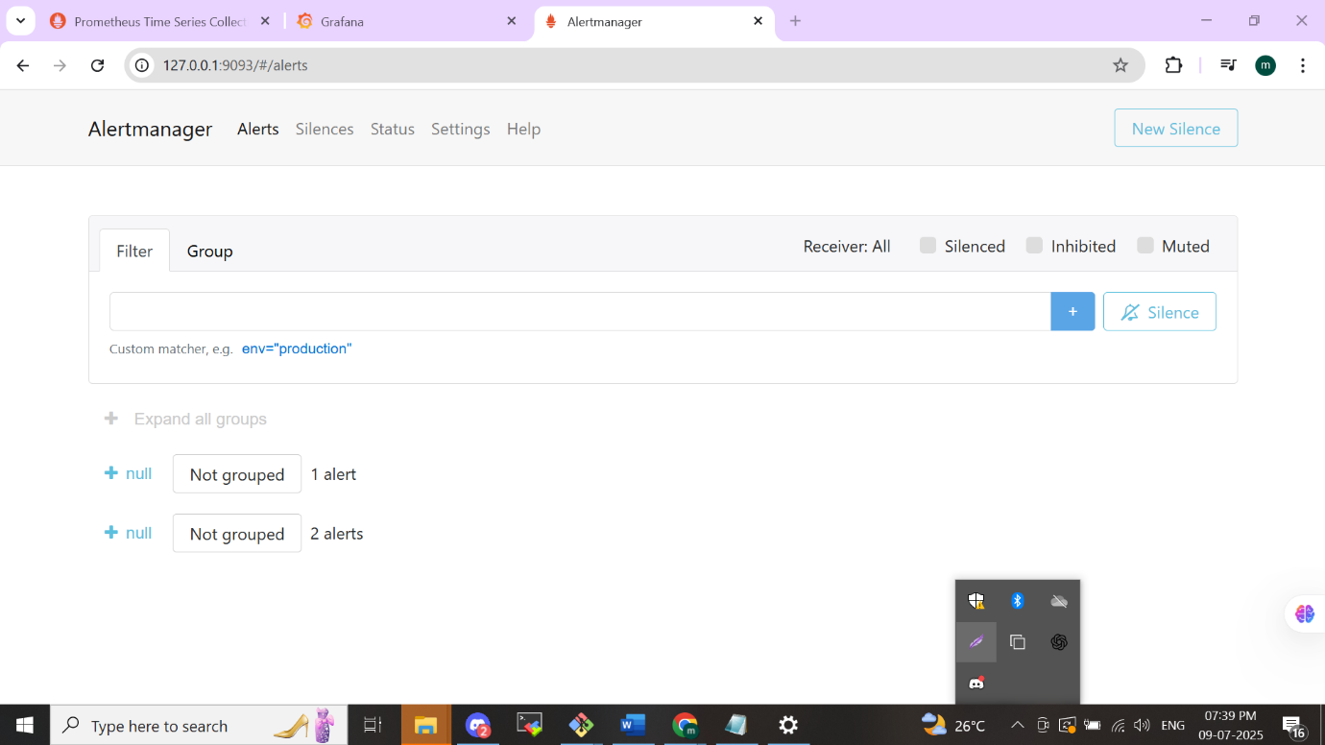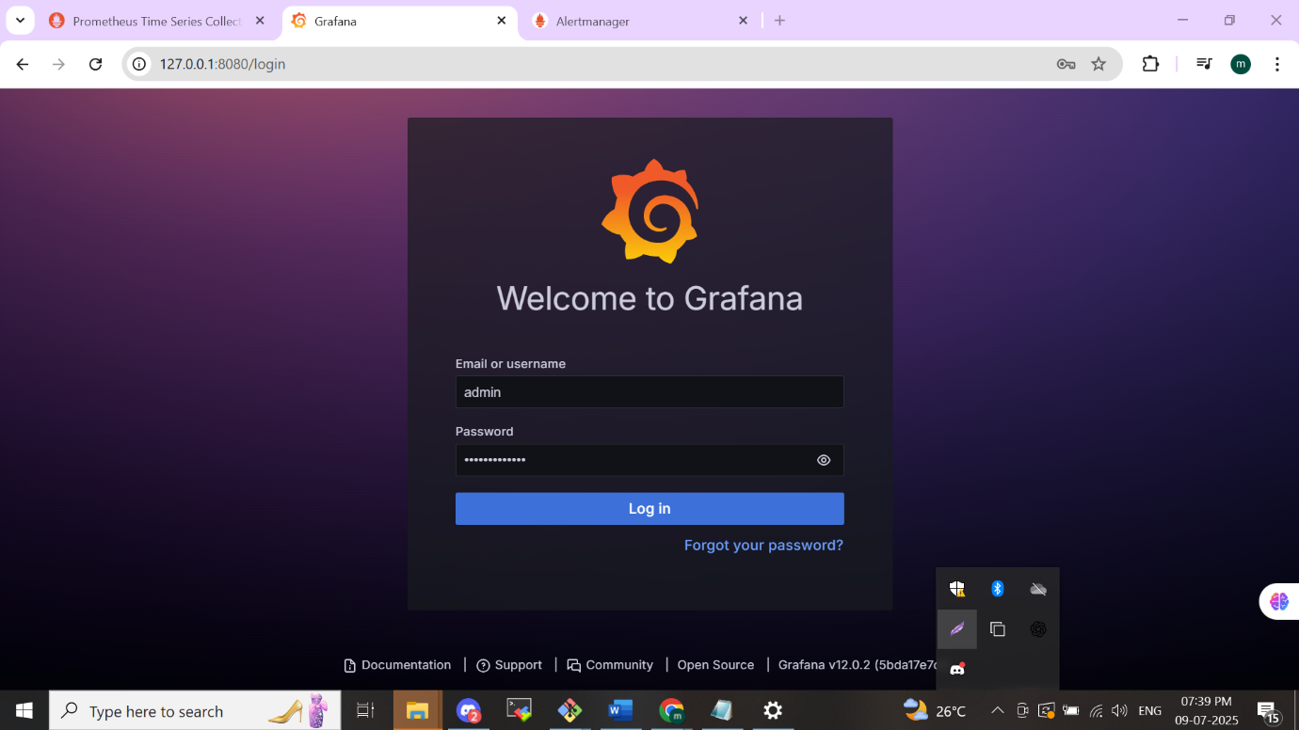

**Module-3**

**Metrics and PromQL in Prometheus**

* **Concepts Covered:**
  + Introduction to PromQL and basic querying techniques.
  + Aggregation and functions in PromQL to analyze metrics data.
* **Key Learning:**
  + Master the Prometheus Query Language (PromQL) for querying and analysing metrics.

Basic concepts in metrics first key pillar in observability is metrics

**Metrics in Prometheus:**

Prometheus metrics are the fundamental data points that capture measurements from monitored systems. They offer visibility into system performance, health, and operational behaviour.

**Labels:** Every metric comes with associated labels—key-value tags that distinguish different dimensions of the data, such as the specific service, instance, or endpoint it represents.

**What is PromQL?**

**PromQL** (Prometheus Query Language) is a versatile, expressive syntax for extracting and processing data from Prometheus.

With PromQL, you can fetch and transform time-series data, apply arithmetic operations, combine and summarize multiple series, and leverage a host of built-in functions for deeper analysis.

**PromQL Highlights:**

* **Targeted Series Selection:** Use filters to pinpoint and retrieve exactly the metrics you need.
* **Arithmetic Operations:** Perform calculations directly on your metric values.
* **Aggregation:** Summarize and roll up data across several time series.
* **Rich Function Library:** Access an extensive set of functions for complex querying and analysis.

**Exporters and its function on Prometheus**

Once the infrastructure is provisioned, Prometheus begins scrapes metrics /pull by querying each exporter. The Node Exporter gathers system-level data from every node—such as CPU, memory, and filesystem statistics—while application exporters collect pod‑level metrics for your services. Database exporters, in turn, provide metrics like query throughput and connection usage. Although there are many specialized exporters available, these three (infrastructure, application, and database) are the most commonly used in Kubernetes environments.

With Prometheus continuously collecting this data, we can then build rich Grafana dashboards to visualize key metrics in real time—giving us clear insights into node health, application performance, and database behaviour.

The primary responsibility of the Prometheus is to scrap the metrics. There are some important sources to scrap the metrics they are 1) node exporter – it will run on our Kubernetes cluster as a pod and it will collect the information for all of your node in eks cluster, such as the CPU information of your node, the memory information of your node from the system file information of your nodes. 2) Kube-state-metrics-The second way the Prometheus can scrape the information from the Kube-state-metrics. This is another type of exporter or a plugin on your Kubernetes cluster as a pod its talk with api -server of the Kubernetes cluster it will take lot of information from the Kubernetes cluster such as pod-status ,Deployment status ,Replicates ,Services, ConfigMap ,these type of information can be capture from the Kube-state metrics.3)Custom-Metrics-These are the metrics it related to the application very closely .example – the application will process to https request time related are example for the custom metrics, Number of user are created account on the application , in several time period. That is Called Instrumentation of metrics. Its created by the developer once they are creating and application they will customise it depends on the client interest or the behaviour of the application.

Once the Prometheus will collect the metrics in it will be stored in the time-based database. Without the exporter the capability of the metrics scraps by prometues will go down. These are the sources of Prometheus. Inside the Prometheus there is a database is there it’s a time-based database the metrics are arranged as time base stored in the database. The user can query the data from the time-based database by the promql query language, the work flow happen once the user will access threw the http server of the Prometheus the help of the promque(Prometheus query language) language, the time-based database will give the information based on the query, in the format of graph or raw format you like.

**Alert Manager**

In the previous module we discuss about the Alert manager service in the case we created. The Alert manager is responsible for managing alerts generated by the Prometheus server. It takes care of deduplicating, grouping, and routing alerts to the appropriate notification channels such as PagerDuty, email, or Slack.

**NB**:- *In the infra we use port forward methos we can deploy the services in the ingress and ingress-controller its also include in the repo. Now am I am using the port forward method for the demo purpose. In Realtime environment we use ingress and ingress controller for the deployment of these services.*

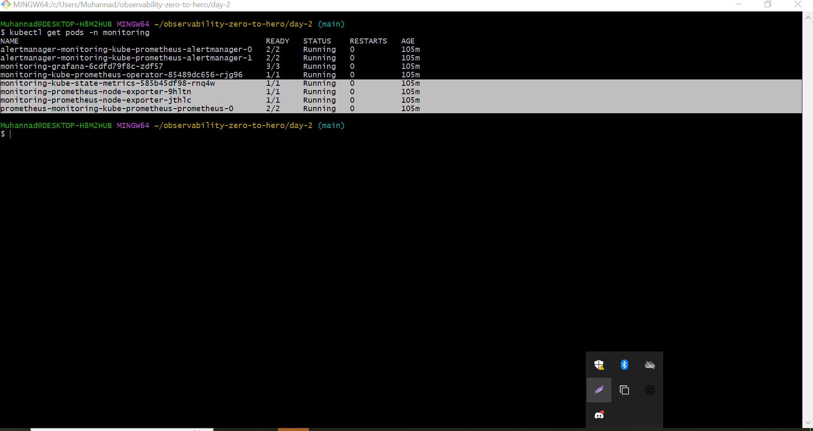

We can see the pods we are installed by helm other than alert manager, Prometheus and Grafana we can see the node-exporters and kube-statemetrics we can see there as in the above image.

We can see the metrics are scraped by the node exporter and stored in in the **/metrics**. This /metrics are the end point of the node exporter.

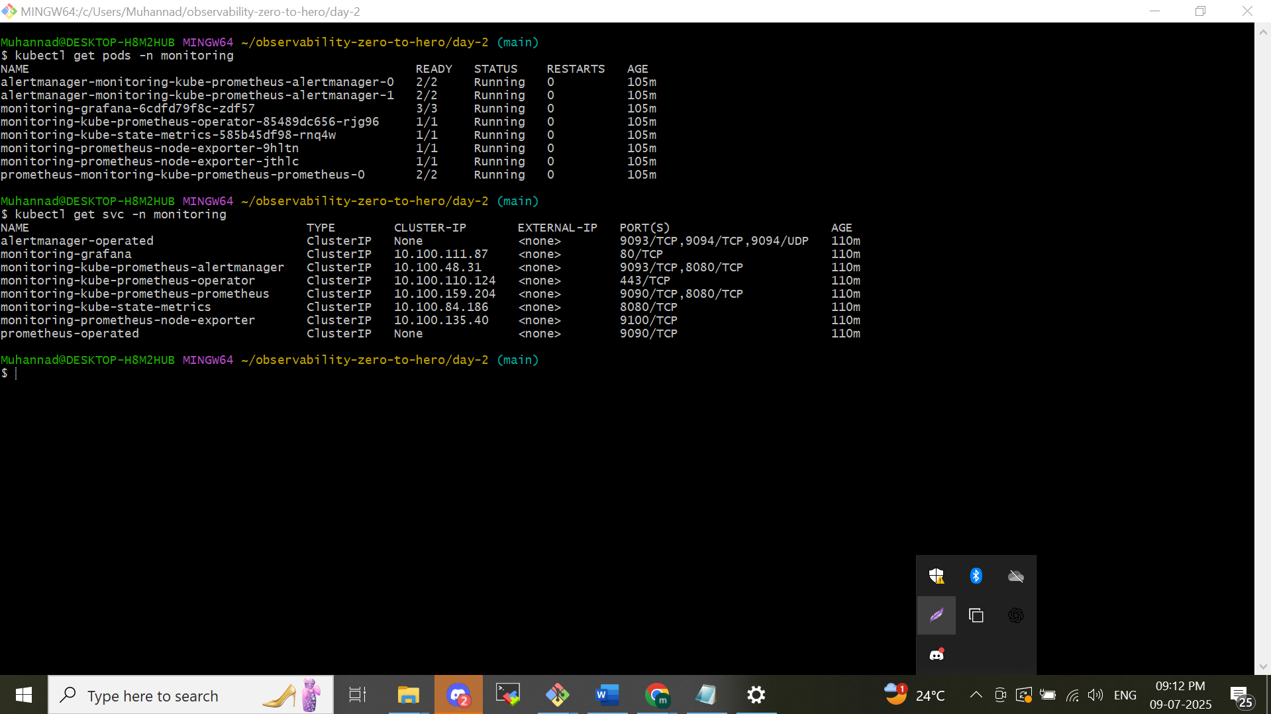

We created the eks cluster as in node so all the nodes are in ec2 instance format. Go to one of the node and go to session and in the cli of the node give the curl command with ip address of the node exporter with port number and the /metrics as like this

*– curl 10.100.135.40:9100/metrics*

You will be able to see the metrics of the node pass by node exporter from the end **point /metrics**

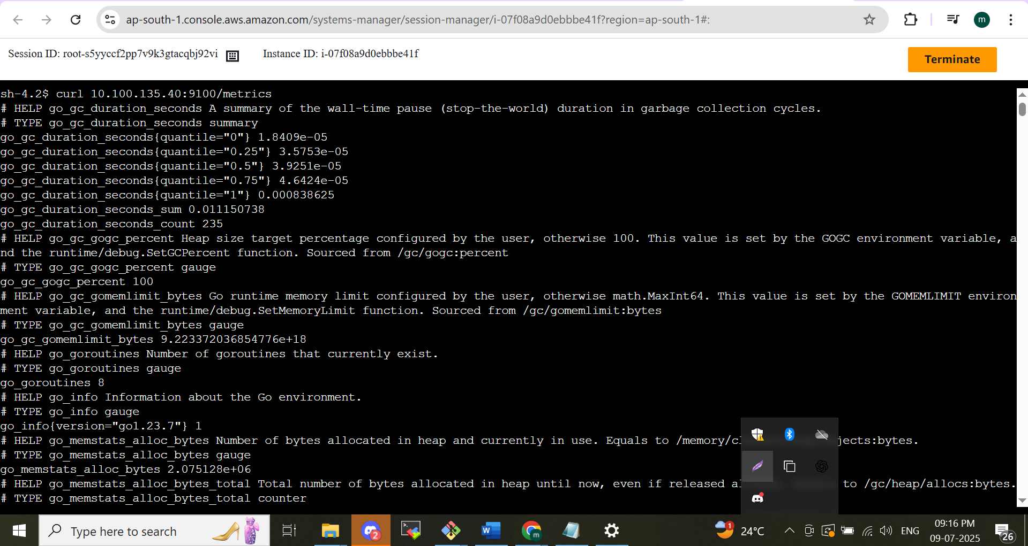

Metrics of the kube-state-metrics exporter u can see by same command by change the ip and port number as

*curl 10.100.84.186:8080/metrics*

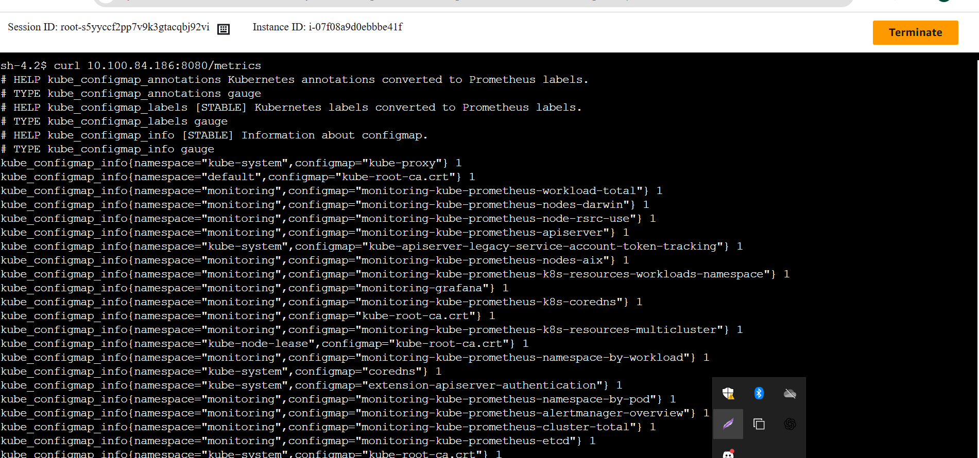

In this we can see all the metrics are seen we can see the separate metrics by using Prometheus query language apply in Prometheus dash board and see the visualized version in Grafana dashboard that are showing below

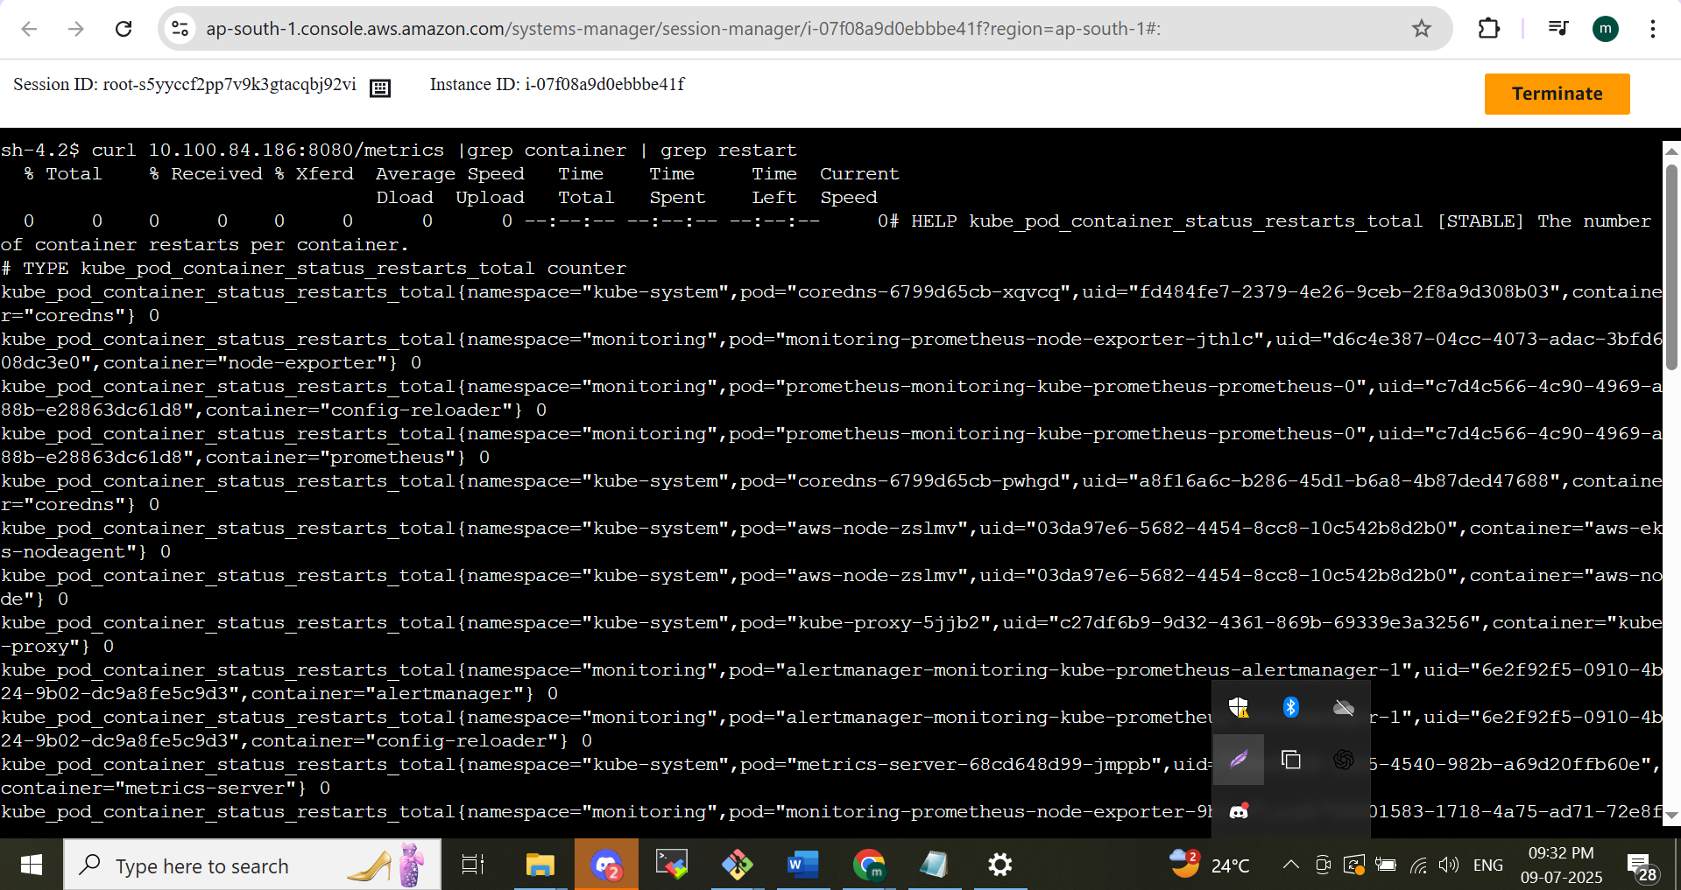

I grep the metrics how many times the init container will restart the can be see . its also bulky we can do it in Prometheus by the Prometheus query language let see below

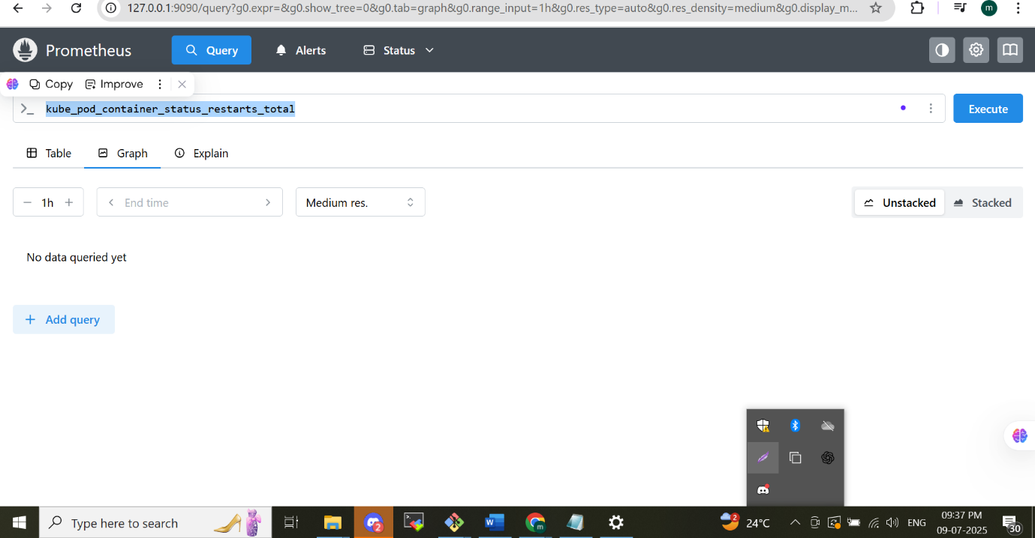

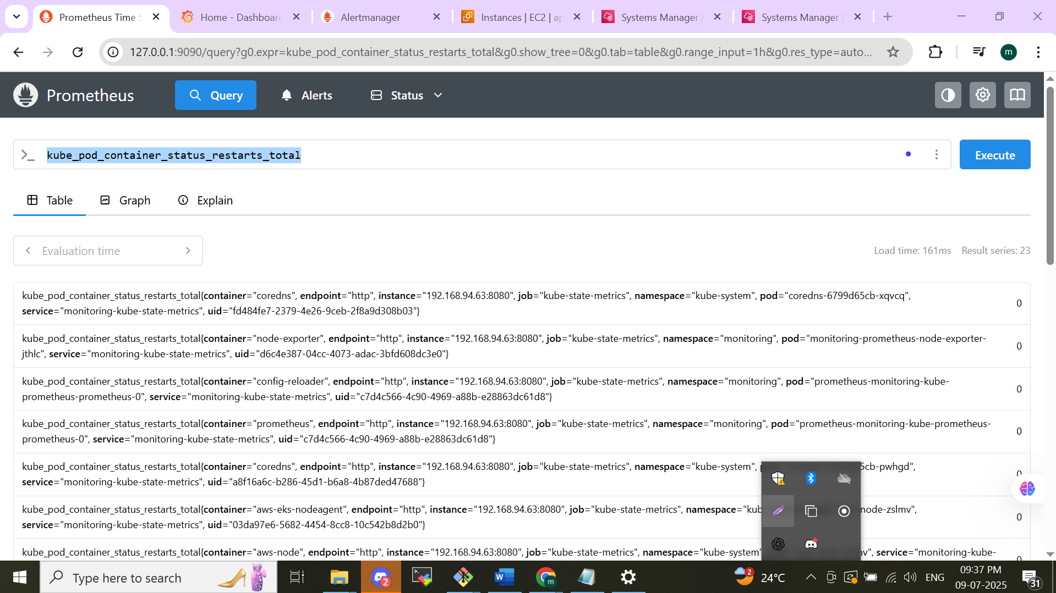

**You can see the metrics**

Graph representation in Prometheus by using a fake pod depoy in the default name space and we can see the metrics and represented graph so I am creating a pod restart scenario by the command below

*kubectl run busybox-crash --image=busybox -- /bin/sh -c "exit 1"*

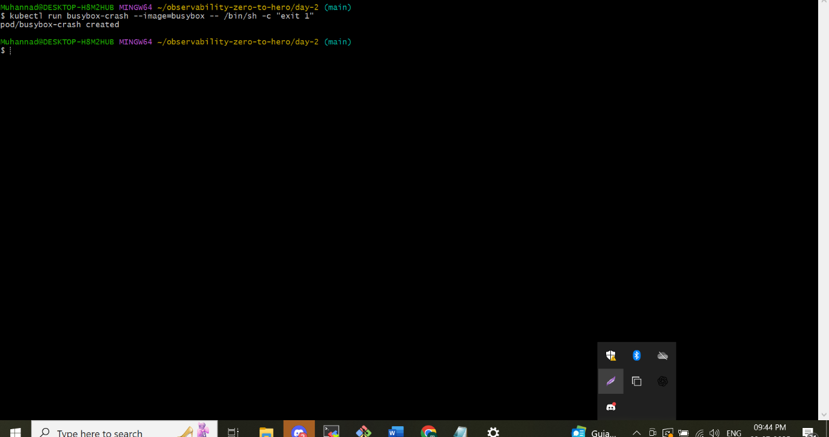

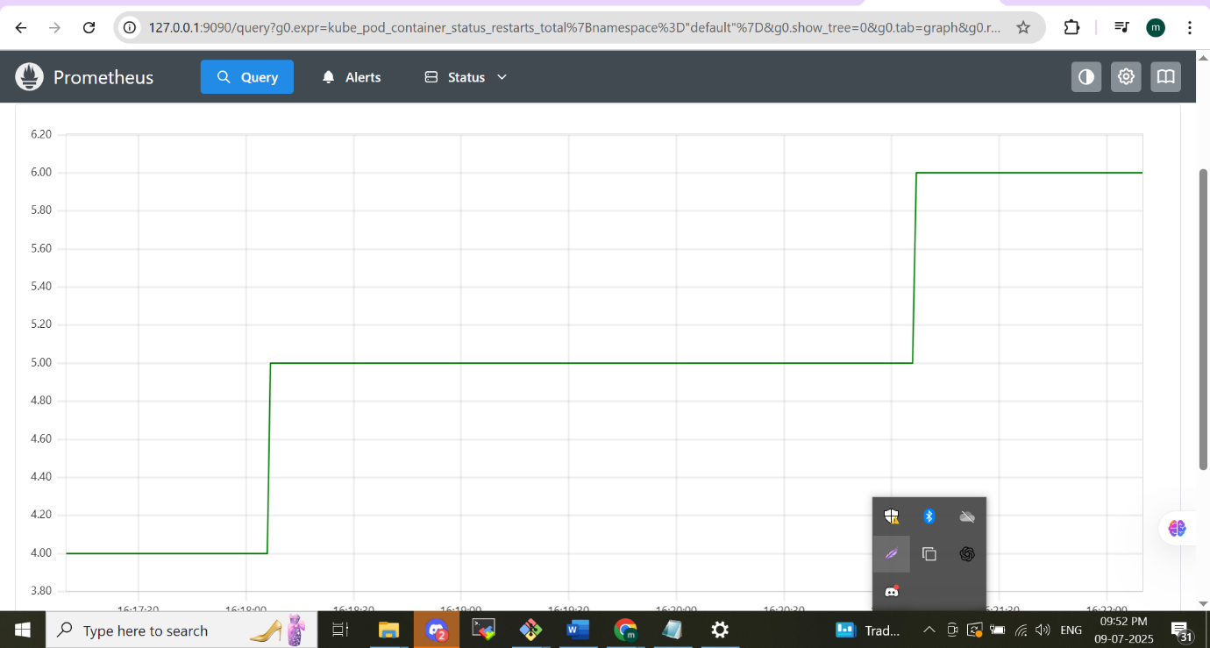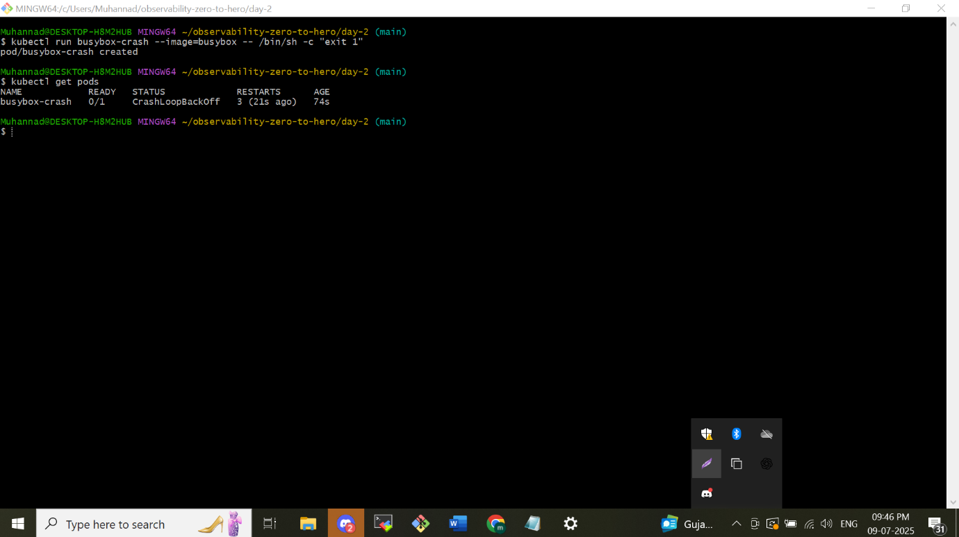

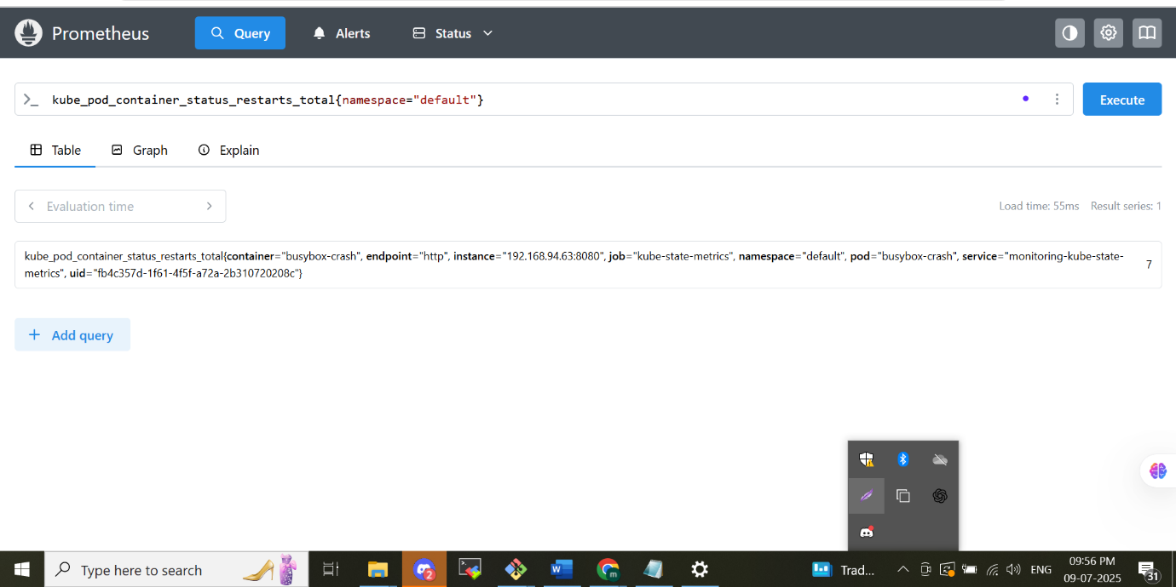

**Combining Series & Built‑In Functions in PromQL**

**Aggregation** in PromQL lets you merge multiple time‑series into one by grouping on shared labels.

* **Total CPU Consumption:**

promql

CopyEdit

sum(rate(node_cpu_seconds_total[5m]))

This expression rolls up CPU usage from every node into a single metric.

* **Namespace‑Level Average Memory:**

promql

CopyEdit

avg(container_memory_usage_bytes) by (namespace)

Here, memory usage is averaged across containers and broken out per namespace.

**Handy Range Functions**

* **rate()**  
  Calculates the average per‑second increase of a counter over a sliding window.

promql

CopyEdit

rate(container_cpu_usage_seconds_total[5m])

Measures how quickly CPU time is accumulating over the last five minutes.

* **increase()**  
  Reports how much a counter has grown during the given interval.

promql

CopyEdit

increase(kube_pod_container_status_restarts_total[1h])

Shows the total number of container restarts in the past hour.

* **histogram_quantile()**  
  Derives a specific percentile from histogram buckets.

promql

CopyEdit

histogram_quantile(0.95, sum(rate(apiserver_request_duration_seconds_bucket[5m])) by (le))

**Grafana**

The better visualization on a better dashboard platform. The advantage of we choose Grafana is 1)we are using in future with other platform to replace the Prometheus an put the nagois its also support by Grafana. Its has better dashboard also. In Grafana 2)we can gave the authentication and authorization.

Login to grafana by username –admin password -prom-operator

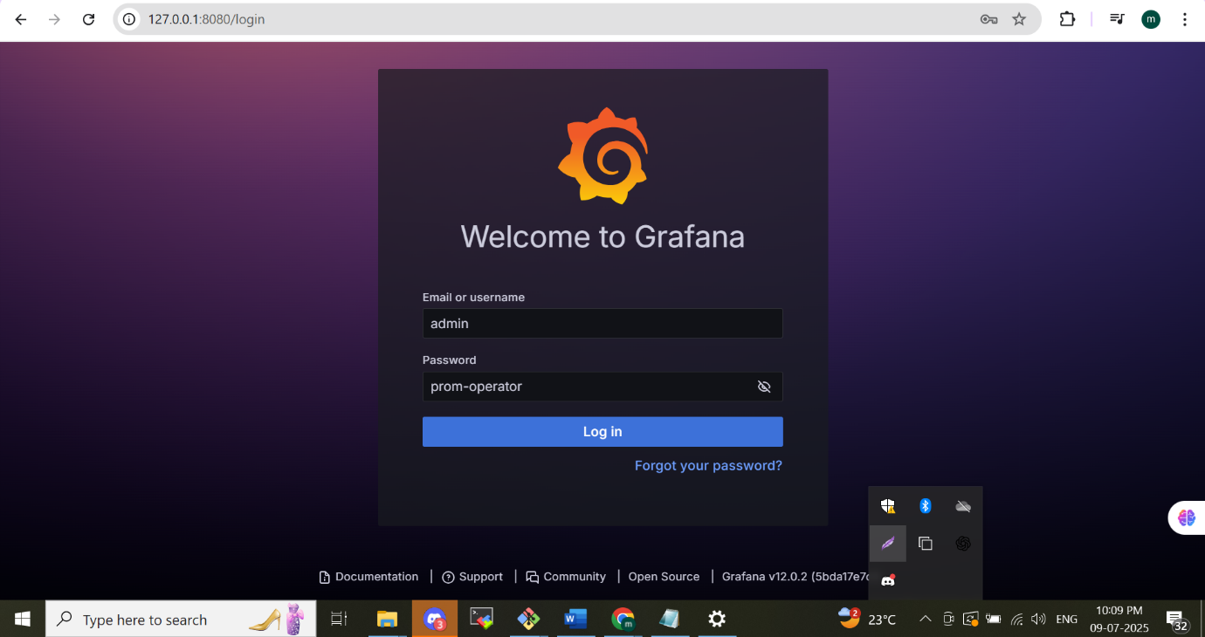

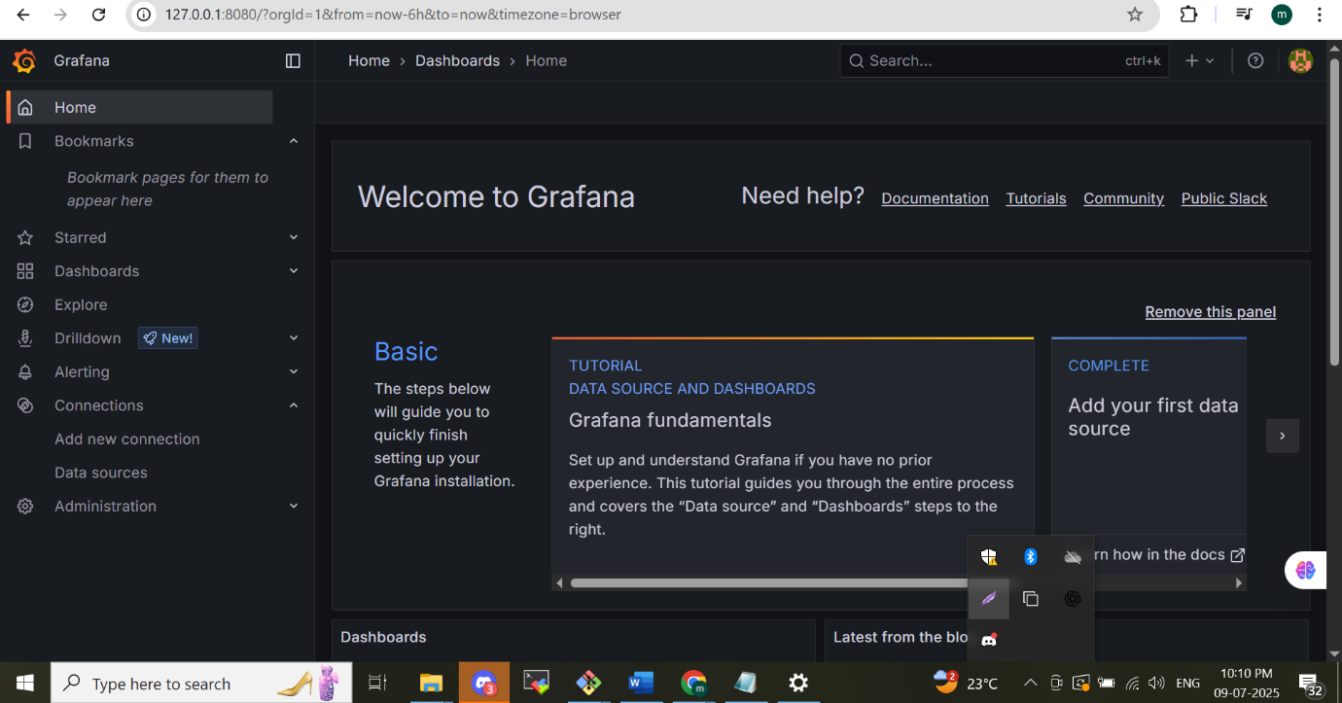

We can choose the privilege for the person as user admin and make to limit permission for users in this by authentication and authorization.

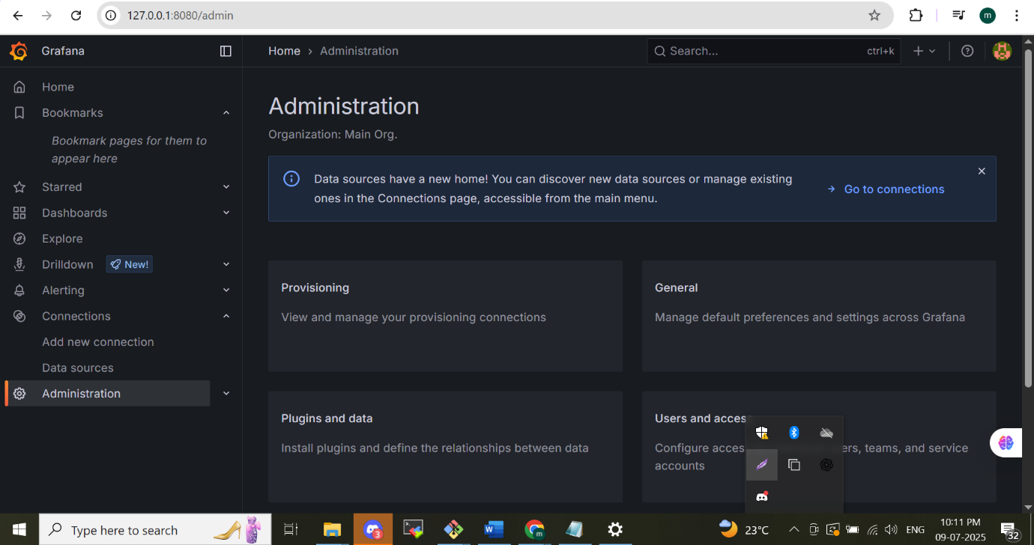

Grafana predefined dashboard

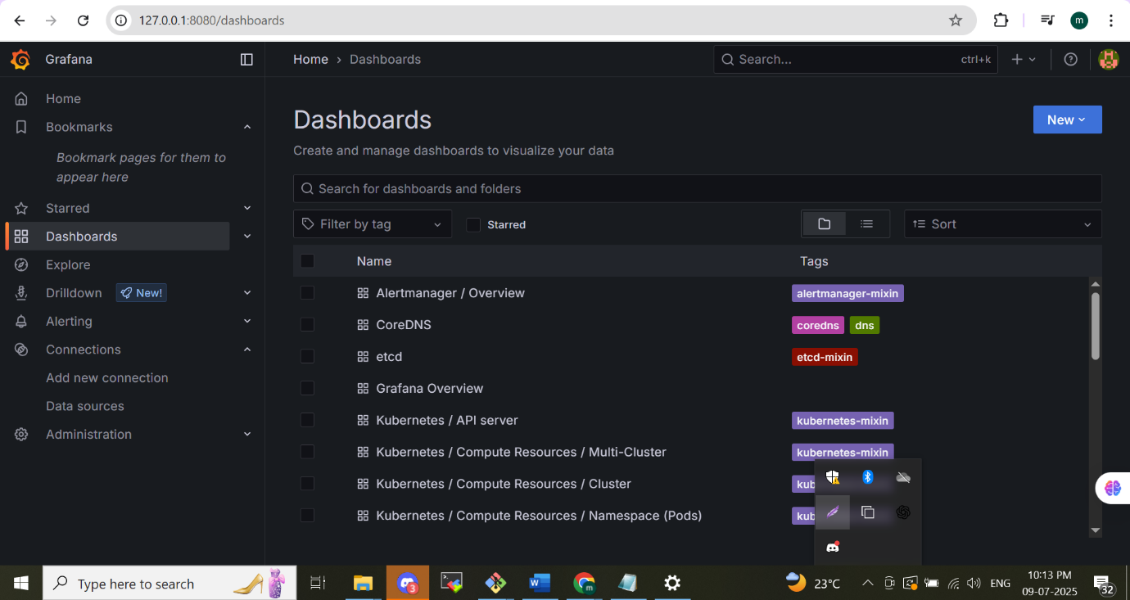

We deploy a busy box application its node related information like CPU utilization can be see below

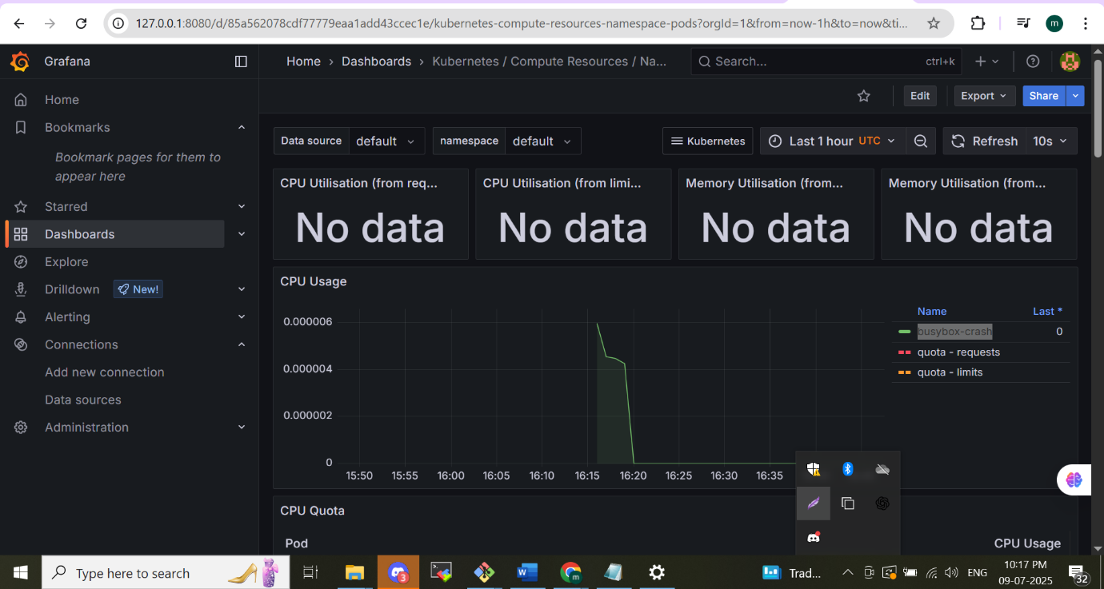

As above shown like name space of default we are deployed busy box app its CPU utilization can be see, now the kubesystem name space we can see multiple Kubernetes pods are running its also seen below

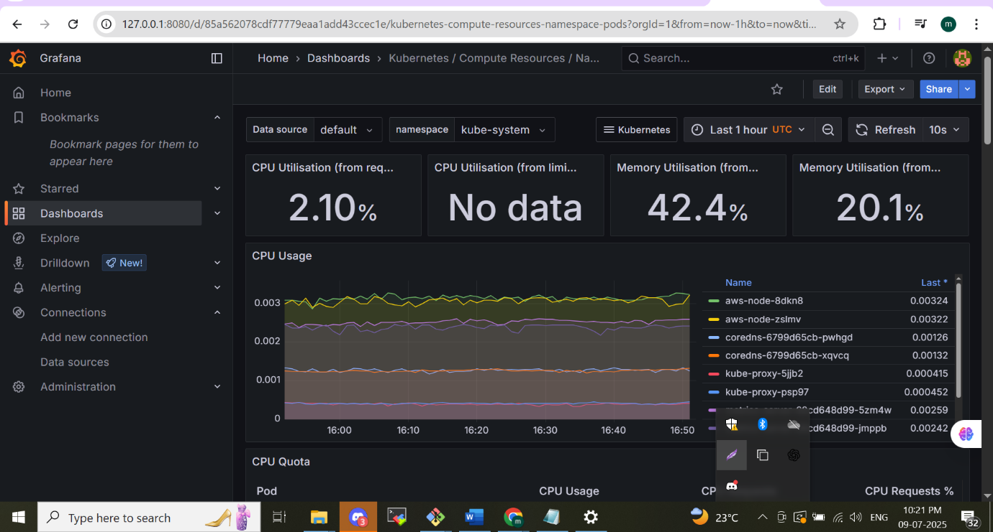

*NB : Both the Prometheus and Grafana are install by helm in same eks cluster so by default the Prometheus by default configure in Grafana*

**Custom metrics**

The developer will create these metrics depend on the application needs there are 4 types of custom metrics are there

1. **Gauges**
2. **counter**
3. **summery**
4. **histogram**

These are the main custom metrics in Prometheus. These are the metrics we customised for the application it’s the contribution from the developer it’s called instrumenting the metrics. Its will follow on the next modules

**Module -4**

**Instrumentation and Custom Metrics**

* **Concepts Covered:**
  + Instrumentation for adding monitoring capabilities to applications.
  + Understanding different types of metrics in Prometheus: Counter, Gauge, Histogram, and Summary.
  + Writing custom metrics in a Node.js application using the prom-client library.
  + Dockerizing the application and deploying it on Kubernetes.
  + Setting up Alertmanager for alerting based on custom metrics.
* **Key Learning:**
  + Learn how to instrument applications to expose custom metrics.
  + Configure alerts in Alertmanager to monitor application performance.
  + Understand how to work with different types of metrics in Prometheus.

**Instrumentation**

Instrumentation is the practice of equipping your applications, systems, or services with built‑in monitoring capabilities. It involves embedding code or deploying specialized tools to gather metrics, logs, and traces that reveal how your system is behaving and performing.

**Purpose of Instrumentation:**

* **Enhanced Insight:** Instrumentation unveils the hidden workings of your applications and infrastructure.
* **Metric Gathering:** By tracking vital statistics—such as CPU load, memory usage, request throughput, and error frequencies—you gain a clear picture of system health and performance.
* **Rapid Diagnosis:** When failures occur, your embedded monitoring data lets you pinpoint root causes swiftly through detailed, actionable information.

Top of Form

**How it Works:**

**Code-Level Instrumentation**: You can add instrumentation directly in your application code to expose metrics. For example, in a Node.js application, you might use a library like prom-client to expose custom metrics.

**Instrumentation in Prometheus:**

* **Exporters:** Prometheus relies on exporters to gather metrics from various systems, presenting them in a scrape‑friendly format.
* **Node Exporter:** Retrieves operating‑system metrics from Linux/Unix hosts.
* **MySQL Exporter:** Extracts performance statistics from MySQL databases.
* **PostgreSQL Exporter:** Captures metrics from PostgreSQL database instances.
* **Custom Metrics:** You can embed instrumentation in your own code to publish application‑specific data—such as tracking how many users log in every minute.

**Types of Metrics in Prometheus**

* **Counter:**  
  A Counter tracks a value that only increases, making it ideal for tallying events such as HTTP requests, errors, or completed tasks.  
  **Use Case:** Counting how many times a container restarts in your Kubernetes cluster.  
  **Metric Example:** kube_pod_container_status_restarts_total
* **Gauge:**  
  A Gauge represents a value that can rise and fall, perfect for monitoring fluctuating measurements like memory consumption, CPU load, or active user counts.  
  **Use Case:** Observing the memory footprint of a container in your Kubernetes environment.  
  **Metric Example:** container_memory_usage_bytes
* **Histogram:**  
  A Histogram groups observed values—such as request durations or payload sizes—into defined buckets, while also keeping a running total and count of all samples.  
  **Use Case:** Recording how long Kubernetes API calls take, segmented into time intervals.  
  **Metric Example:** apiserver_request_duration_seconds_bucket
* **Summary:**  
  Like a Histogram, a Summary collects samples and reports both the cumulative count and sum of those observations, plus user‑specified quantiles (percentiles).  
  **Use Case:** Tracking the 95th‑percentile latency of API requests to pinpoint worst‑case performance.  
  **Metric Example:** apiserver_request_duration_seconds_sum

**Exporters vs Instrumentation**

**Exporters** are capable of collecting predefined sets of metrics that are typically built into the systems they monitor. These metrics are standardized and do not require custom development.  
In contrast, **instrumentation metrics** are custom metrics added directly into the application code by developers. These are tailored to the specific behavior, performance, or business logic of the application, allowing for more granular and purpose-driven observability.

**Used Case example for Instrumentation metrics**

**1. Business Logic Tracking**

**Use Case:**

Track how often a specific business function is called.  
**Example Metric:**

* **checkout_process_total** — Counts how many times users complete the checkout process.

**2. Performance Monitoring**

**Use Case:**

Measure how long a particular function or API call takes.  
**Example Metric:**

* api_response_duration_seconds — Tracks how long your API takes to respond (can use histogram).

**3. Error Rate Tracking**

**Use Case:**

Monitor application-level errors that may not be captured by default metrics.  
**Example Metric:**

* order_processing_errors_total — Counts how many errors occurred during order processing.

**4. Queue or Job Monitoring**

**Use Case:**

Track the number of jobs added or completed from a queue.  
**Example Metric:**

* email_jobs_pending — Number of pending email jobs.
* email_jobs_processed_total — Total number of processed email jobs.

**5. User Interaction Metrics**

**Use Case:** Count or time how often users interact with certain features.  
**Example Metric:**

* user_login_attempts_total — Counts login attempts.
* profile_update_duration_seconds — Time taken to update a profile.

**6. Custom Resource Utilization**

**Use Case:** Track internal resource usage not visible at system level.  
**Example Metric:**

* cache_hit_ratio — Ratio of cache hits to total cache lookups.
* db_connection_pool_usage — Number of database connections in use.

**Project Objectives**

* **Implement Custom Metrics in Node.js Application**: Use the prom-client library to write and expose custom metrics in the Node.js application.
* **Set Up Alerts in Alertmanager**: Configure Alertmanager to send email notifications if a container crashes more than two times.
* **Set Up Logging**: Implement logging on both application and cluster (node) logs for better observability using EFK stack(Elasticsearch, FluentBit, Kibana).
* **Implement Distributed Tracing for Node.js Application**: Enhance observability by instrumenting the Node.js application for distributed tracing using Jaeger. enabling better performance monitoring and troubleshooting of complex, multi-service architectures.

**Architecture Of This Efk Project**

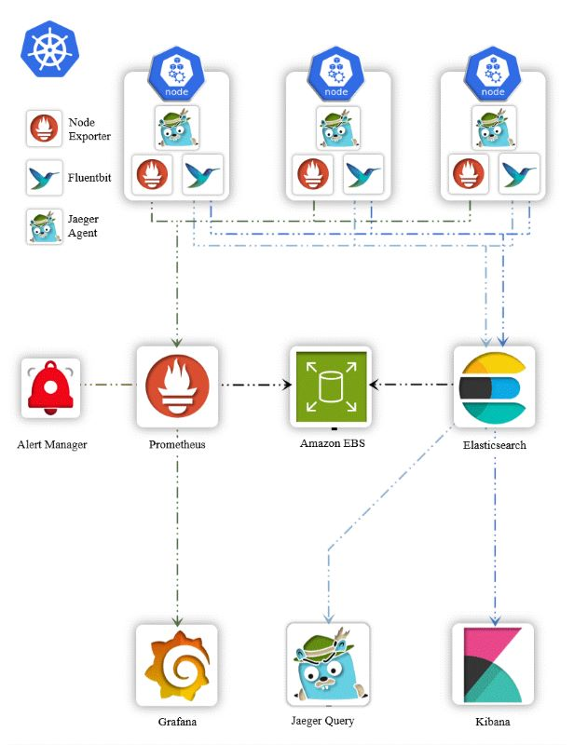

**Custom metrics (instrumentation metrics) mentioned by the developer in this project**

**About the project**

We have two services, **Service A** and **Service B**, which communicate with each other via APIs. Within **Service A**, the application is developed using **Node.js**. The Node.js application is instrumented to expose custom Prometheus metrics.

In the Node.js code, the Prometheus client library is imported as shown below:

*js*

*CopyEdit*

*const promClient = require('prom-client');*

Using this client, we define several instrumentation metrics, each serving a specific purpose:

**1. Counter Metric**

*js*

*CopyEdit*

*const httpRequestCounter = new promClient.Counter({*

*name: 'http_request_total',*

*help: 'Total number of HTTP requests received',*

*});*

* This is a **Counter** type metric named http_request_total.
* It counts the total number of HTTP requests received by the application.
* The value **only increases over time**, making it ideal for tracking event occurrences like request counts.

**2. Histogram Metric**

*js*

*CopyEdit*

*const requestDurationHistogram = new promClient.Histogram({*

*name: 'http_request_duration_seconds',*

*help: 'Duration of HTTP requests in seconds',*

*buckets: [0.1, 0.5, 1, 5, 10],*

*});*

* This is a **Histogram** metric used to measure the duration of HTTP requests.
* Buckets are defined for specific time ranges: 0.1s, 0.5s, 1s, 5s, and 10s.
* It helps analyze how long requests take, giving insight into performance over predefined time intervals.

**3. Summary Metric**

* A **Summary** metric is also defined to track percentiles (e.g., 0.5, 0.9, 0.99) of the request duration.
* This is useful for understanding the distribution of request latencies over time.

**4. Gauge Metric**

* A **Gauge** metric is used to track values that can go **up and down**, such as the duration of asynchronous tasks or current memory usage.

In addition to instrumentation, the application exposes several API endpoints such as:

* /healthy – For health checks
* /servererror – To simulate server errors
* /notfound – To simulate 404 errors
* /logs – For viewing application logs

These endpoints help in generating and analysing meaningful metrics for observability and monitoring.

**STEP 1** -**Create EKS CLUSTER**

eksctl create cluster --name=observability \

--region=ap-south-1 \

--zones=ap-south-1a,ap-south-1b \

--without-nodegroup

eksctl utils associate-iam-oidc-provider \

--region ap-south-1 \

--cluster observability \

--approve

eksctl create nodegroup --cluster=observability \

--region=ap-south-1 \

--name=observability-ng-private \

--node-type=t3.medium \

--nodes-min=2 \

--nodes-max=3 \

--node-volume-size=20 \

--managed \

--asg-access \

--external-dns-access \

--full-ecr-access \

--appmesh-access \

--alb-ingress-access \

--node-private-networking

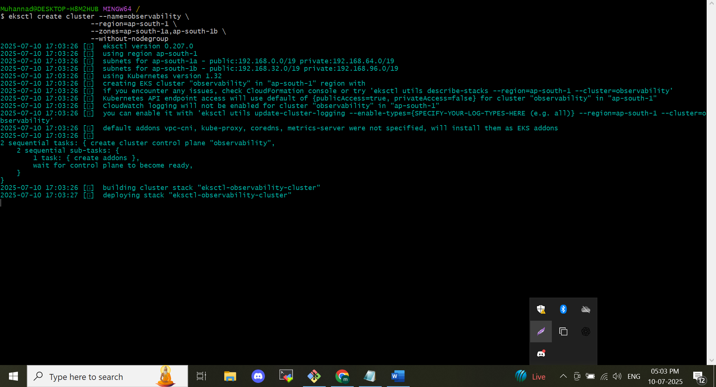

**STEP 2  Install Kube-Prometheus-stack**

helm repo add prometheus-community https://prometheus-community.github.io/helm-charts

helm repo update

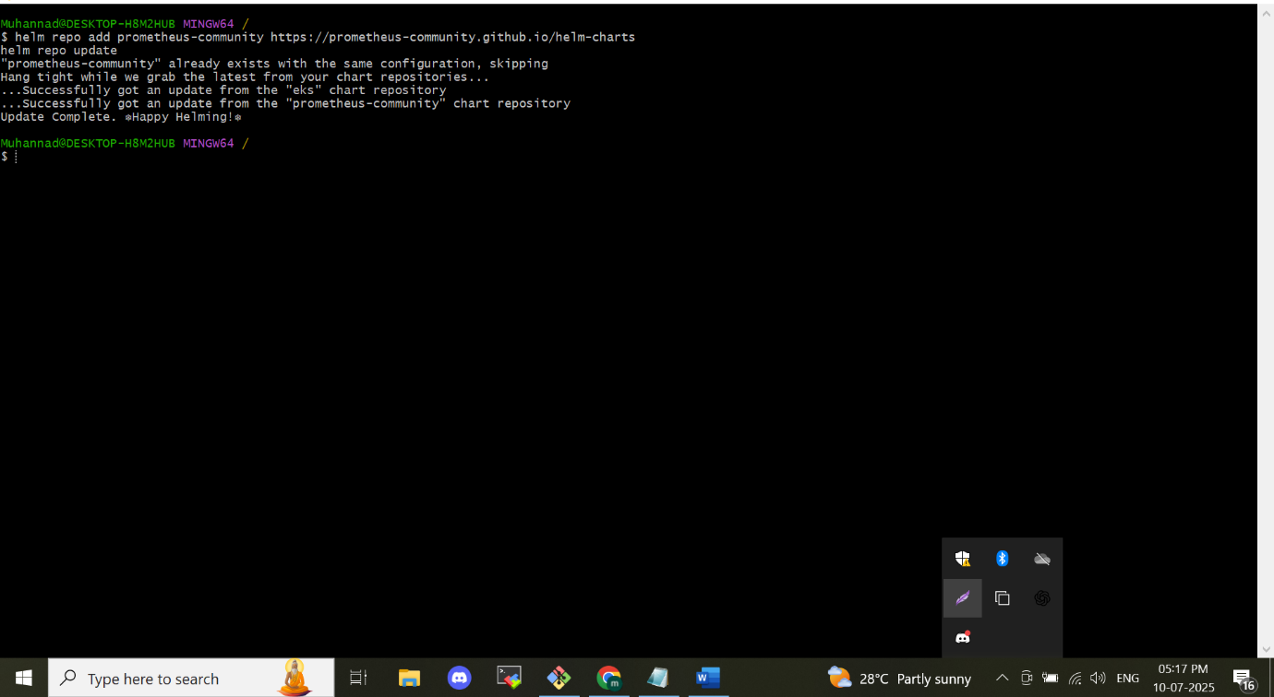

**STEP 3 Deploy the chart into a new namespace "monitoring"**

*kubectl create ns monitoring*

*cd day-2*

*helm install monitoring prometheus-community/kube-prometheus-stack *

-n monitoring \

-f ./custom_kube_prometheus_stack.yml

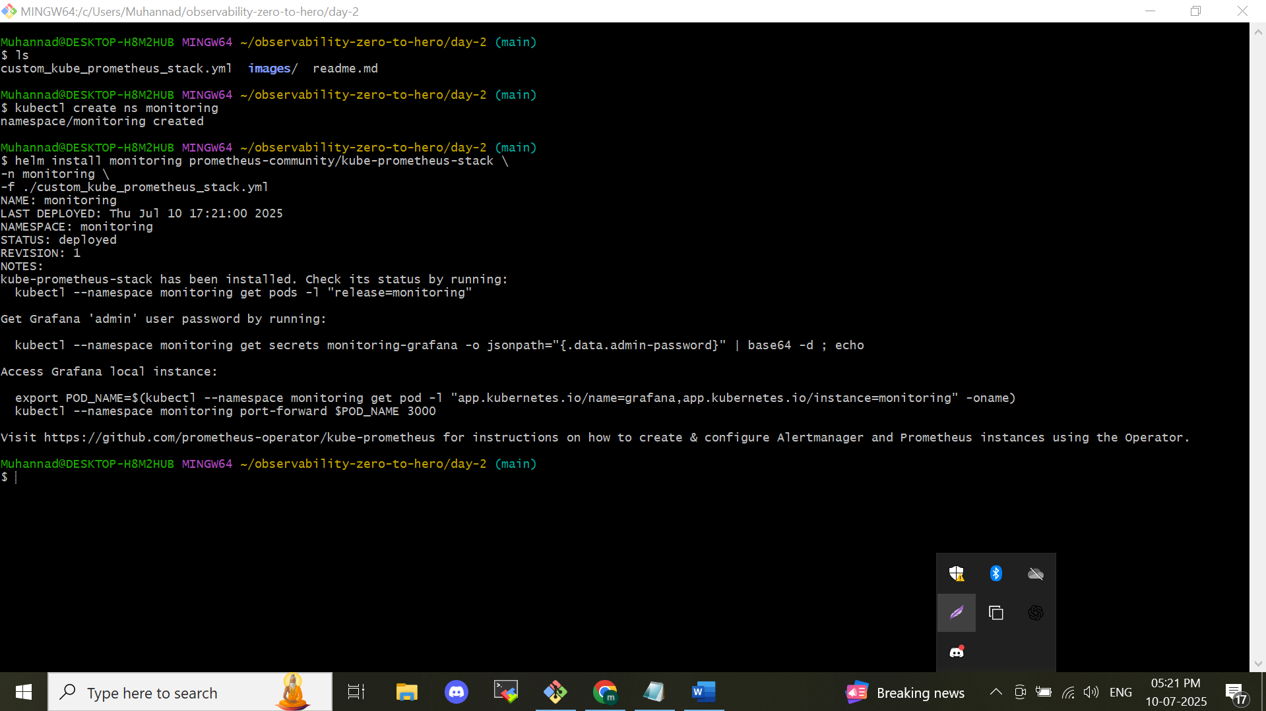

**Step 4: Verify the Installation**

kubectl get all -n monitoring

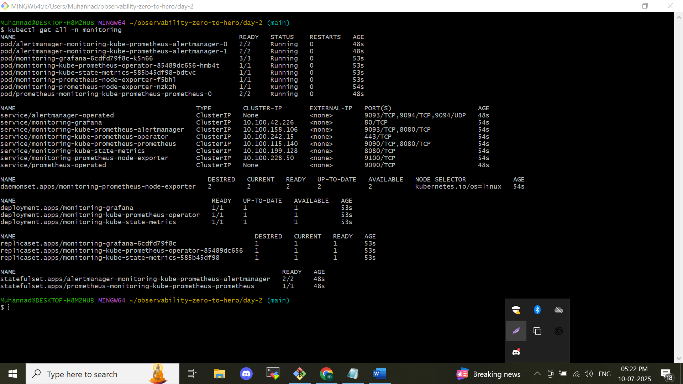

**Step -5 Writing Custom Metrics**

To understand how custom metrics are implemented, refer to the file:  
**https://github.com/muhannadpv786/observability-zero-to-hero.git/day-4/application/service-a/index.js**.

Below is a brief overview of its key components:

**Express Setup**

* Initializes an Express application.
* Sets up HTTP request logging using **Morgan**.

**Structured Logging with Pino**

* Implements a custom logging mechanism using **Pino**, providing structured and efficient log output.

**Prometheus Integration with prom-client**

The application uses the prom-client library to expose Prometheus-compatible metrics:

* **http_requests_total** – A **Counter** metric tracking the total number of HTTP requests.
* **http_request_duration_seconds** – A **Histogram** metric measuring request duration in seconds.
* **http_request_duration_summary_seconds** – A **Summary** metric to track request duration percentiles (e.g., 0.5, 0.9, 0.99).
* **node_gauge_example** – A **Gauge** metric for monitoring asynchronous task durations.

**Defined Routes**

* / – Returns a basic "Running" status message.
* /healthy – Provides a health check response.
* /serverError – Simulates a 500 Internal Server Error.
* /notFound – Simulates a 404 Not Found error.
* /logs – Generates log entries using the custom Pino logger.
* /crash – Simulates a server crash by forcefully exiting the process.
* /example – Demonstrates the use of a Gauge metric to track asynchronous task duration.
* /metrics – Exposes the Prometheus metrics endpoint.
* /call-service-b – Makes an API call to **Service B** and returns its response.

**Step -6 Dockerize & push it to the registry**

**Containerizing Applications and Pushing to Docker Registry**

To containerize the microservices and push them to your Docker registry, follow the steps below:

1. **Navigate to the project directory:**

*bash*

*CopyEdit*

*cd day-4*

1. **Build Docker Image for Service A:**

*bash*

*CopyEdit*

*docker build -t <your-docker-username>/<repo-name>:<tag> application/service-a/*

*Example: docker build -t muhannadpv/demoservice-a:v application/service-a/*

1. **Build Docker Image for Service B:**

*bash*

*CopyEdit*

*docker build -t <your-docker-username>/<repo-name>:<tag> application/service-b/*

*Example: docker build -t muhannadpv/demoservice-b:v application/service-b/*

1. **Or Use Pre-Built Images**

If you prefer not to build the images yourself, you can use the pre-built ones:

* *muhannadpv/demoservice-a:v*
* *muhannadpv/demoservice-b:v*

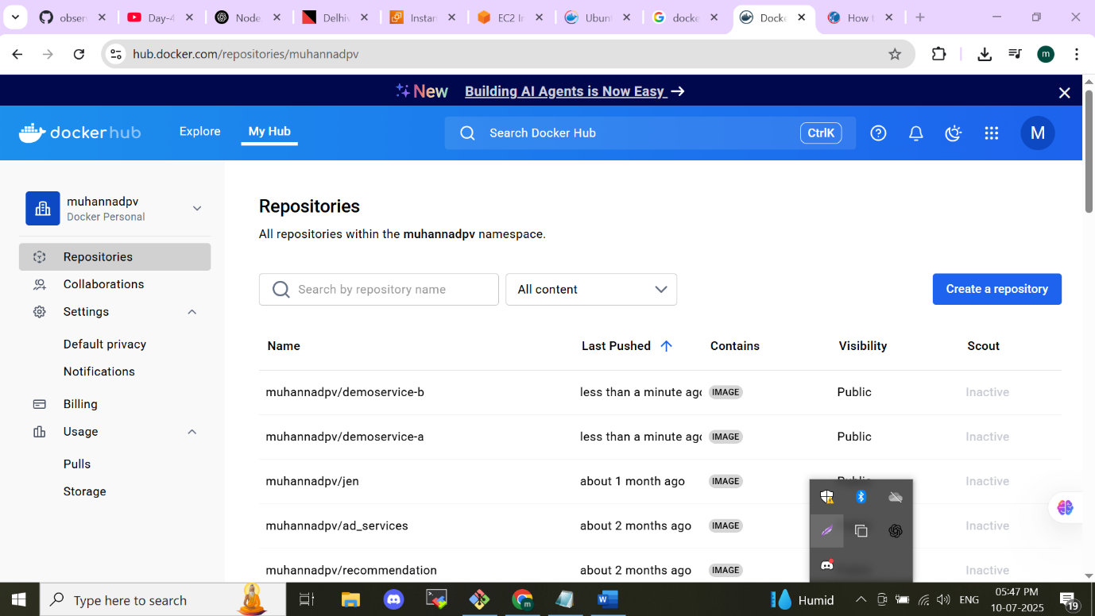

**3) Kubernetes manifest**

**Deploying to Kubernetes**

1. **Review the Kubernetes Manifests**  
   Navigate to the day-4/kubernetes-manifest/ directory and review the manifest files to understand the configurations.
2. **Apply the Manifests to Your Cluster**  
   Create a namespace and deploy the resources using the following commands:

*bash*

*CopyEdit*

*kubectl create ns dev*

*kubectl apply -k kubernetes-manifest/*

**Test the Application Endpoints**

Once the deployment is successful, obtain the **LoadBalancer DNS name** and test the following routes in your browser or via curl:

*/healthy*

*/serverError*

*/notFound*

*/logs*

*/example*

*/metrics*

*/call-service-b*

**Automated Testing (Optional)**

To automatically test the endpoints and generate metrics, you can run the provided script:

./test.sh <LOAD_BALANCER_DNS_NAME>

This script will send randomized requests to various endpoints, helping populate metrics for monitoring purposes.

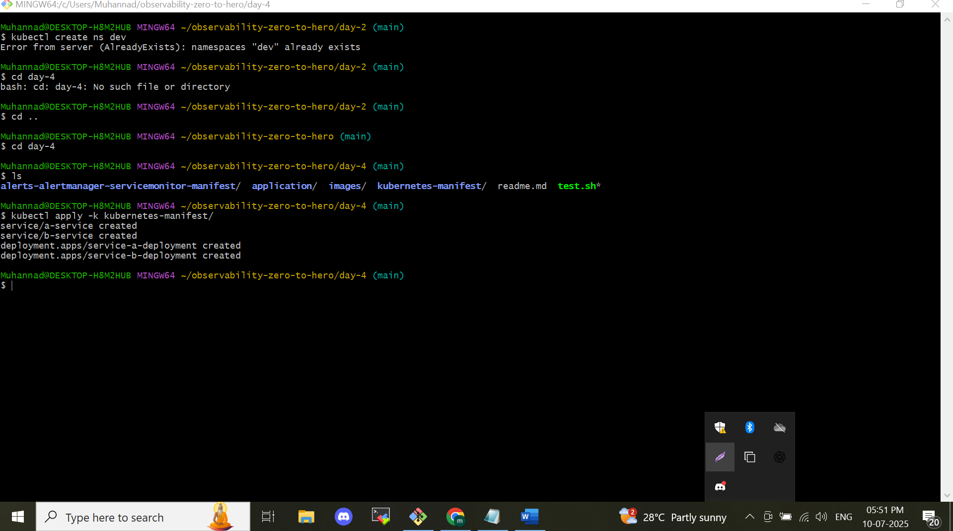

Load balancer test on

*healthy*

*/serverError*

*/notFound*

*/logs*

*/example*

*/metrics*

*/call-service-b*

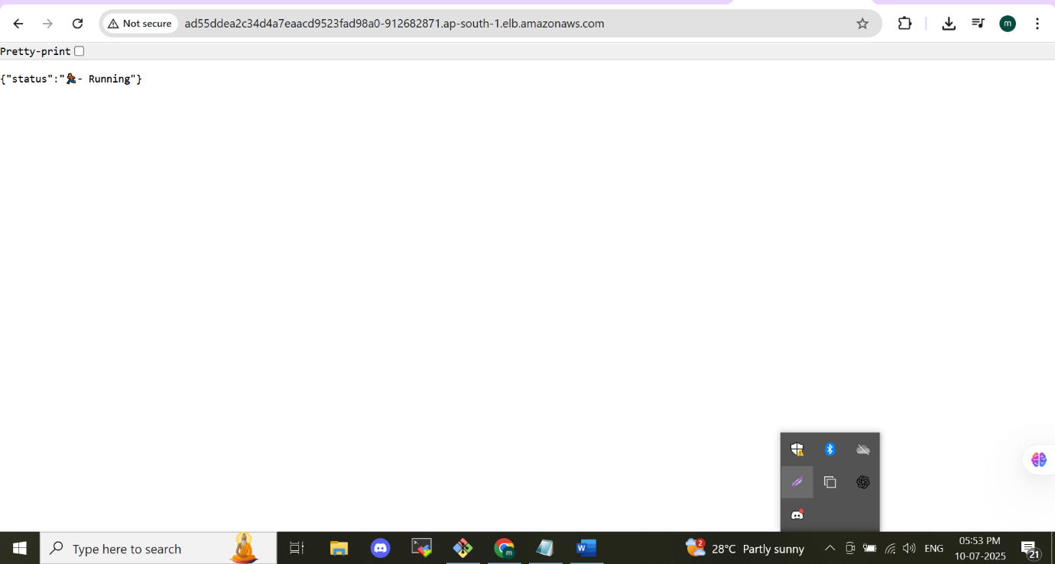

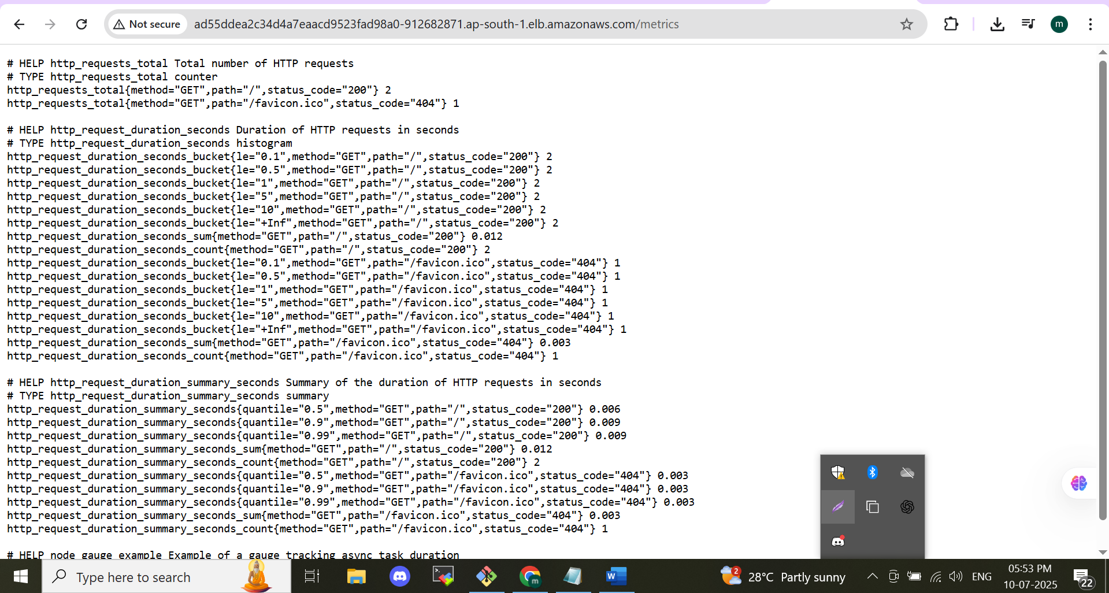

**Expose the Prometheus by port forward**

By expose the port forward we can see the instrumental metrics . by default we cannot see the instrumental metrics. inside the eks cluster the Prometheus can identify the pod by **service discovery** method only the Prometheus can identify the metrics we created by custom.To port forward the Prometheus by kubectl port-forward service/prometheus-operated -n monitoring 9090:9090

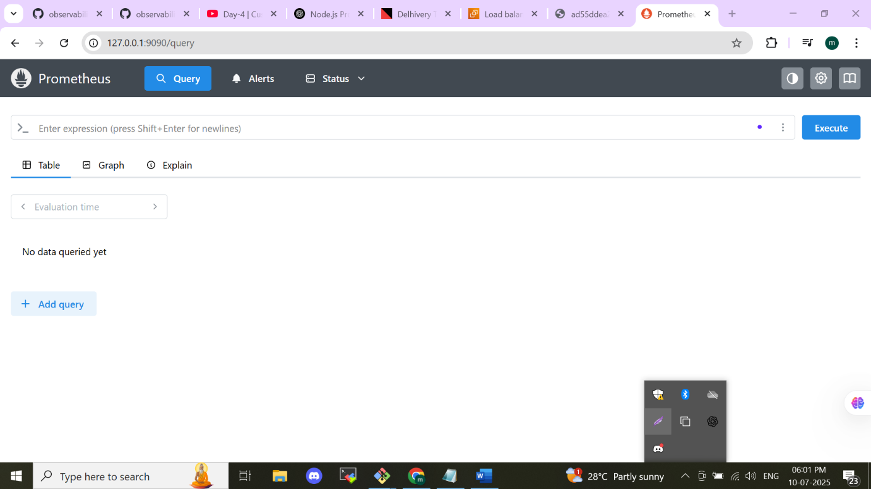

Just check before implement service discovery instrument metrics named as “http_requests_total” can be check on Prometheus

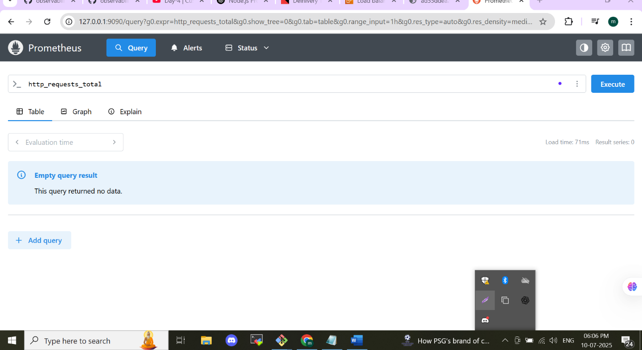

Apply the command for enable service discovery

*kubectl apply -k alerts-alertmanager-servicemonitor-manifest/*

then check the instrumented metrics as given below we can get the output

* http_requests_total: counter
* http_request_duration_seconds: histogram
* http_request_duration_summary_seconds: summary
* node_gauge_example: gauge for tracking async task duration

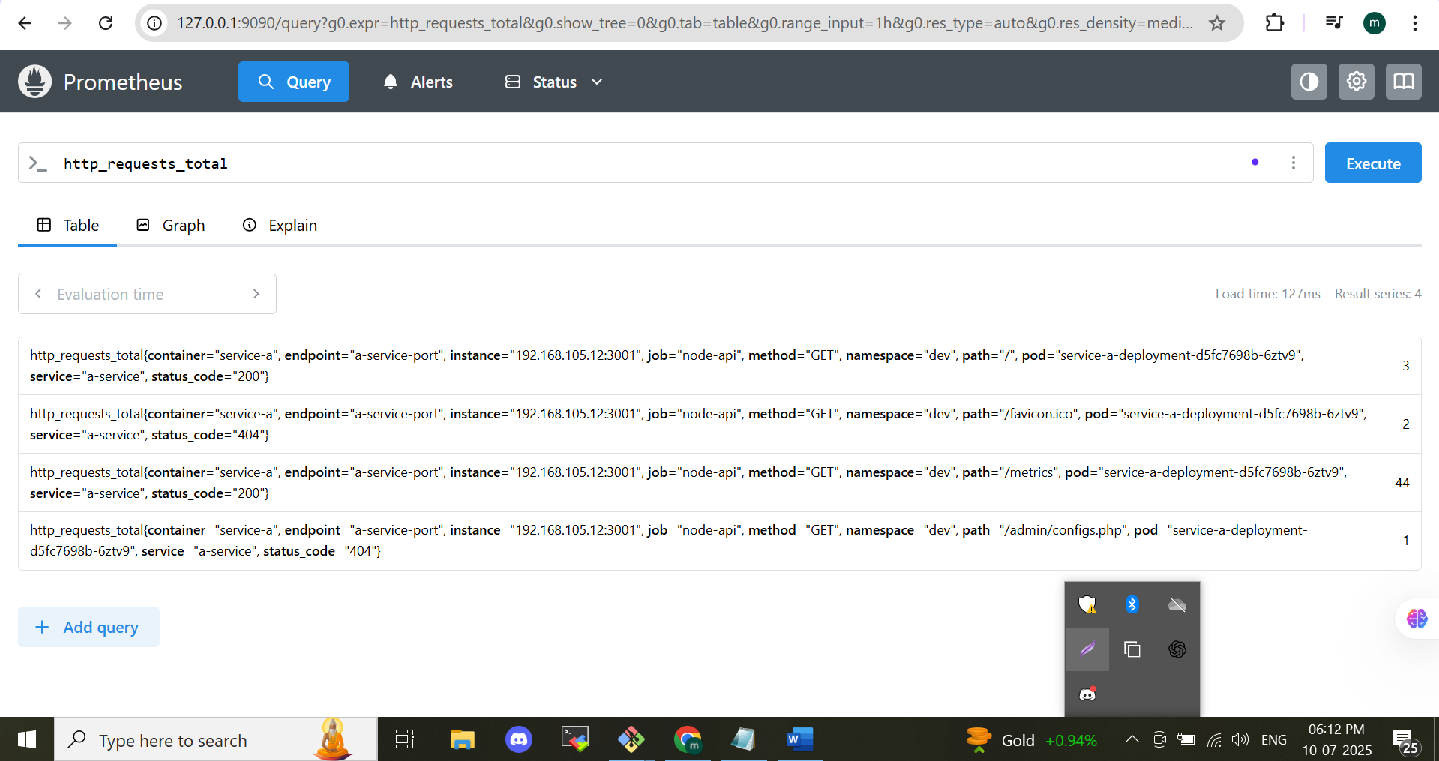

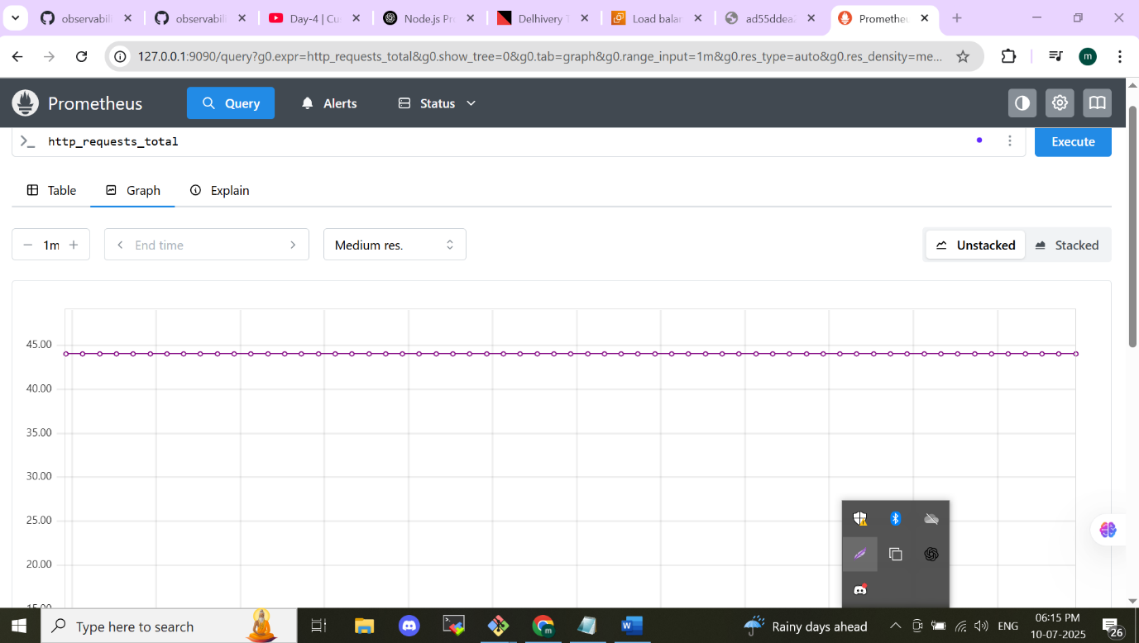

The alert manager am installing for my gmail account let see the alert manger will gave the notification to my email.

Am creating a password in my gmailaccount an pass to my script I can get the alert in my email account

**6) Testing Alerts**

* To test the alerting system, manually crash the container more than 2 times to trigger an alert (email notification).
* To crash the application container, hit the following endpoint

<<LOAD_BALANCER_DNS_NAME>>/crash

* You should receive an email once the application container has restarted at least 3 times.The alert will given in the code for HighCpuUsage, PodRestart

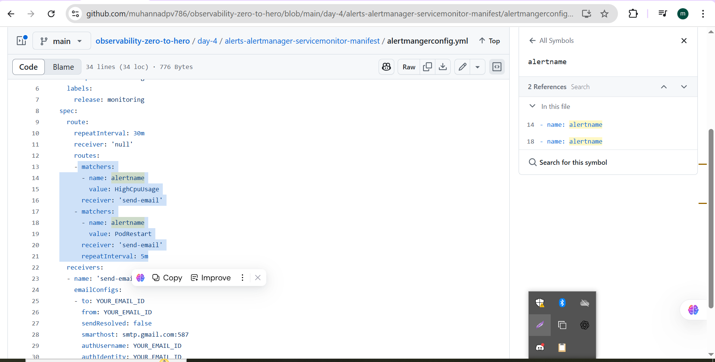

**7) Alert Manager Configuration**

Start by reviewing the Alertmanager configuration files located at:  
**day-4/alerts-alertmanager-servicemonitor-manifest/**  
Here’s a summary of the setup process:

**Email Notification Setup**

Before configuring Alertmanager, you'll need credentials to send alert notifications via email. In this project, we use **Gmail** as the SMTP provider, though alternatives like **AWS SES** or **SendGrid** are also compatible.

* Go to your Google Account settings, search for **"App passwords"**, and generate a new password.
* Update the generated password inside the file:  
  **day-4/alerts-alertmanager-servicemonitor-manifest/email-secret.yml**

Additionally, be sure to **replace the placeholder email address** in the file: **alertmanagerconfig.yml**  
with your own email ID to receive notifications.

**Alert Rules Overview**

* **HighCpuUsage**:  
  Sends a **warning** alert if the average CPU usage exceeds 50% for more than 5 minutes.
* **PodRestart**:  
  Triggers a **critical** alert if any pod restarts more than 2 times.

**Deploy Alert Manager Resources**

Apply the Alert Manager and related manifests using:

*kubectl apply -k alerts-alertmanager-servicemonitor-manifest/*

Wait 4–5 minutes, then open the **Prometheus UI** to verify that the custom metrics from the Node.js app are visible:

* http_requests_total – Counter
* http_request_duration_seconds – Histogram
* http_request_duration_summary_seconds – Summary
* node_gauge_example – Gauge for tracking asynchronous task duration

**8)Testing the Alerts**

To verify that alerts are working:

1. Manually **crash the application container** multiple times to trigger a pod restart.
2. Use the following endpoint to force a crash:

http://<LOAD_BALANCER_DNS_NAME>/crash

1. Once the container restarts more than **2 times**, Alertmanager should send an **email notification** to the address configured earlier.

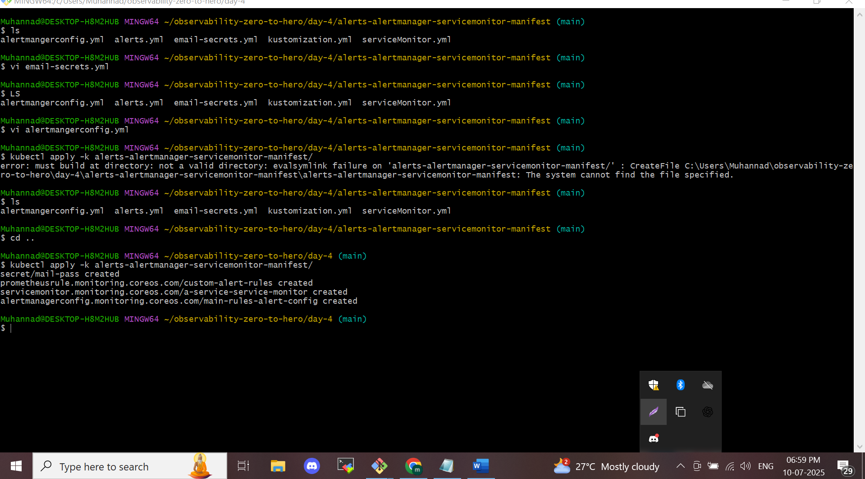

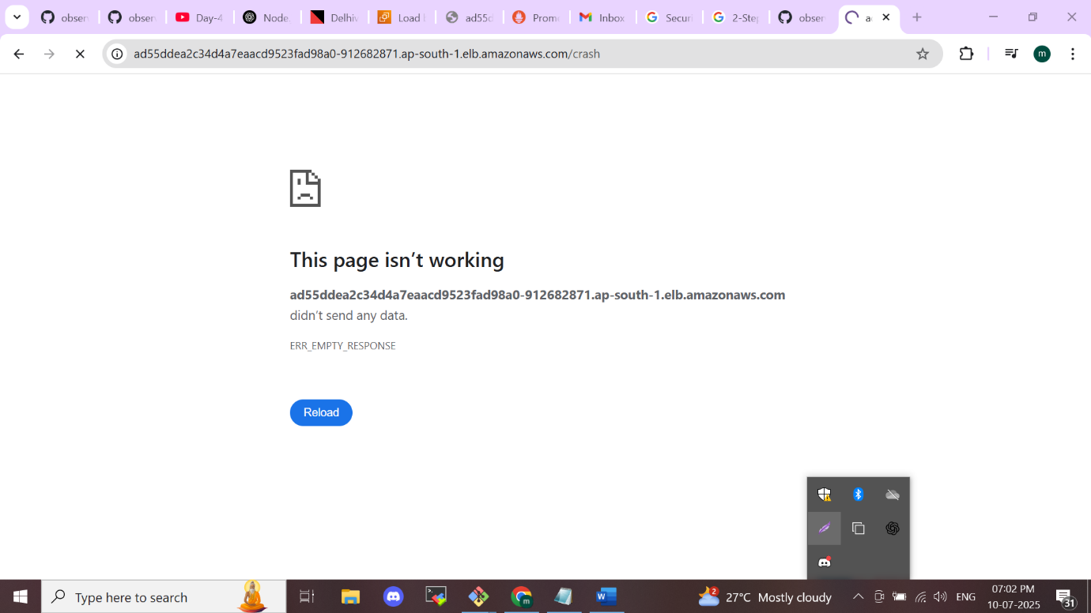

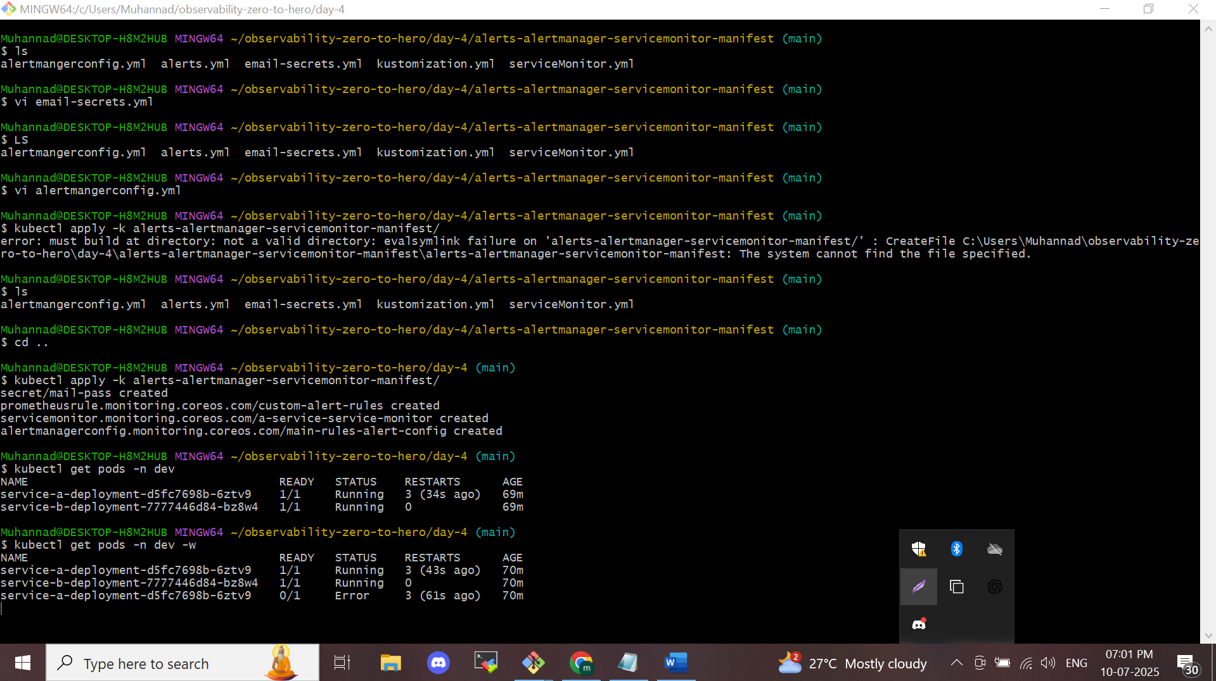

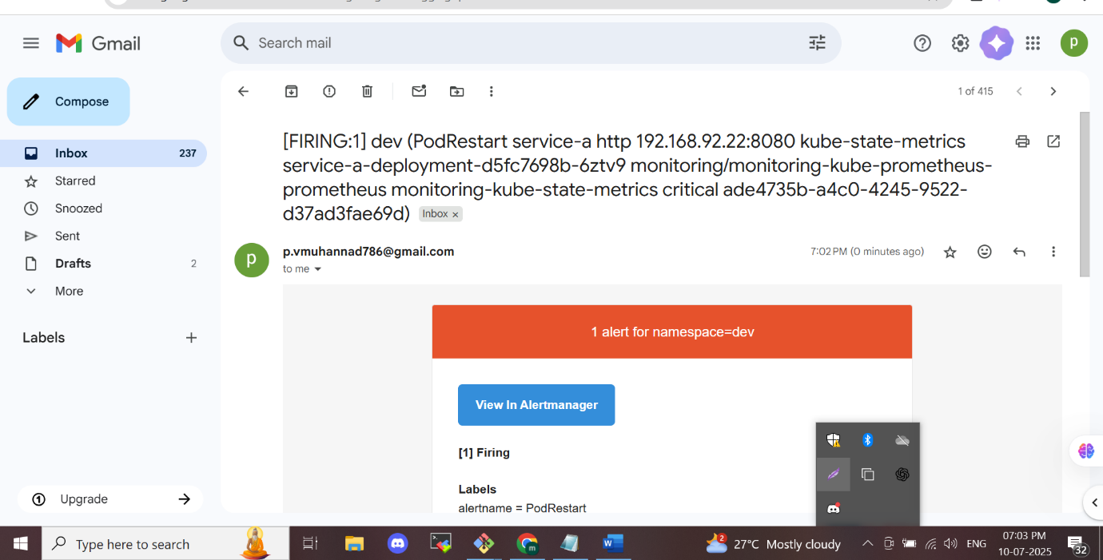

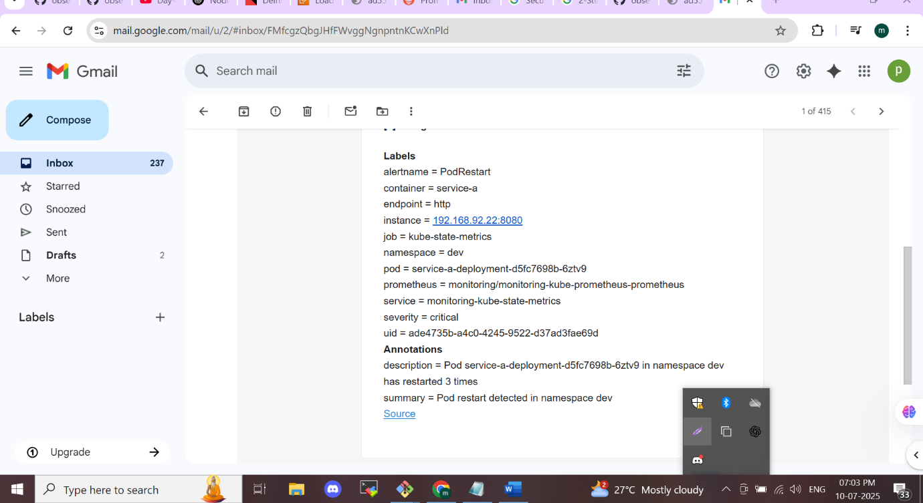

**MODULE-5**

**Logging with EFK Stack**

* **Concepts Covered:**
  + Introduction to logging in distributed systems and Kubernetes.
  + Setting up the EFK stack (Elasticsearch, Fluentbit, Kibana) on Kubernetes.
  + Detailed setup and configuration for collecting and visualizing logs.
  + Cleaning up the Kubernetes cluster and resources.
* **Key Learning:**
  + Understand the importance of logging and how to set up

**Topics You’ll Explore:**

* Fundamentals of **logging** in **distributed systems** and Kubernetes environments.
* Deploying the **EFK stack**—**Elasticsearch**, **Fluent Bit**, and **Kibana**—within a Kubernetes cluster.
* Step-by-step configuration for **log collection**, storage, and **visualization**.
* Cleaning up the cluster and removing associated **logging components** after deployment.

**Key Takeaways:**

* Gain a solid understanding of why **logging** is essential in modern cloud-native applications.

Learn how to **deploy and configure** a complete logging pipeline using the **EFK stack** in **Kubernetes.**

**Logging Overview**

Logging plays a vital role in distributed systems like Kubernetes. It enables you to track application behavior, identify issues early, and maintain the health of microservices running in the cluster.

**Why Logging Matters**

* **Troubleshooting**: Logs reveal valuable insights during application failures or unexpected behaviour.
* **Audit Tracking**: They maintain a history of actions and events, helping identify who did what and when.
* **Performance Analysis**: Logs can uncover performance issues and slowdowns in services.
* **Security Monitoring**: Unusual or unauthorized activities can be detected through log analysis.

**Common Kubernetes Logging Solutions**

* EFK Stack (Elasticsearch, Fluent Bit, Kibana)
* EFK Stack (Elasticsearch, FluentD, Kibana)
* ELK Stack (Elasticsearch, Logstash, Kibana)
* Loki Stack (Promtail + Loki + Grafana)

**EFK Stack Breakdown**

EFK is a widely adopted solution for Kubernetes log aggregation and visualization:

* **Elasticsearch**: Acts as a search engine that stores and indexes logs, allowing fast query access.
* **Fluent Bit**: A lightweight, efficient log collector that gathers logs from multiple sources and forwards them to Elasticsearch.
* **Kibana**: Provides a user-friendly dashboard for viewing and analyzing logs stored in Elasticsearch.

**Architecture**

**EFK Architecture Overview**

In the **EFK stack**, the log collector component—**Fluent Bit**—is deployed as a **DaemonSet**, much like **Node Exporter** in the Prometheus ecosystem. This means one Fluent Bit pod runs on each node in the Kubernetes cluster to collect logs locally.

Fluent Bit reads logs from all pods on its node and forwards them to **Elasticsearch**, which acts as the central log database. Since Elasticsearch stores persistent log data, it is considered a **stateful** application. Typically, an **EBS (Elastic Block Store)** volume is attached to Elasticsearch to persist the logs on disk.

Once logs are stored in Elasticsearch, they can be **visualized using Kibana**, which functions similarly to **Grafana**, but specifically for logs.

**EFK Workflow Summary:**

1. **Fluent Bit** (DaemonSet) reads log messages from all Kubernetes nodes.
2. It forwards these logs to **Elasticsearch**, which stores and indexes the data.
3. **Elasticsearch** uses persistent storage (EBS) to retain logs.
4. **Kibana** serves as the **UI/dashboard**, where users can run queries and visualize logs.
5. When a user searches logs through Kibana, the query is executed against Elasticsearch, which returns the matching results.

**EFK vs ELK Stack**

| **Feature** | **EFK Stack** | **ELK Stack** |
| --- | --- | --- |
| Components | Elasticsearch, Fluent Bit, Kibana | Elasticsearch, Logstash, Kibana |
| Log Collector | Fluent Bit | Logstash |
| Performance | Lightweight & optimized for Kubernetes | Resource-intensive but more powerful |
| Use Case | Ideal for Kubernetes environments | Better for complex log pipelines |

The key difference between EFK and ELK lies in the **log collection component**:

* **EFK uses Fluent Bit**, a lightweight log forwarder.
* **ELK uses Logstash**, a feature-rich log aggregator.

**Fluent Bit vs Logstash**

| **Feature** | **Fluent Bit** | **Logstash** |
| --- | --- | --- |
| Purpose | Log forwarder | Log aggregator |
| Performance | High efficiency, low resource usage | Higher CPU/RAM usage |
| Capabilities | Basic filtering, parsing | Advanced filtering, parsing, aggregation |
| Best Use Case | Kubernetes-native logging | Complex log transformations and enrichment |

* **Logstash** offers rich features such as log aggregation, advanced filtering, and tagging before logs reach Elasticsearch.
* **Fluent Bit**, while faster and lighter, offers limited filtering and processing capabilities compared to Logstash.



**Step to install efk stack and deploy a application and get the logs in efk stack**

**Prerequisites**

Create an eks cluster and deploy the promethues stack by helm as similar as the previous project

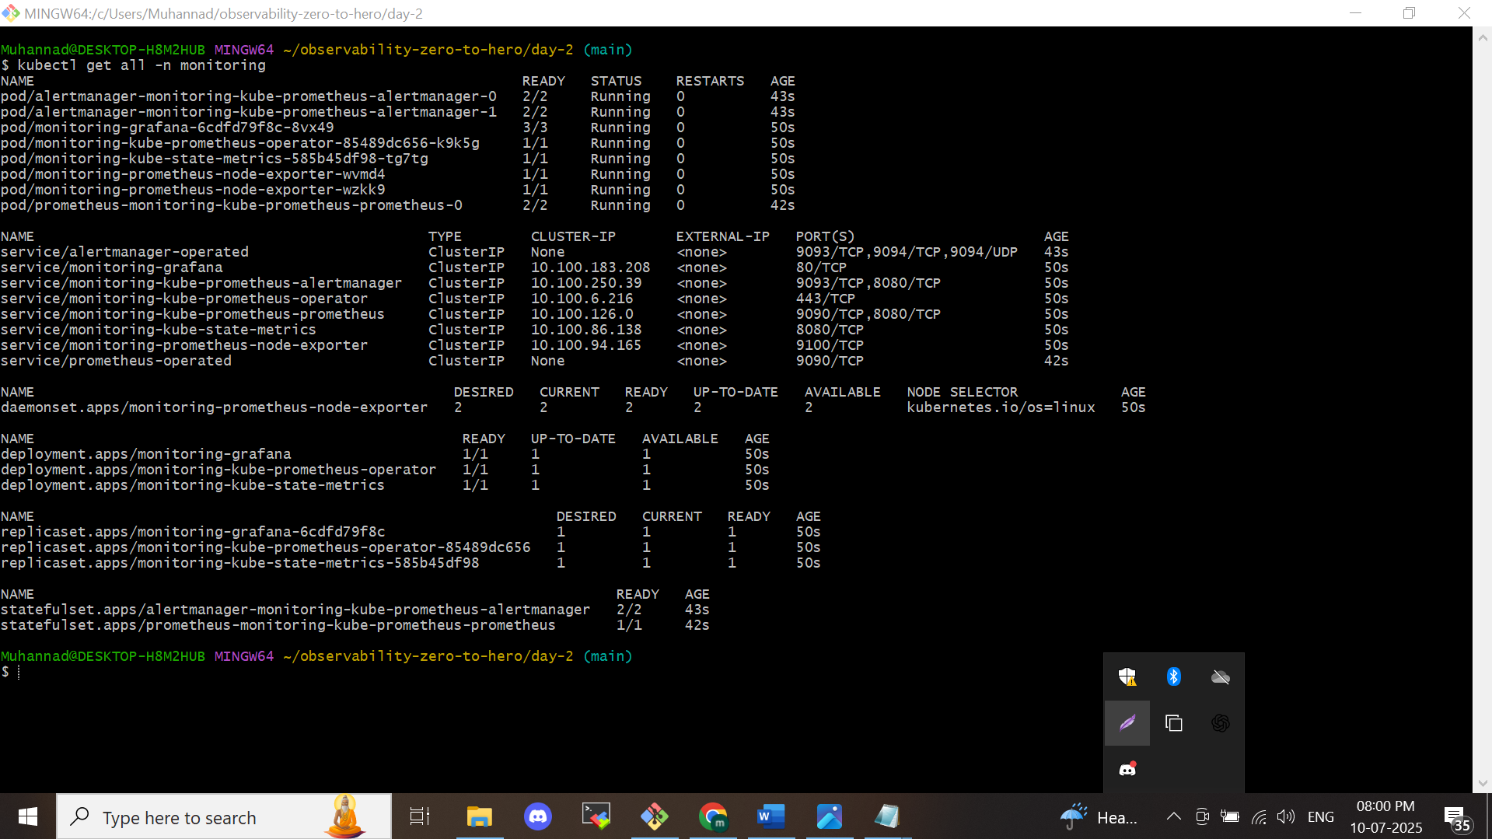

**Step 1: Create an IAM Role for the EBS CSI Controller**

*eksctl create iamserviceaccount *

*--name ebs-csi-controller-sa *

*--namespace kube-system *

*--cluster observability *

*--role-name AmazonEKS_EBS_CSI_DriverRole *

*--role-only *

*--attach-policy-arn arn:aws:iam::aws:policy/service-role/AmazonEBSCSIDriverPolicy *

*--approve*

This command sets up an IAM role that the EBS CSI controller will use to interact with AWS services. It grants the necessary permissions to manage EBS volumes from within the Kubernetes cluster. Later, we’ll associate this role with a Kubernetes service account.

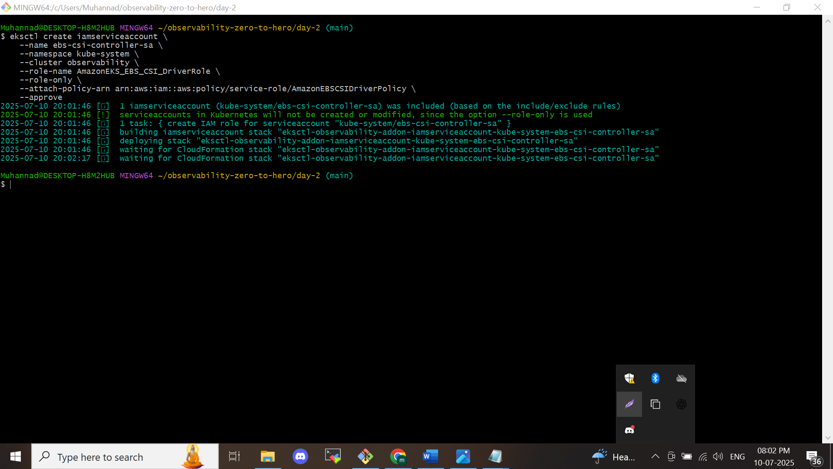

**Step 2: Get the IAM Role ARN**

*ARN=$(aws iam get-role --role-name AmazonEKS_EBS_CSI_DriverRole --query 'Role.Arn' --output text)*

This retrieves the Amazon Resource Name (ARN) of the IAM role that was created. You'll need this ARN to link the role to the EBS CSI driver.

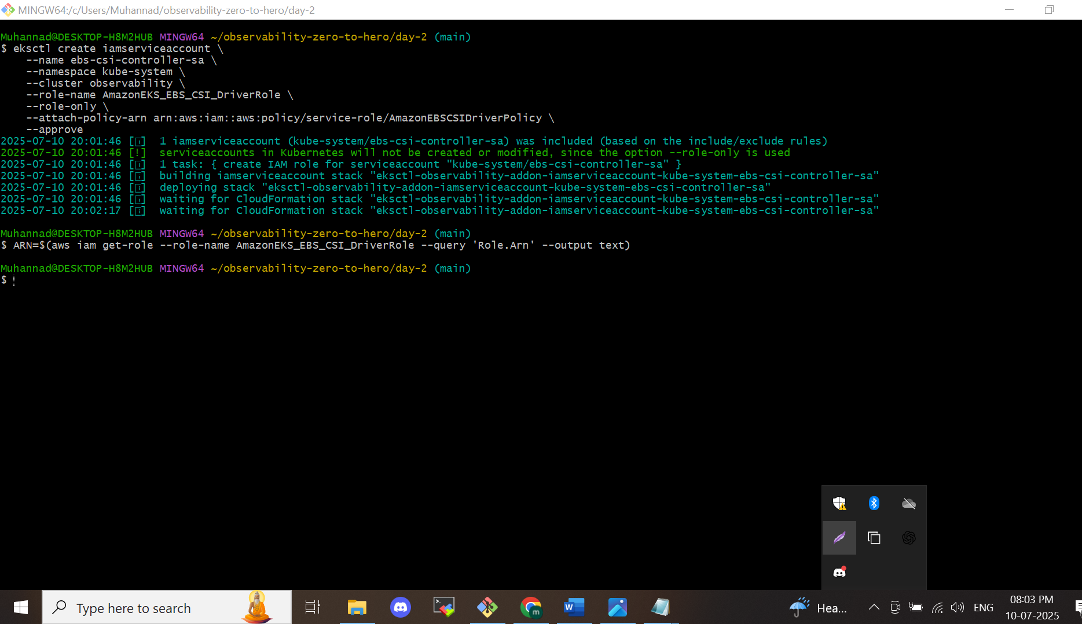

**Step 3: Install the EBS CSI Driver Add-on**

*eksctl create addon *

*--cluster observability *

*--name aws-ebs-csi-driver *

*--version latest *

*--service-account-role-arn $ARN *

*--force*

This command installs the AWS EBS CSI driver as an add-on to your Kubernetes cluster, using the IAM role specified earlier. The driver is now authorized to create and manage EBS volumes securely.

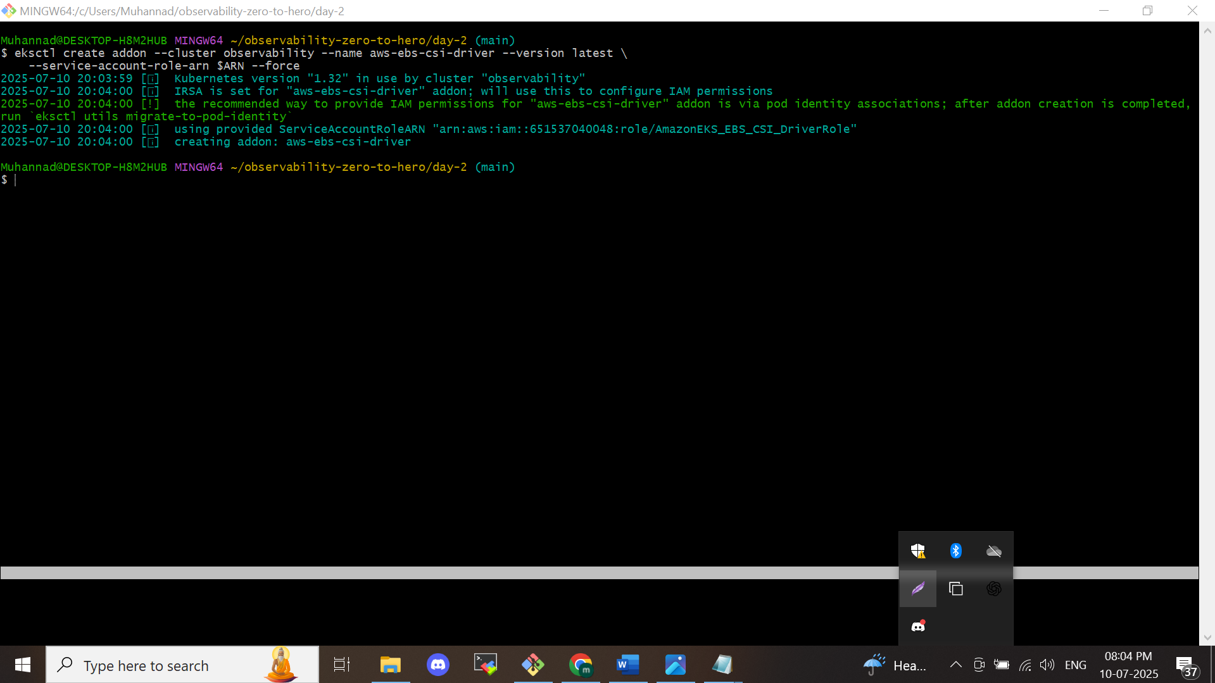

**Step 4: Create a Namespace for Logging**

*kubectl create namespace logging*

We’re creating a dedicated namespace named logging to organize and manage all logging-related components.

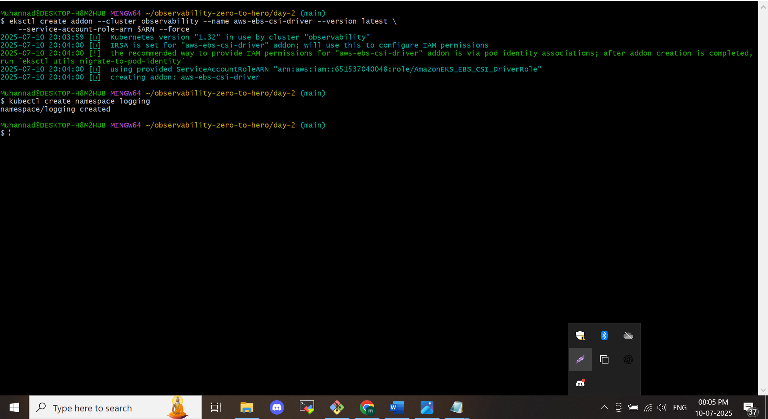

**Step 5: Deploy Elasticsearch with Helm**

*helm repo add elastic https://helm.elastic.co*

*helm install elasticsearch elastic/elasticsearch *

*--set replicas=1 *

*--set volumeClaimTemplate.storageClassName=gp2 *

*--set persistence.labels.enabled=true *

*-n logging*

This installs Elasticsearch into the logging namespace with one replica, persistent volume storage, and labeling enabled for data retention.

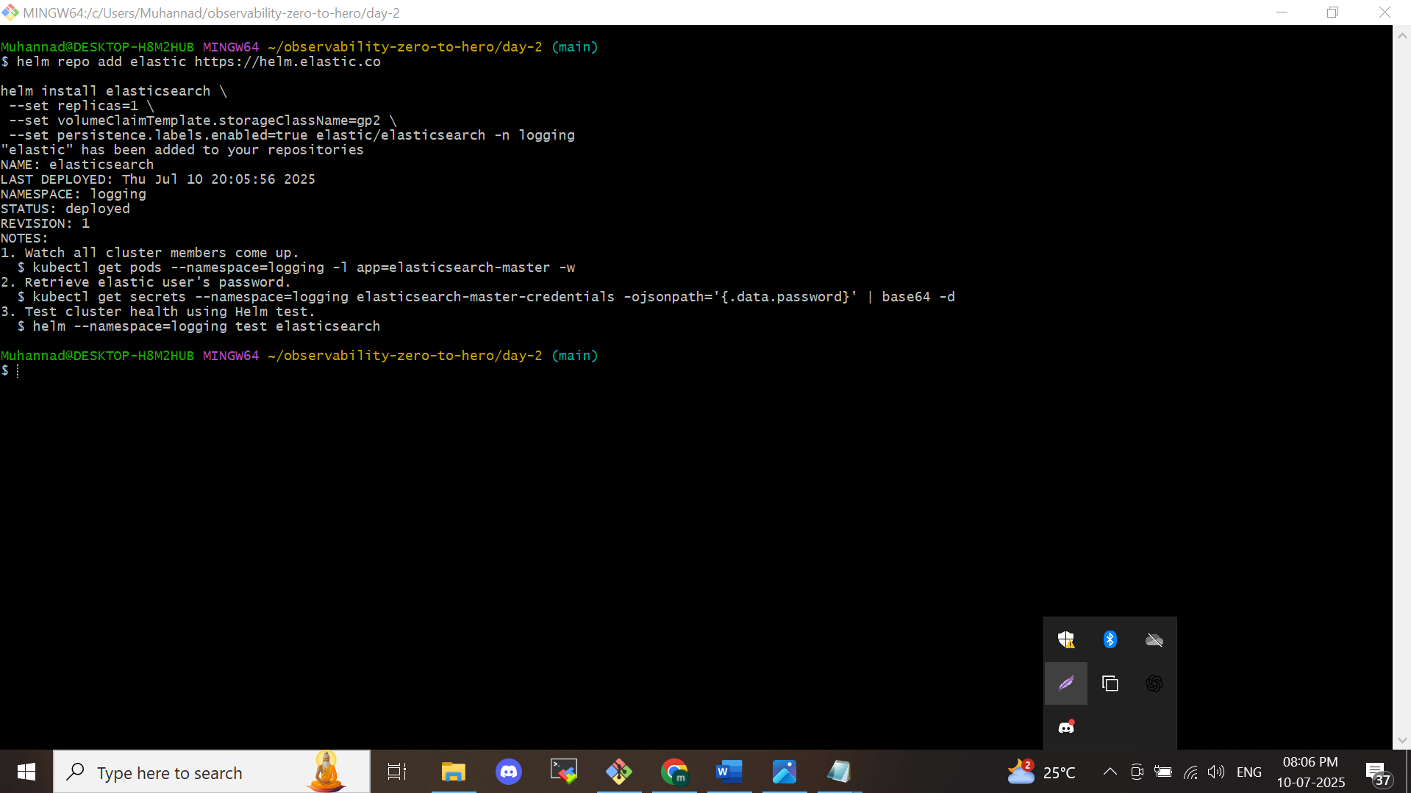

**Step 6: Get Elasticsearch Credentials**

# Retrieve username

*kubectl get secrets --namespace=logging elasticsearch-master-credentials -ojsonpath='{.data.username}' | base64 -d*

# Retrieve password

*kubectl get secrets --namespace=logging elasticsearch-master-credentials -ojsonpath='{.data.password}' | base64 -d*

These commands fetch and decode the base64-encoded credentials needed to log in to the Elasticsearch dashboard.  
**Important:** *Save these credentials securely for later use.*

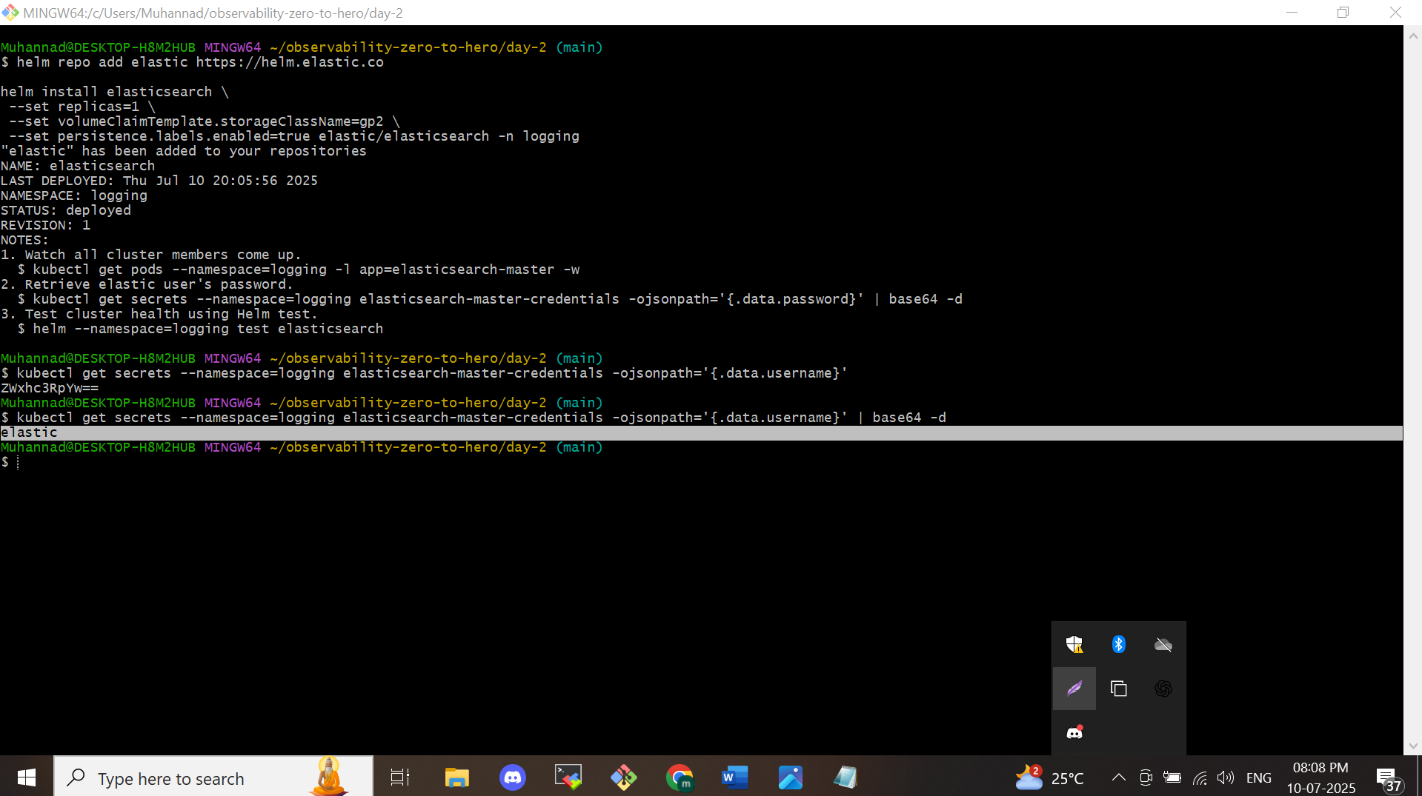

**Step 7: Install Kibana**

*helm install kibana elastic/kibana *

*--set service.type=LoadBalancer *

*-n logging*

Kibana is a dashboard tool for visualizing data stored in Elasticsearch. Here, we’re exposing it via a LoadBalancer to allow access from outside the cluster.

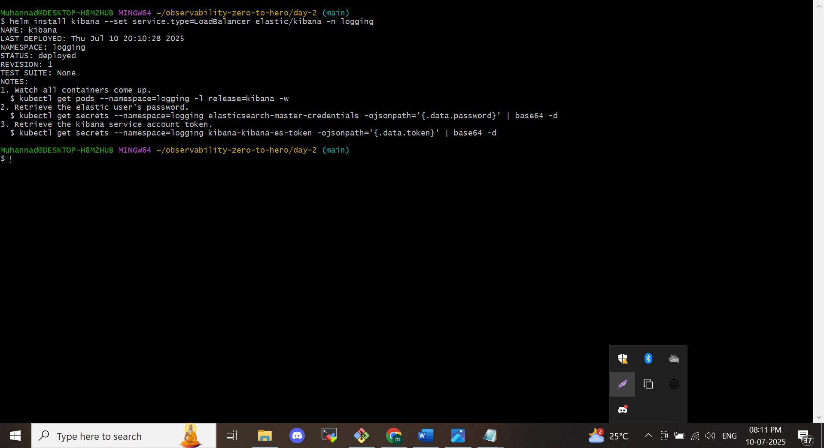

**Step 8: Install Fluent Bit with Custom Settings**

**Reminder:** Edit the fluentbit-values.yaml file and replace the HTTP_Passwd field with the password retrieved in Step 6 (e.g., NJyO47UqeYBsoaEU).

*helm repo add fluent https://fluent.github.io/helm-charts*

*helm install fluent-bit fluent/fluent-bit *

*-f fluentbit-values.yaml *

*-n logging*

This installs Fluent Bit, which collects logs from containers and ships them to Elasticsearch based on the configuration provided.

Edit the password of the file **fluentbit-values.yml**



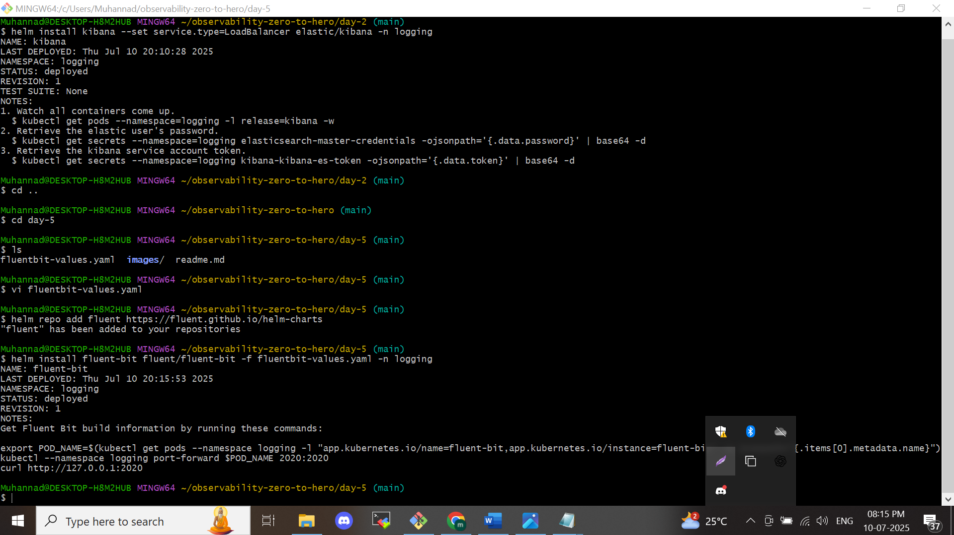

**Final Step: Confirm the EFK Setup**

You've now successfully deployed the **EFK stack** (Elasticsearch, Fluent Bit, Kibana) in your Kubernetes cluster.  
To confirm:

1. Open Kibana in your browser:  
   http://<LOAD_BALANCER_DNS_NAME>:5601
2. Log in with the username and password from Step 6.
3. Create a new **data view** to start exploring the logs collected from your cluster.

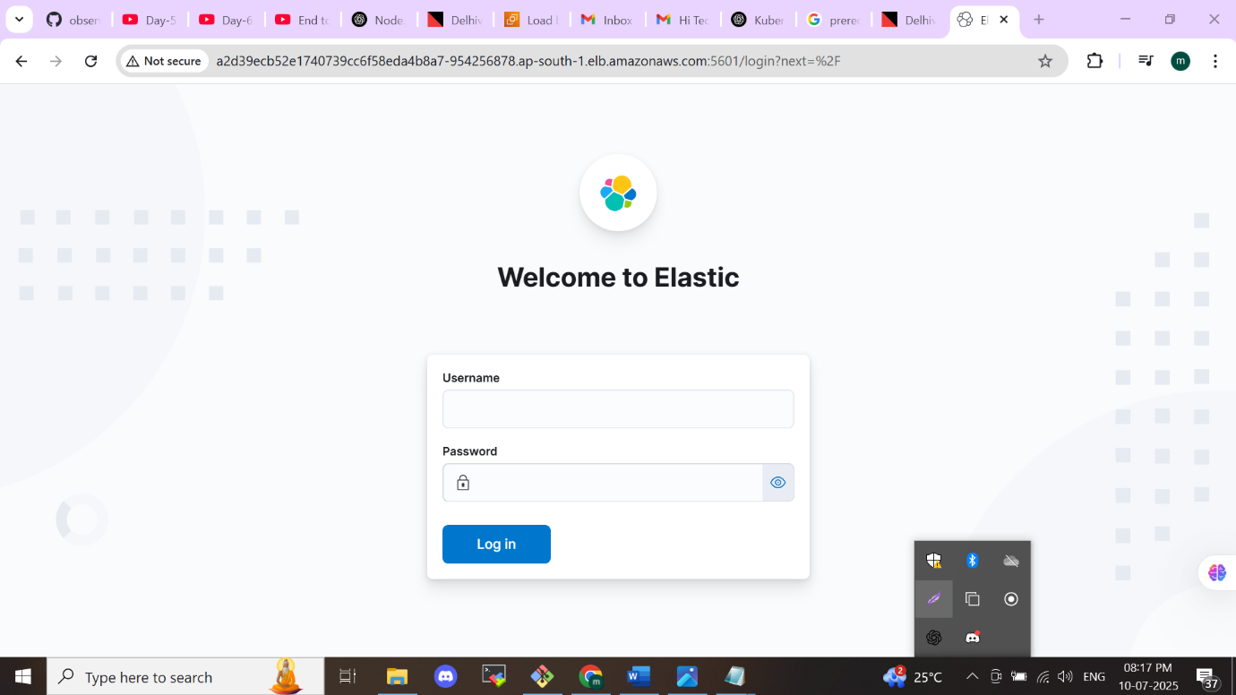

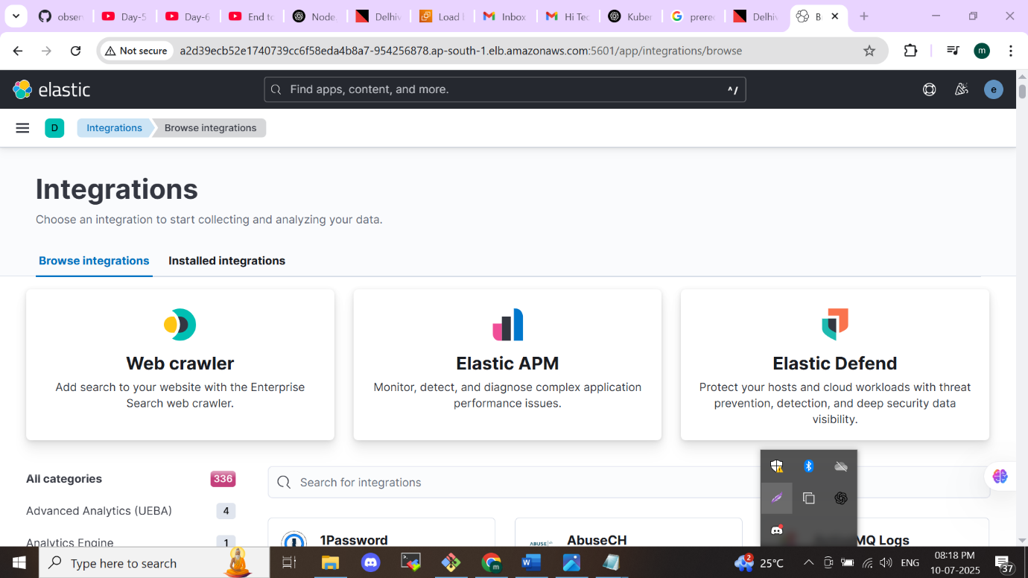

Now we deploy an application and see the logs in elasticsearch

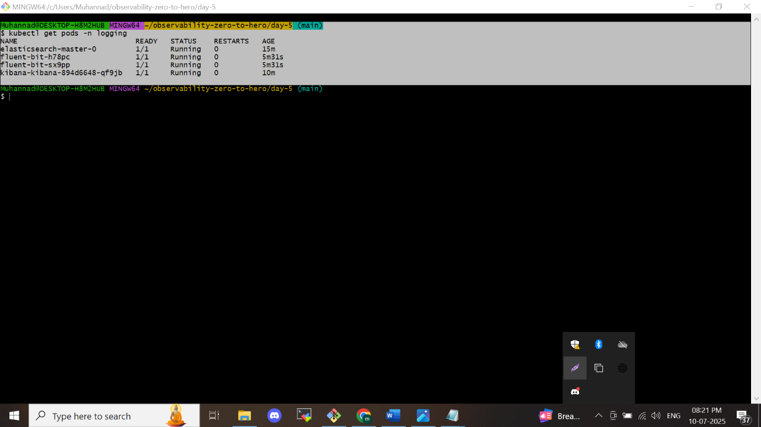

Go to folder of the application we are deploy in to efk stack

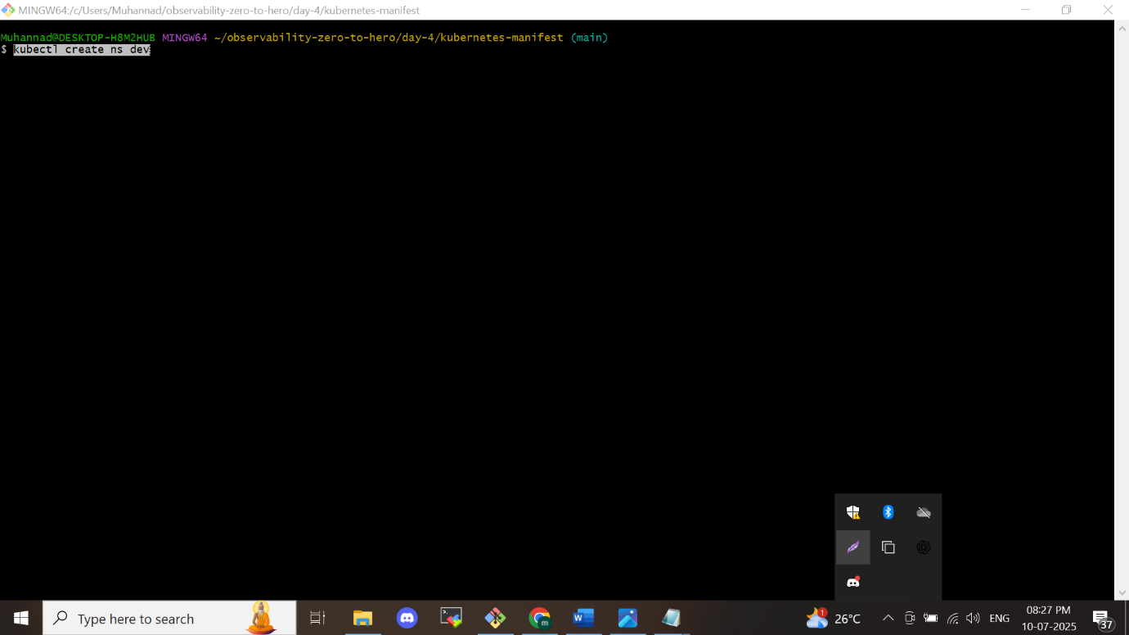

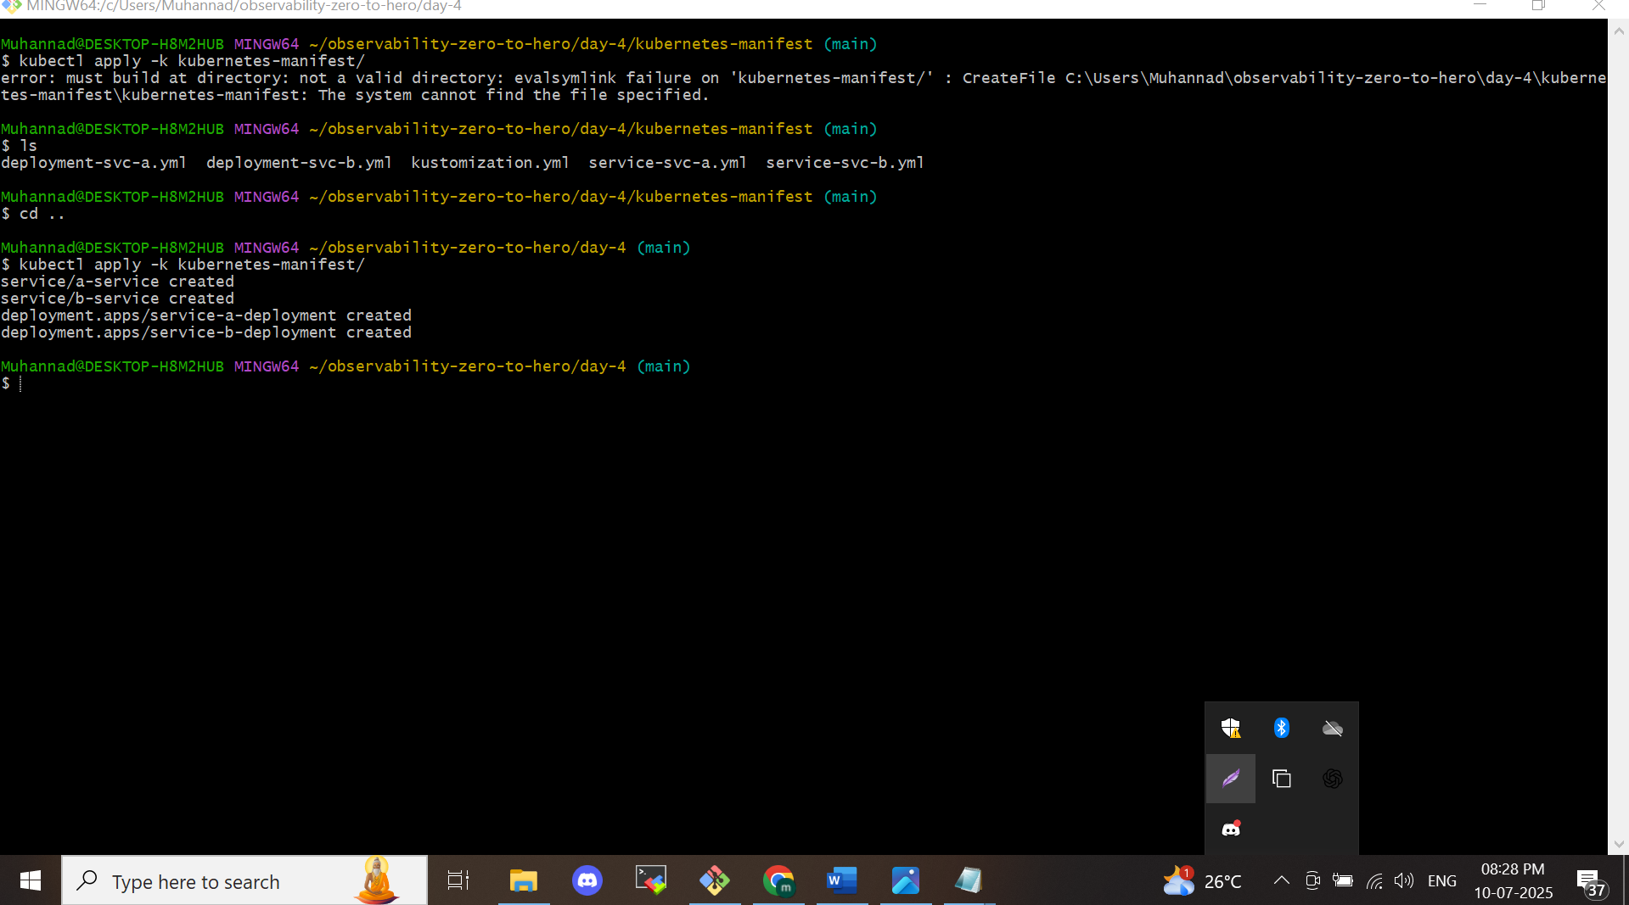

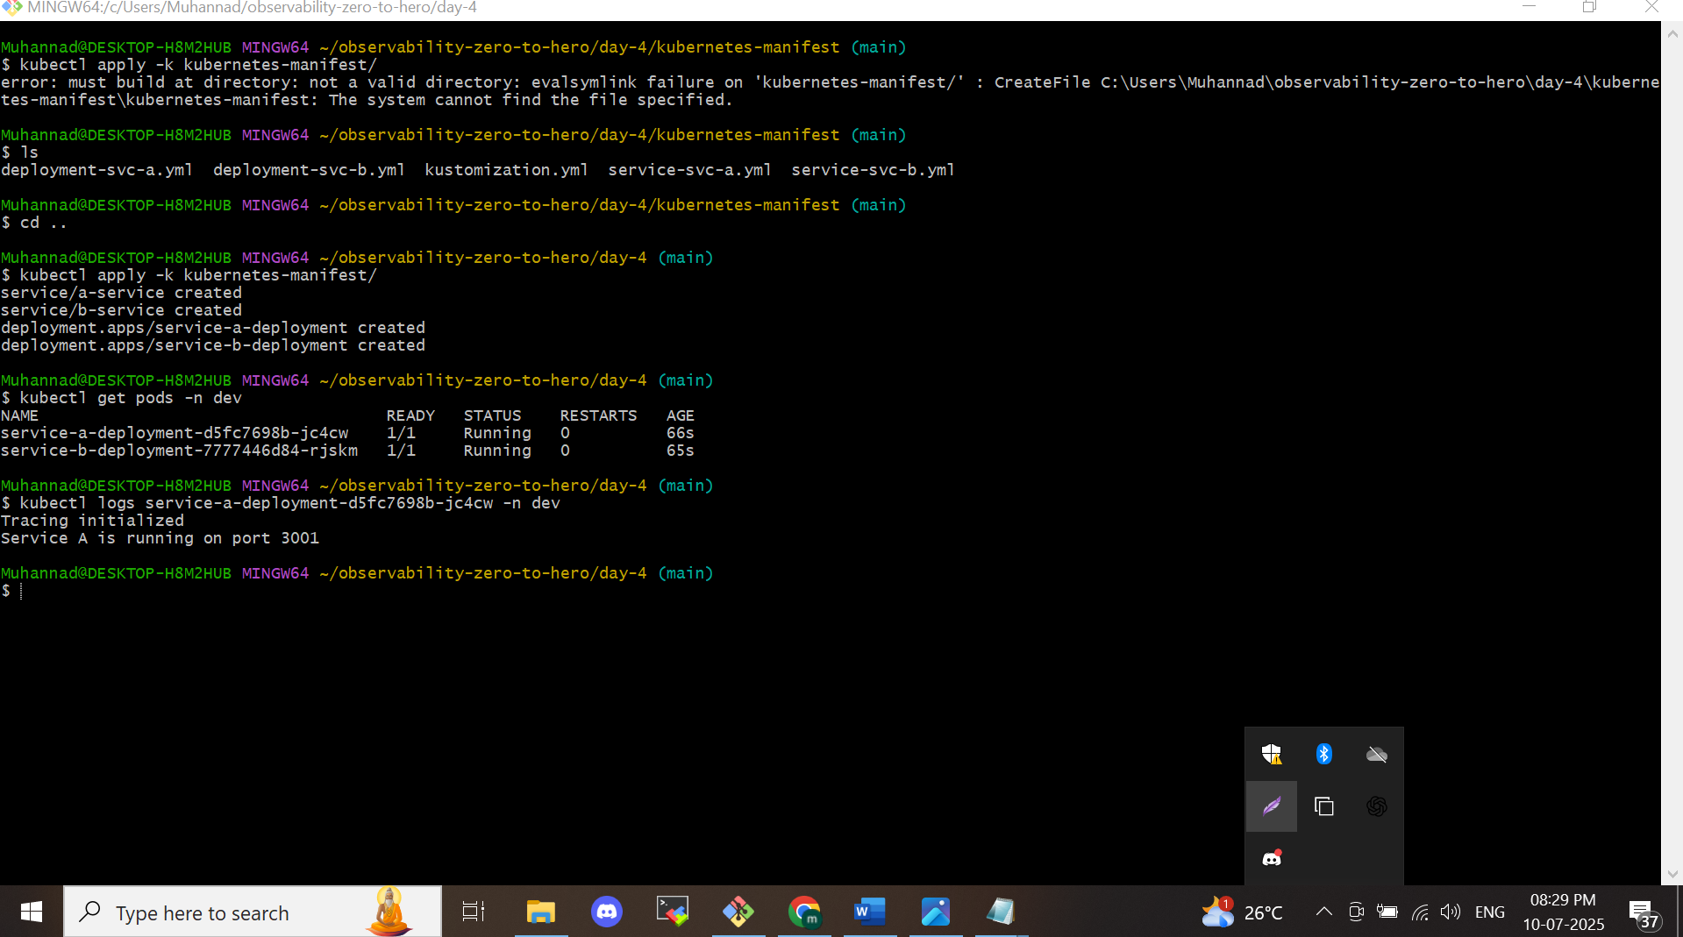

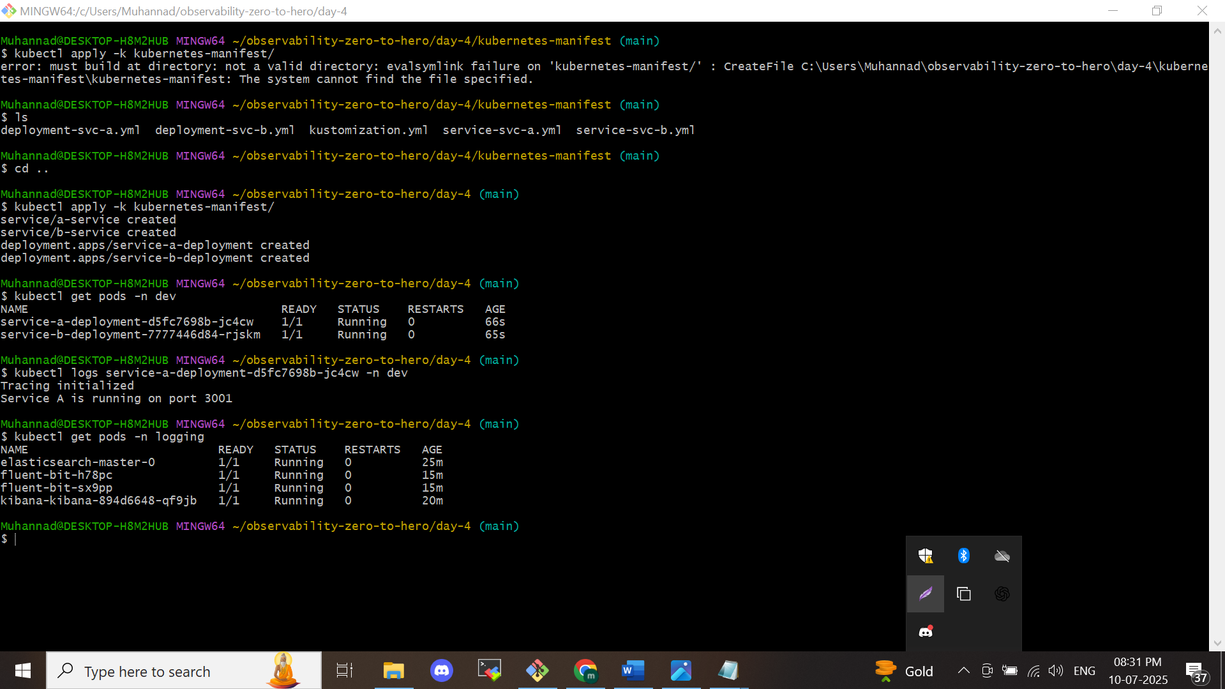

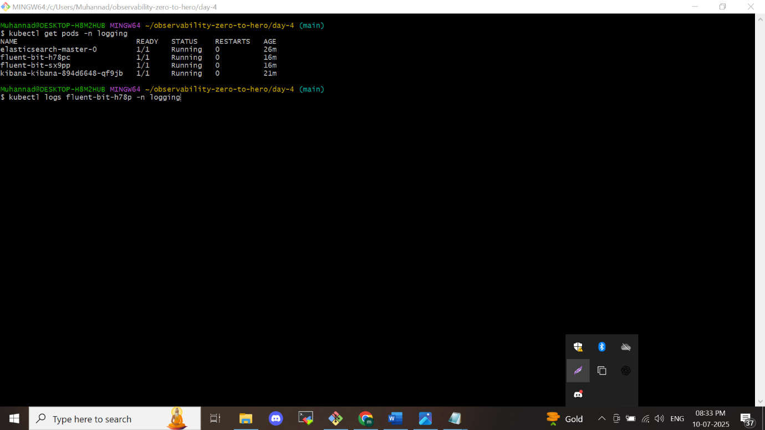

To check the fluent bit will take the logs from app

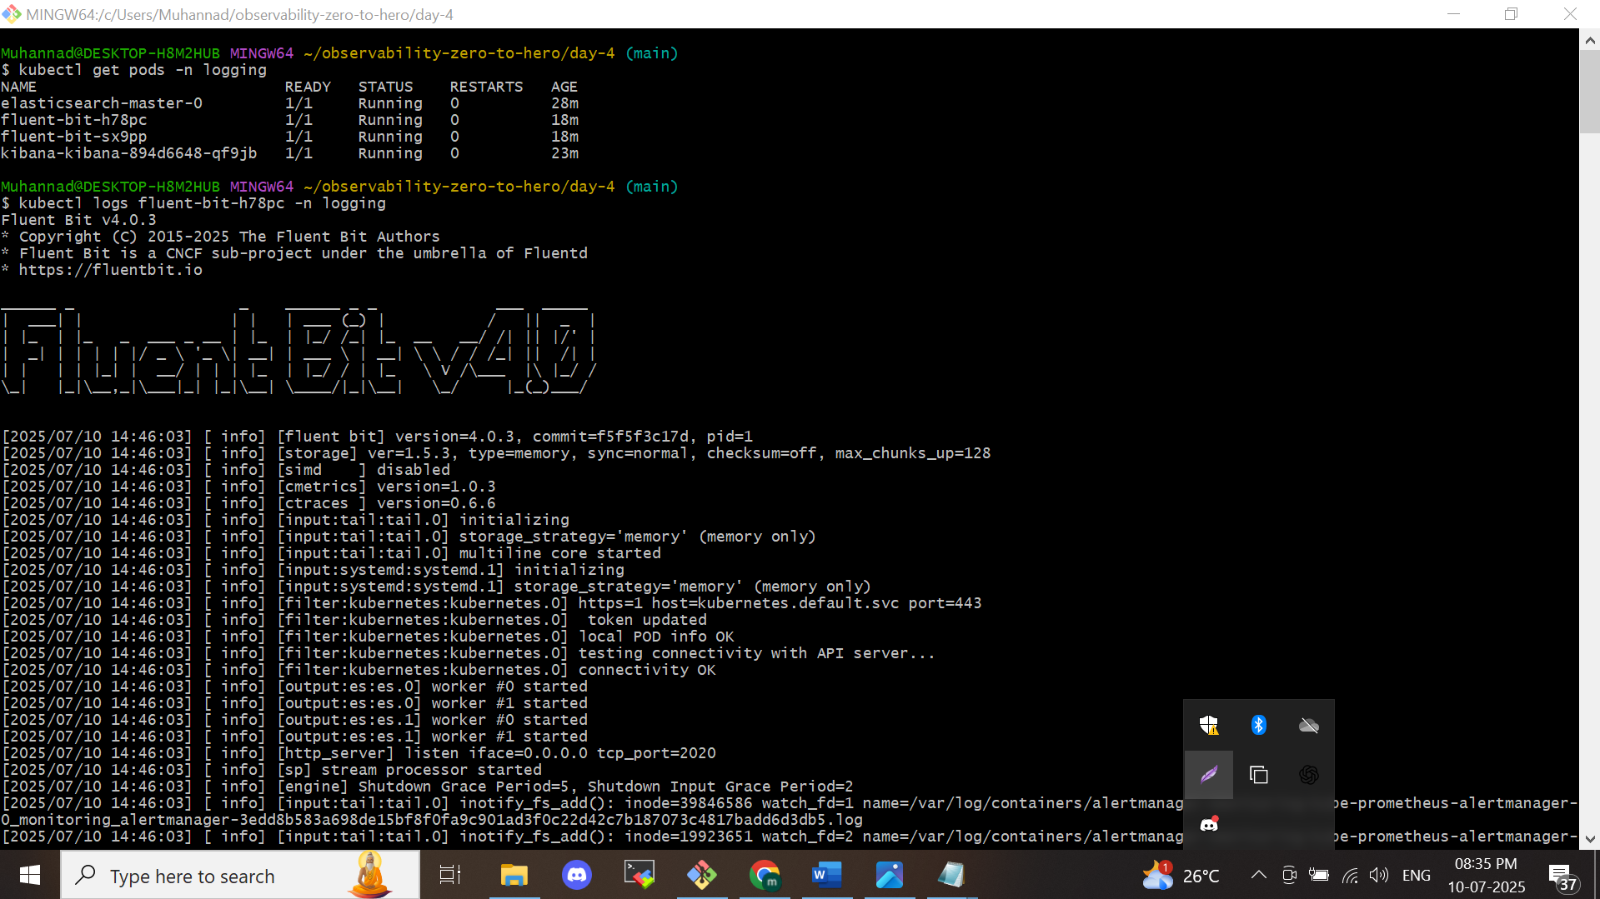

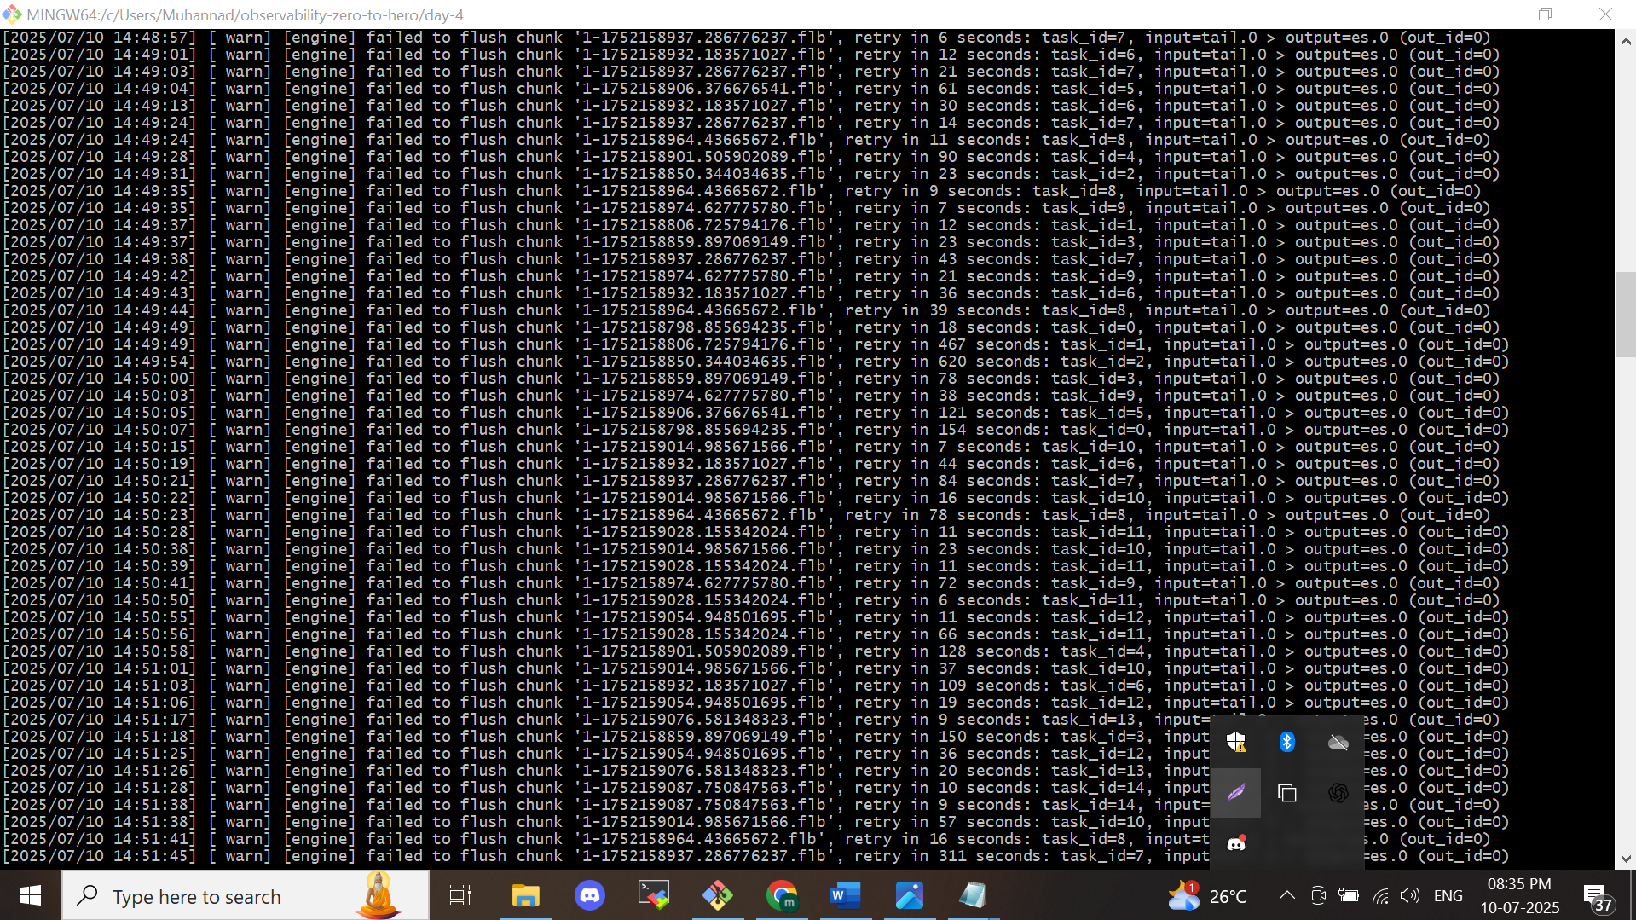

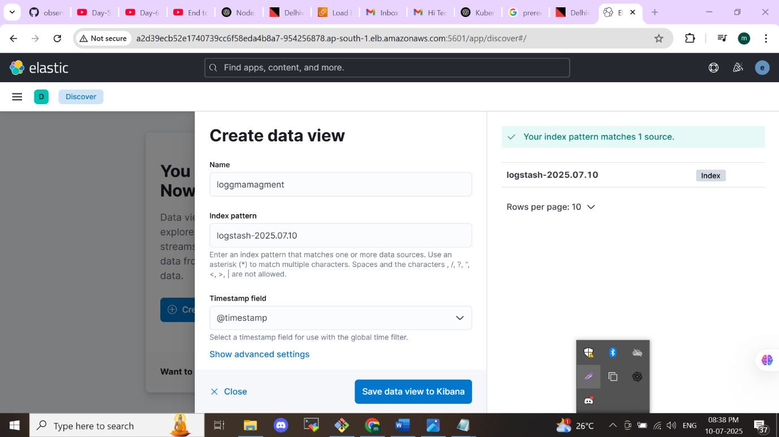

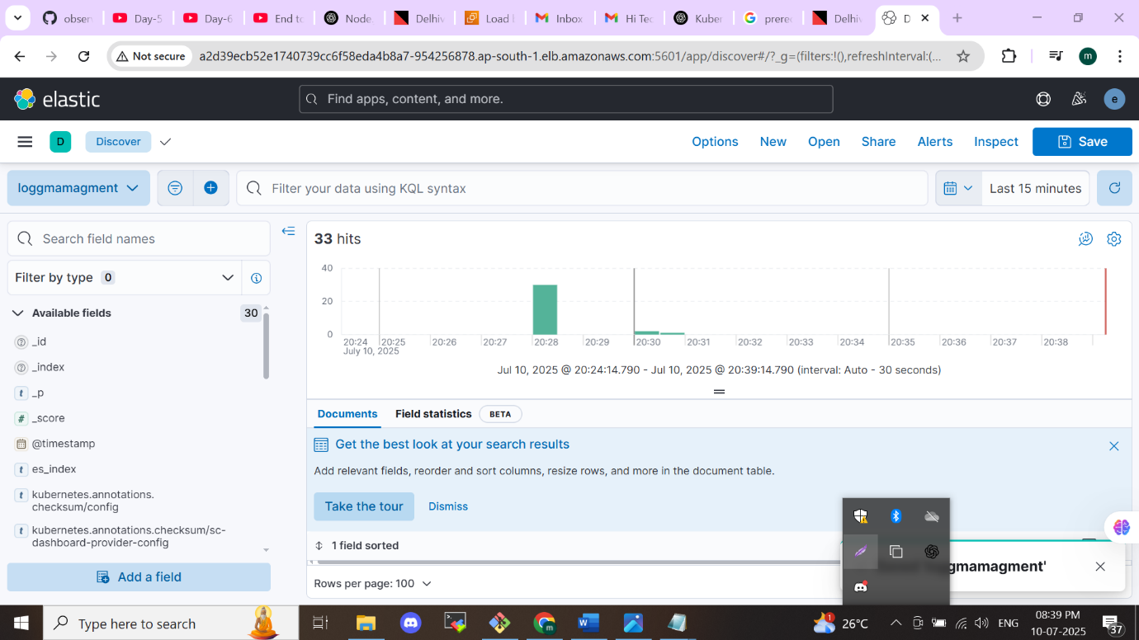

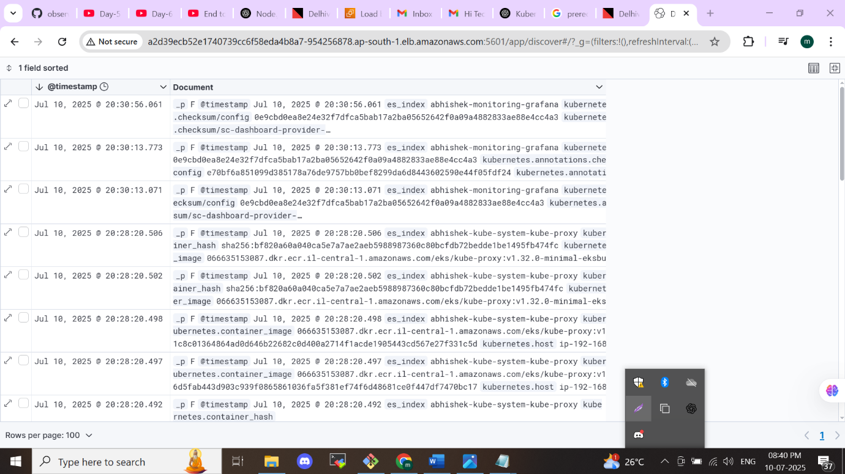

**Module -6**

**Distributed Tracing with Jaeger**

* **Concepts Covered:**
  + Introduction to Jaeger and its architecture for distributed tracing.
  + Setting up Jaeger in a Kubernetes cluster using Helm.
  + Instrumenting services using OpenTelemetry to enable tracing.
  + Viewing and analyzing traces in the Jaeger UI.
  + Cleaning up the environment after setting up Jaeger.
* **Key Learning:**
  + Gain insights into distributed tracing and how it helps in debugging and performance optimization.
  + Learn how to set up and configure Jaeger for tracing in a microservices architecture.

**Topics Covered:**

* Overview of **Jaeger** and its architecture designed for distributed tracing.
* Deploying Jaeger in a **Kubernetes cluster** using **Helm charts**.
* Enabling tracing by **instrumenting microservices** with **OpenTelemetry**.
* Exploring and analyzing **trace data** using the **Jaeger web interface**.
* Cleaning up resources after completing the setup.

**What You'll Learn:**

* Understand the fundamentals of **distributed tracing** and how it assists in **debugging** and **performance tuning** across microservices.
* Learn the **end-to-end setup** of Jaeger for tracing requests in a **microservices-based architecture**, including how to configure and use it effectively.

**What is Jaeger?**

**Jaeger** is an open-source distributed tracing tool designed to monitor, analyze, and troubleshoot performance issues in microservices-based systems. It provides visibility into how requests move through a system by tracing their full lifecycle and measuring how long each step takes. **Why Use Jaeger?**

In modern cloud-native applications, a single user request often spans multiple services. When failures or latency issues occur, it can be difficult to identify the root cause. **Jaeger** addresses this by:

* **Detecting Performance Bottlenecks**: Identify where time is being spent within your services.
* 🔍 **Tracing Error Sources**: Follow the request path to pinpoint where failures occur.
* **Improving Latency**: Analyze request flow to optimize the performance of your application.

**Key Jaeger Concepts**

* **Trace**  
  A trace captures the full journey of a request as it flows through various services. It acts like a timeline or roadmap showing each step involved in handling the request.
* **Span**  
  Each trace consists of multiple spans. A span represents a single unit of work — like an API call, a function execution, or a database query — and includes its start time and duration.
* **Tags**  
  Tags are key-value pairs attached to spans, providing metadata such as the HTTP method, response status, or custom labels that give more context to the operation.
* **Logs**  
  Logs within a span capture detailed events or messages (e.g., errors or important checkpoints) that occurred during that specific operation.
* **Context Propagation**  
  To track a request across services, Jaeger relies on context propagation. Each service passes trace information (headers or metadata) along the request chain, ensuring continuity in the trace.

**Architecture**

**Introduction to Distributed Tracing**

In modern microservices-based architectures, applications are made up of many small, independent services communicating over the network. When an issue occurs—like slow response times or failed requests—it can be difficult to pinpoint exactly where things went wrong. This is where **distributed tracing** comes in.

**Distributed tracing** helps track requests as they travel through multiple services, providing a detailed view of each step in the journey. This visibility is essential for debugging, performance tuning, and understanding system behavior in real time.

**Implementing Tracing: Who Does What?**

There are two main roles involved in enabling distributed tracing:

**1. Application Developers**

Developers are responsible for **instrumenting the application**—this means embedding trace points in the code using standard libraries. It’s similar to how they add custom **metrics** or **logging**.

The most widely used standard today is **OpenTelemetry**, which provides cross-language support and integrations for many popular frameworks. Instrumentation captures details such as request durations, errors, and service-to-service communication.

**2. DevOps / SRE Engineers**

DevOps and Site Reliability Engineers handle the **infrastructure setup** for tracing. This includes deploying and configuring tools like **Jaeger**, which is a widely used, lightweight, and open-source distributed tracing system.

Other tracing solutions include **Datadog**, **Zipkin**, **AWS X-Ray**, etc., but Jaeger is commonly preferred for its simplicity and Kubernetes-native compatibility.

**How Does Jaeger Work?**

Jaeger operates through four main components, each playing a critical role in the tracing pipeline:

**1. Agent**

* The **Jaeger Agent** runs as a sidecar or DaemonSet near the application.
* It **receives trace data** from the instrumented application code.
* Without developer instrumentation, the agent has nothing to collect.

**2. Collector**

* The **Collector** takes the trace data from agents and **processes** it.
* It ensures the data is valid, batches it, and prepares it for storage.

**3. Storage Backend**

* Jaeger does not come with built-in storage; you need to **configure a backend** like **Elasticsearch**.
* The Collector forwards the trace data to the configured database where it can be stored and queried later.

**4. User Interface (UI)**

* The **Jaeger UI** provides a visual dashboard where users can search, explore, and analyze traces.
* When a user runs a query in the UI, it is sent to the backend (via the Query service), which fetches results from the storage (e.g., Elasticsearch), and displays the trace data.

**Summary**

Distributed tracing offers deep insights into how requests flow through microservices. It bridges the gap between logs and metrics by showing the full path of a request, from start to finish.

With proper **instrumentation by developers** and **setup by DevOps/SRE teams**, tools like **Jaeger** enable powerful, real-time observability into application performance and health.

**Setting Up Jaeger for Distributed Tracing**

**Prerequisites**

Before setting up Jaeger for distributed tracing, ensure the following requirements are met:

* **An EKS Cluster is Already Created**  
  You should have a running Amazon EKS (Elastic Kubernetes Service) cluster where the tracing infrastructure will be deployed. Included the promethues stack. For the elasticsearch is a statefulset it will connet with ebs volume by attach the iam role with service account on top of oidc provider.in previous example we done the same procedure we can do here.
* **Day 4 Application is Deployed**  
  Make sure the microservices application provided on **Day 4** is already deployed to your EKS cluster. This application has been **pre-instrumented for tracing** using **Open Telemetry**.
* **Instrumentation Code is in Place**  
  Inside the application code, you'll find a file named tracing.js located in:
  + day-4/application/service-a/tracing.js
  + day-4/application/service-b/tracing.js

**Step 1: Instrument Your Application Code**

To begin tracing, you need to **add tracing logic into your application**—this process is called **instrumentation**. Most modern languages offer tracing libraries or middleware that simplify this step.  
In our case, we’ve already instrumented our services using **OpenTelemetry**. You can find the implementations in:

* day-4/application/service-a/tracing.js
* day-4/application/service-b/tracing.js

**Step 2: Understand Jaeger Components**

Jaeger is composed of multiple components that work together for tracing:

* **Agent**: Gathers trace data directly from the instrumented services.
* **Collector**: Receives trace data from the agents and processes it.
* **Query Service**: Offers a web UI for exploring trace data.
* **Storage Backend**: Stores the collected traces (e.g., Elasticsearch).

**Step 3: Export Elasticsearch CA Certificate**

Use this command to extract the CA certificate from the Elasticsearch secret and save it as ca-cert.pem:

*kubectl get secret elasticsearch-master-certs -n logging -o jsonpath='{.data.ca\.crt}' | base64 --decode > ca-cert.pem*

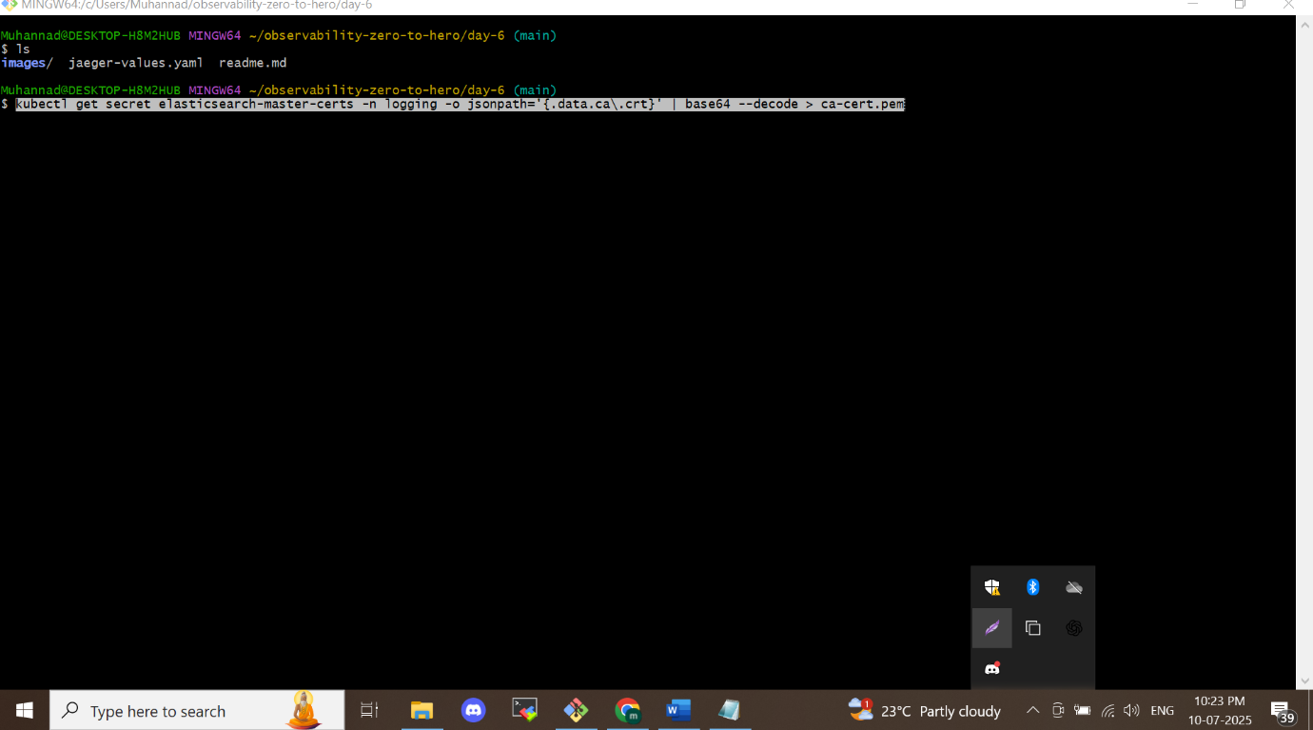

**Step 4: Create the tracing Namespace**

This creates a dedicated namespace in your Kubernetes cluster to host all Jaeger-related resources:

*kubectl create ns tracing*

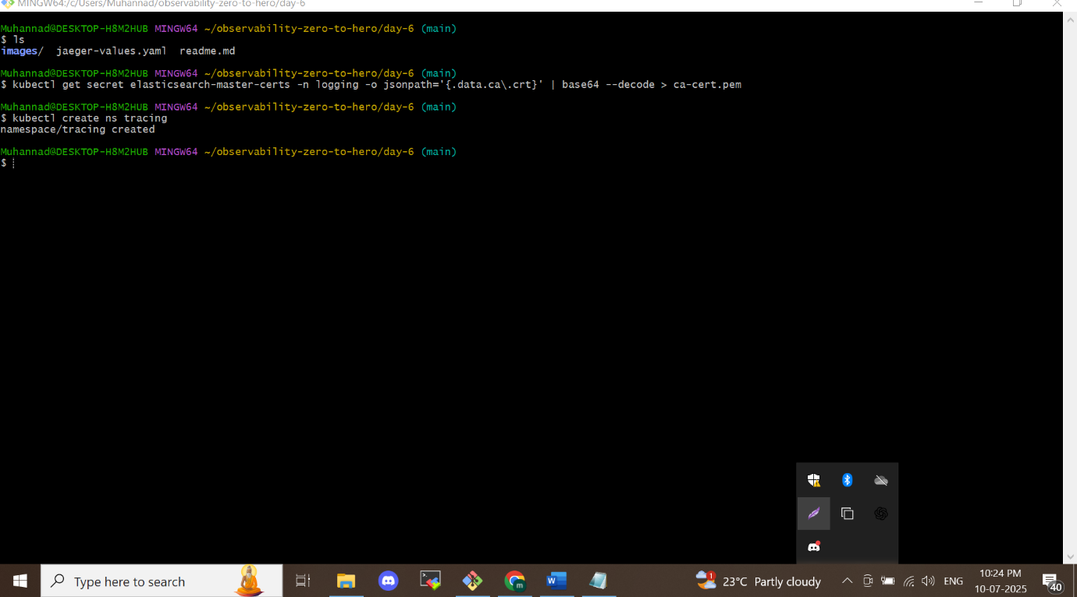

**Step 5: Configure TLS via ConfigMap**

Create a ConfigMap named jaeger-tls that includes the CA certificate. This will be used for secure communication:

*kubectl create configmap jaeger-tls --from-file=ca-cert.pem -n tracing*

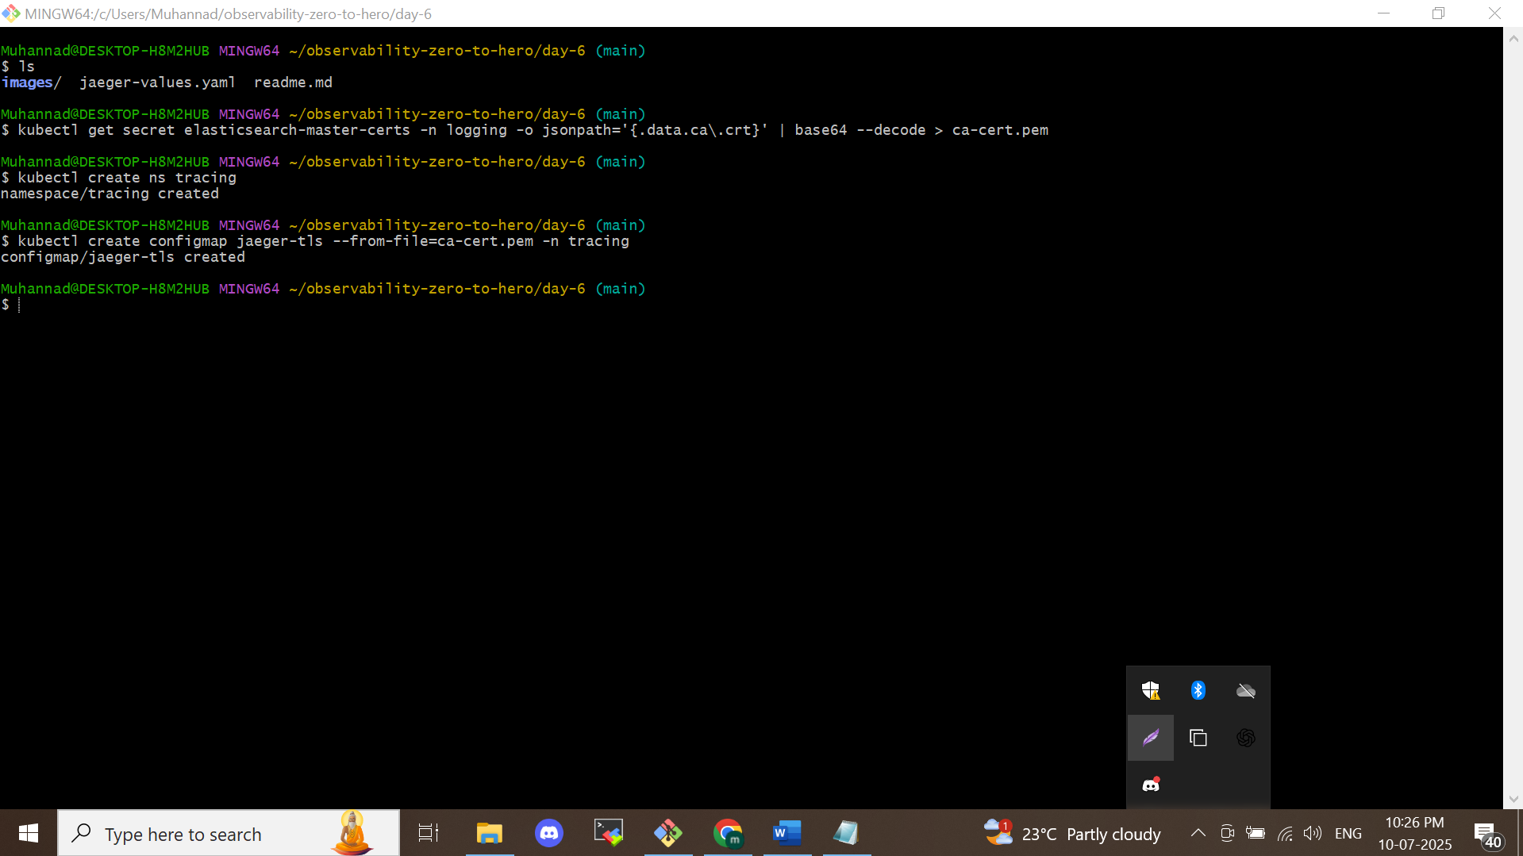

**Step 6: Create a Secret for Elasticsearch TLS**

Set up a Kubernetes Secret containing the CA certificate, which Jaeger will use to securely connect to Elasticsearch:

*kubectl create secret generic es-tls-secret --from-file=ca-cert.pem -n tracing*

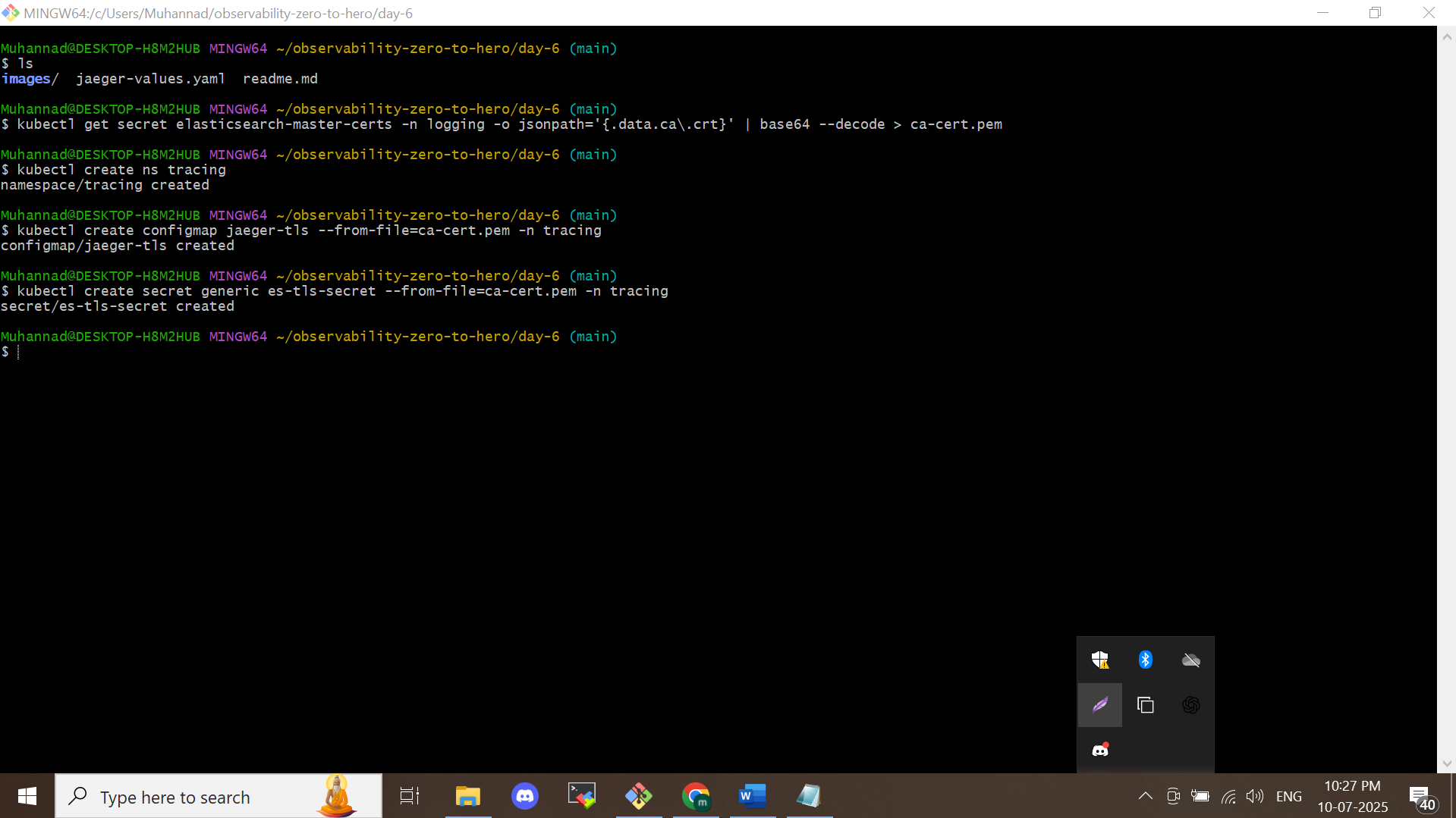

**Step 7: Add Jaeger Helm Chart Repository**

Add the official Jaeger Helm chart repository so that it can be used for installation:

*helm repo add jaegertracing https://jaegertracing.github.io/helm-charts*

*helm repo update*

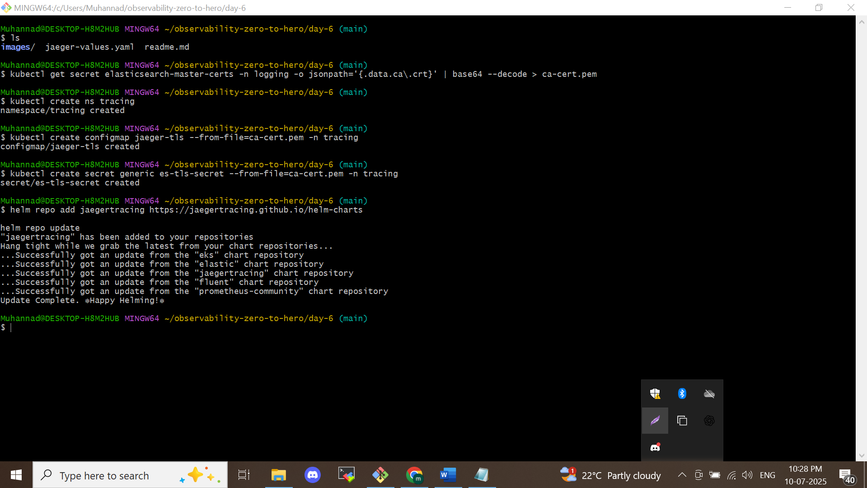

**Step 8: Install Jaeger Using Custom Values**

**Note**: Before running the installation, update the password and any required fields in the jaeger-values.yaml file using the password obtained in Day 4, Step 6 (e.g., NJyO47UqeYBsoaEU).

Deploy Jaeger into the tracing namespace with your custom configuration:

*helm install jaeger jaegertracing/jaeger -n tracing --values jaeger-values.yaml*

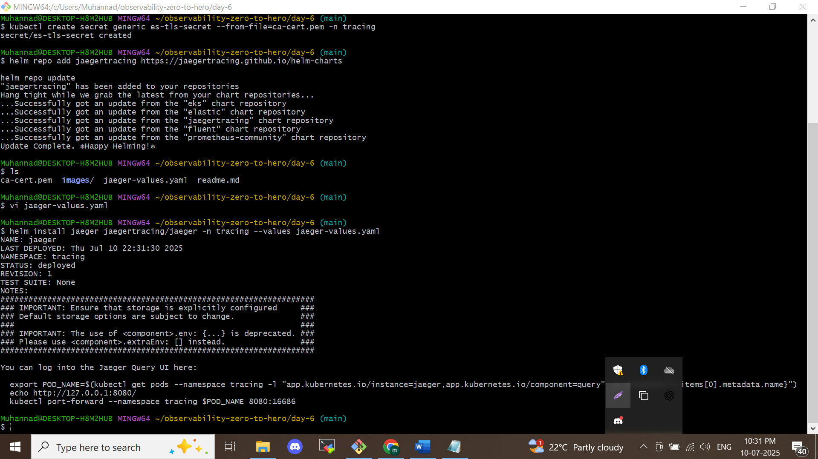

**Step 9: Access Jaeger UI via Port Forwarding**

This command forwards your local port 8080 to Jaeger’s Query service so you can view the Jaeger UI in your browser:

*kubectl port-forward svc/jaeger-query 8080:80 -n tracing*

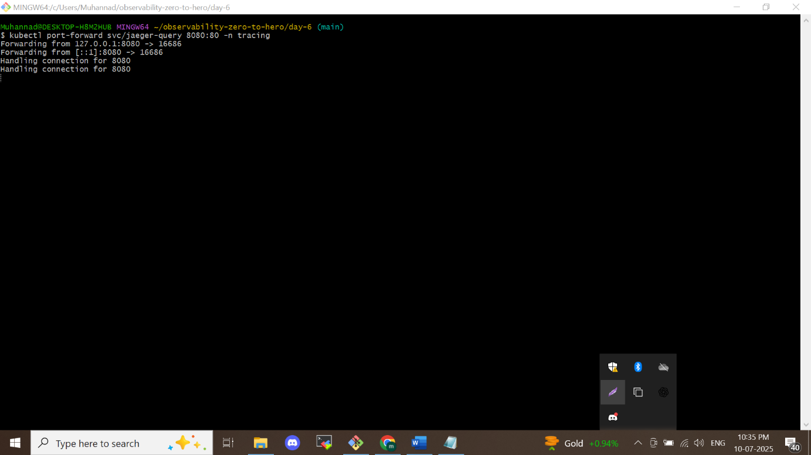

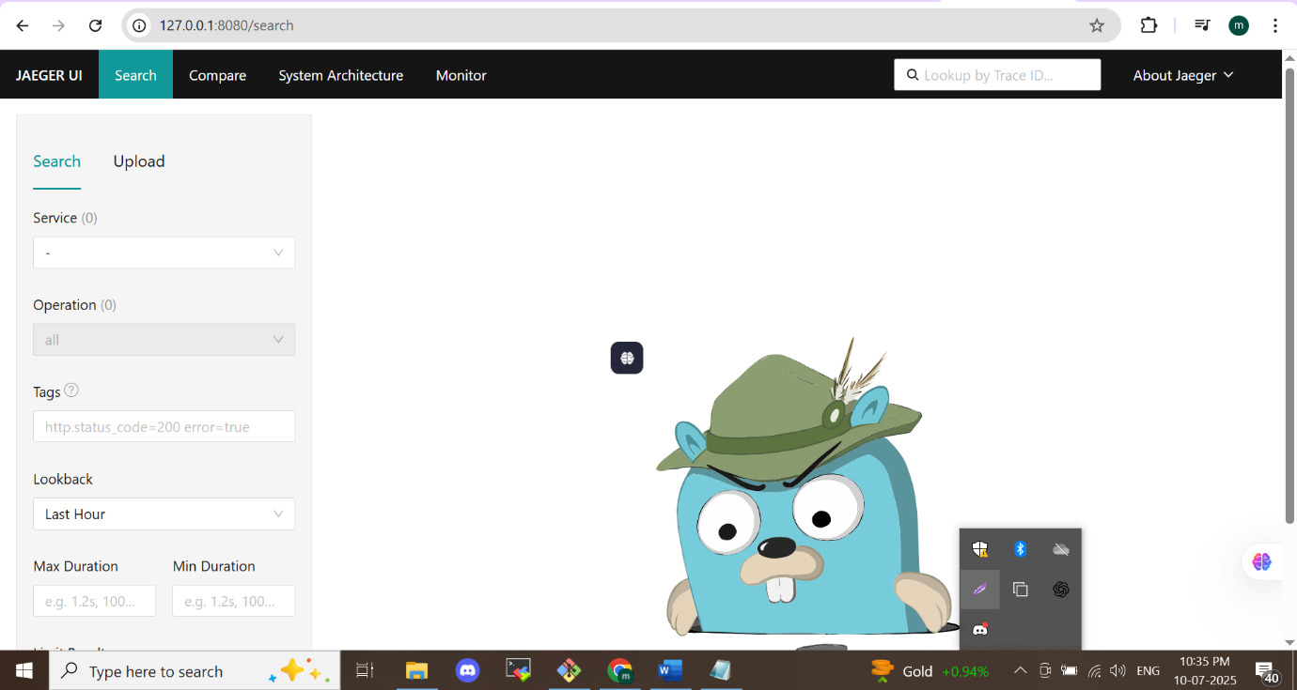

Pods are running

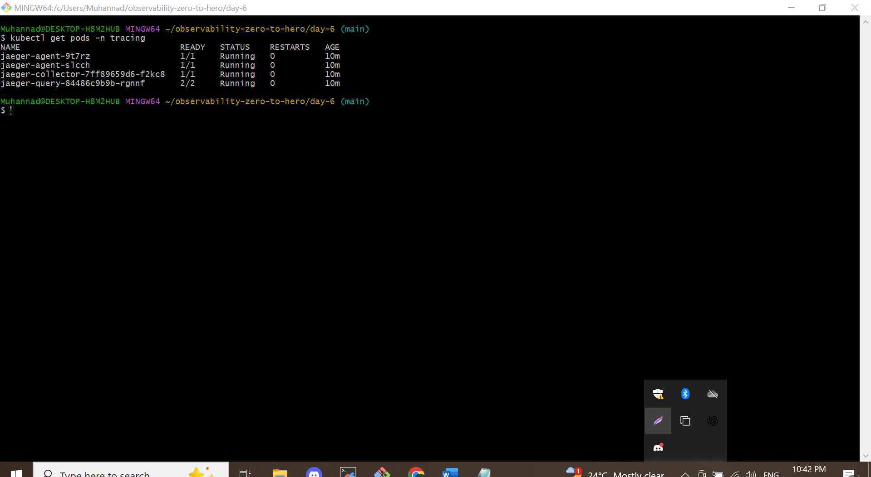

We are tracing the same application on day 4 we use it was instrumented for tracing

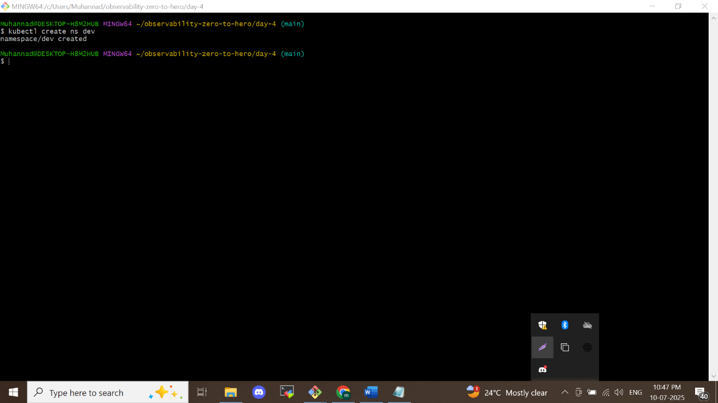

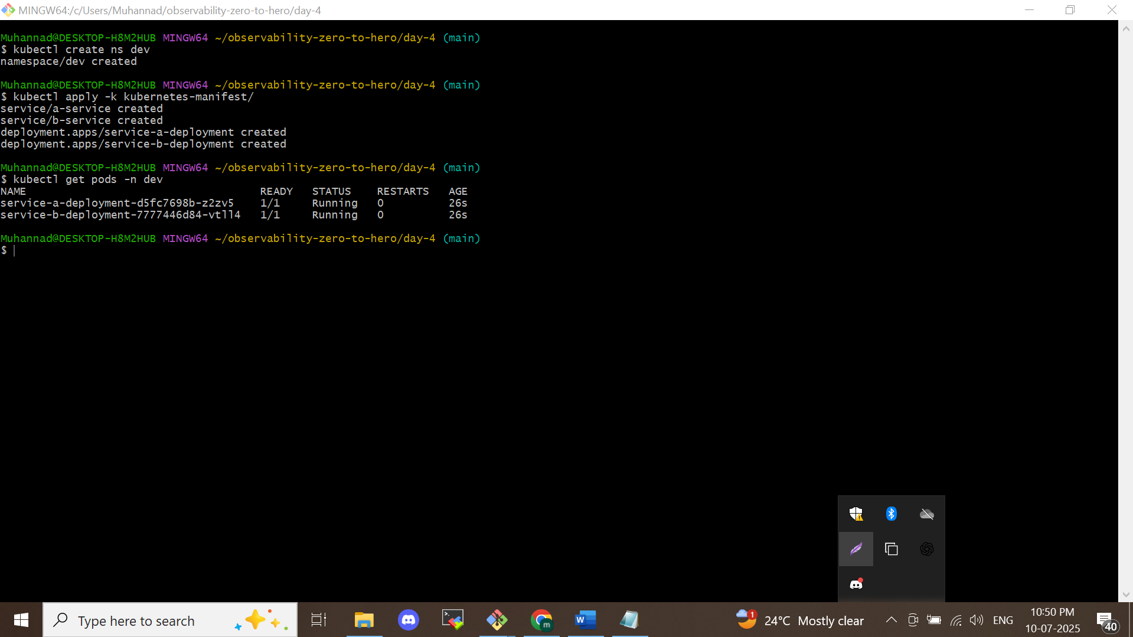

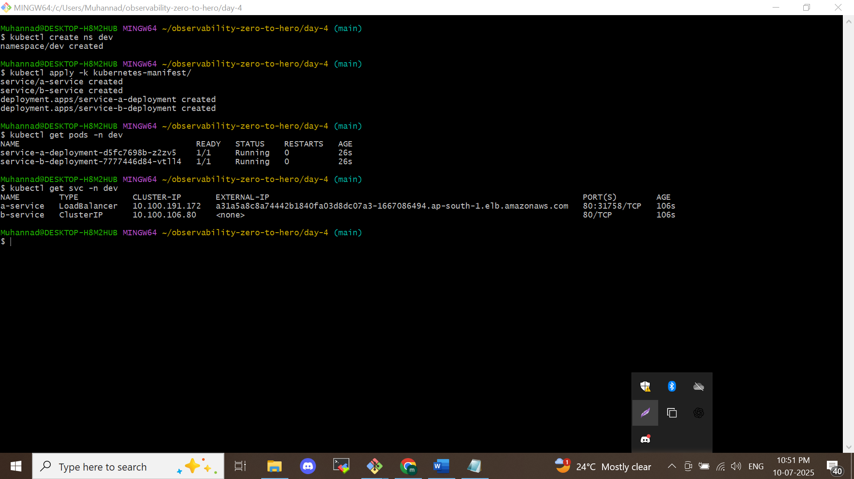

* Application running we can check the traces in different scenarios like

*/*

*/healthy*

*/serverError*

*/notFound*

*/logs*

*/example*

*/metrics*

*/call-service-b*

As loadbalancer url/ above we can see it will reflect traces or not

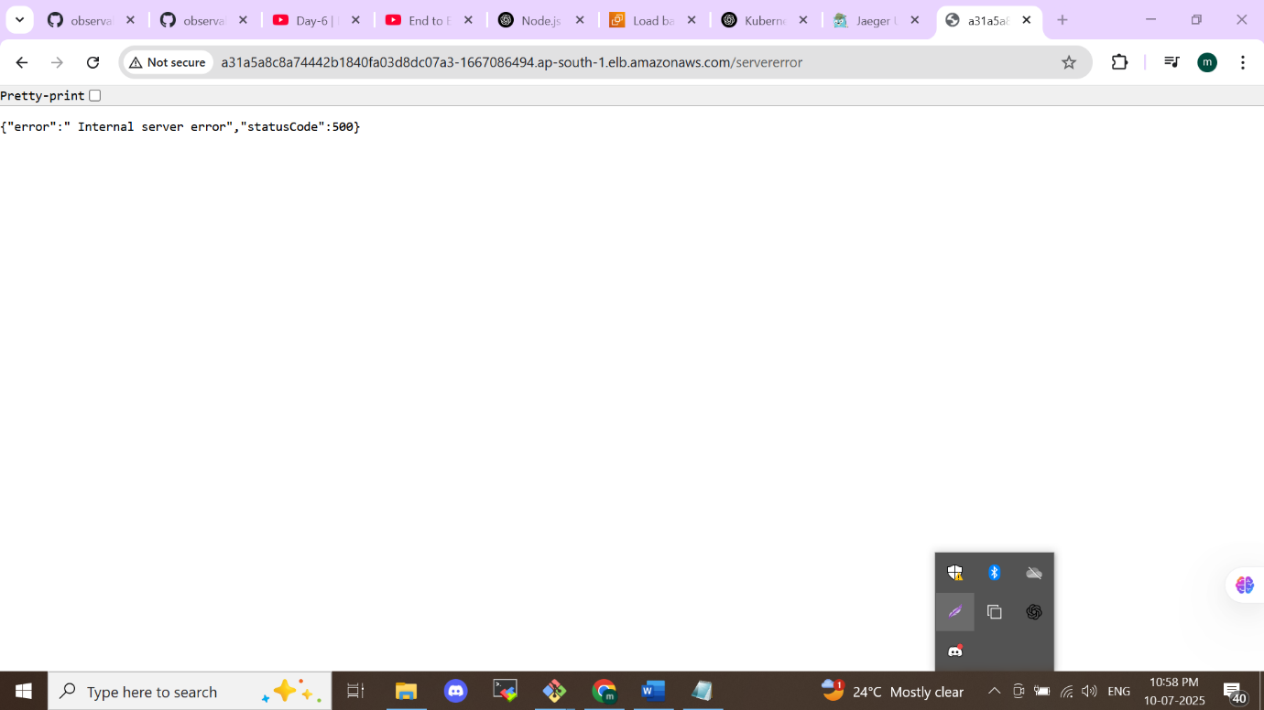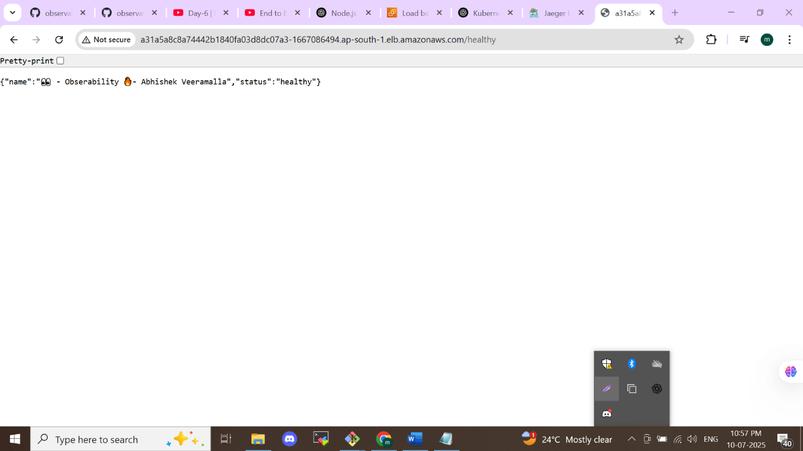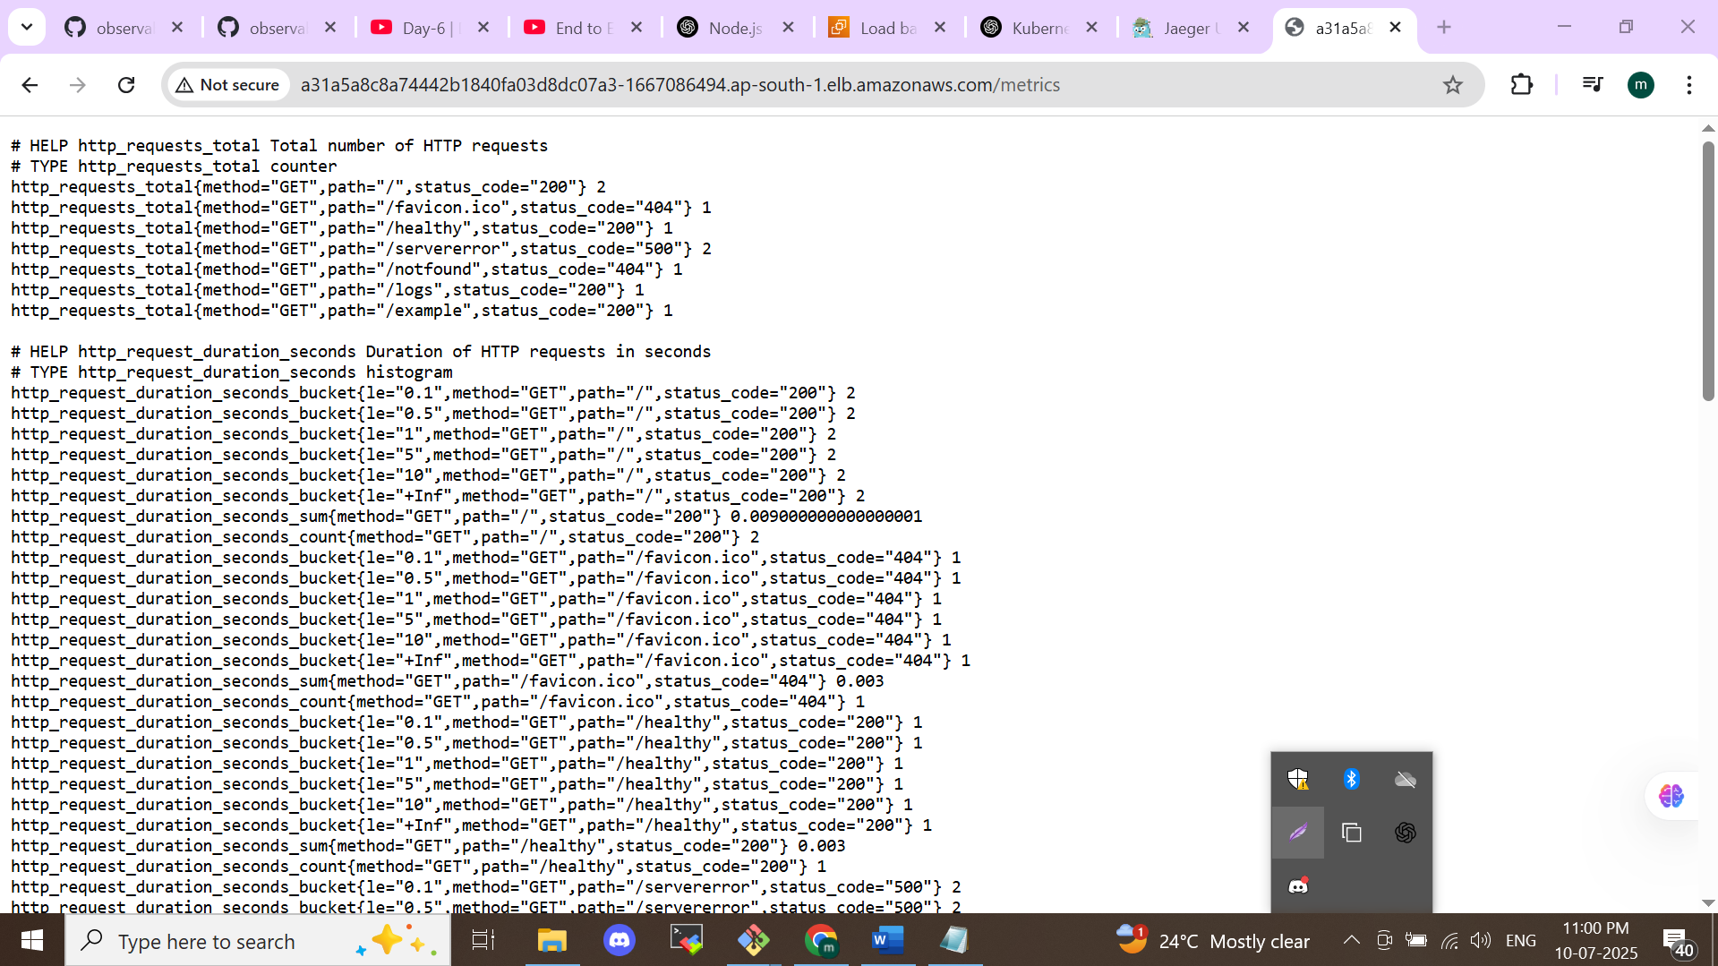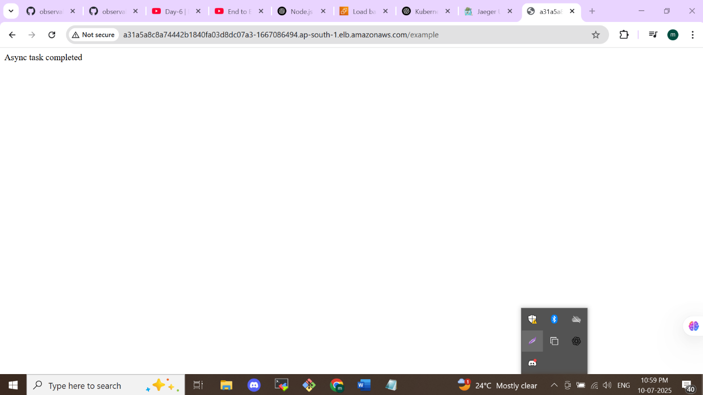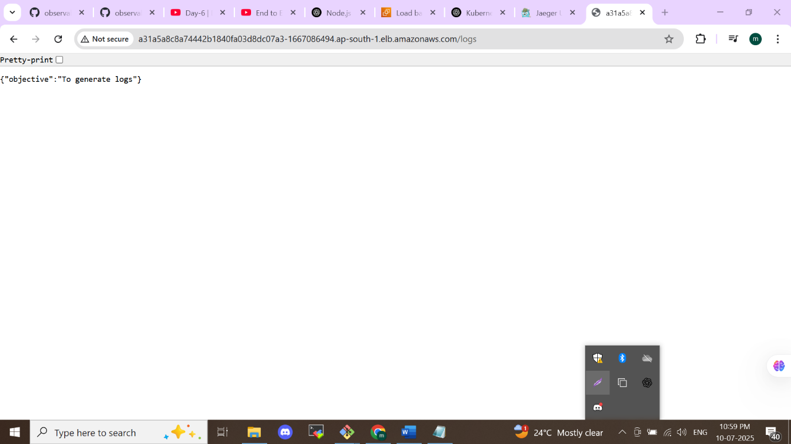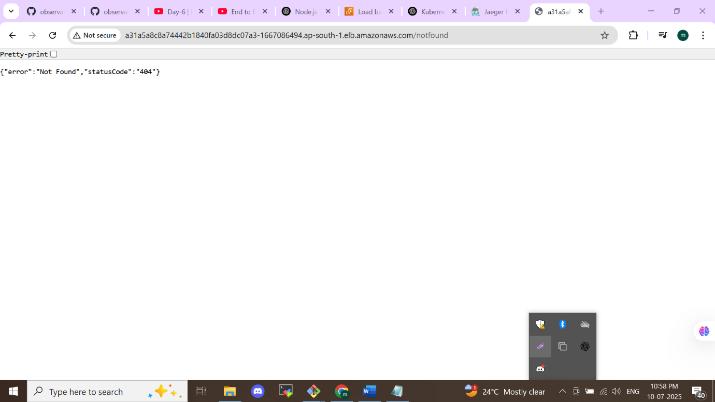

**Jaeger traces**

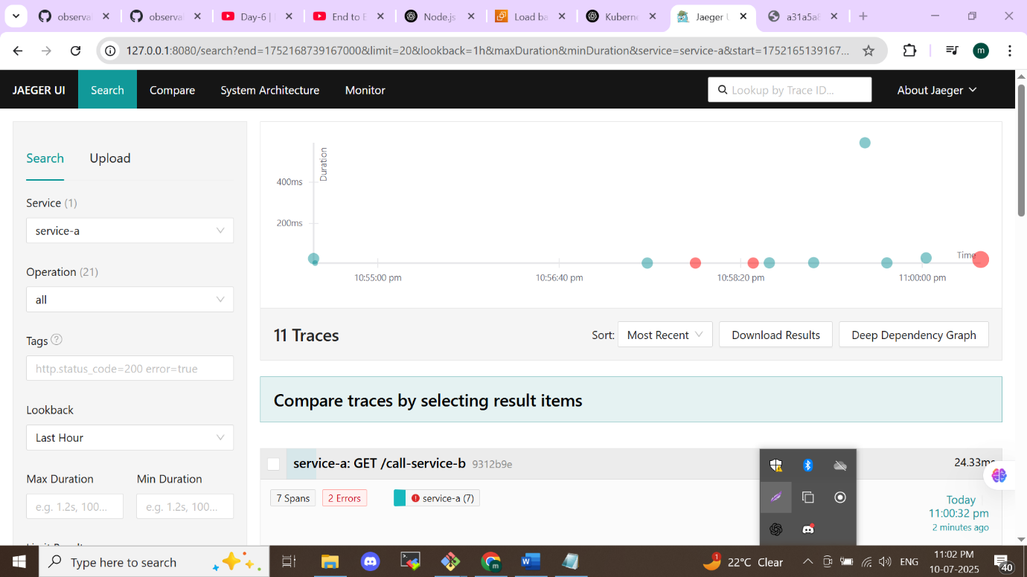

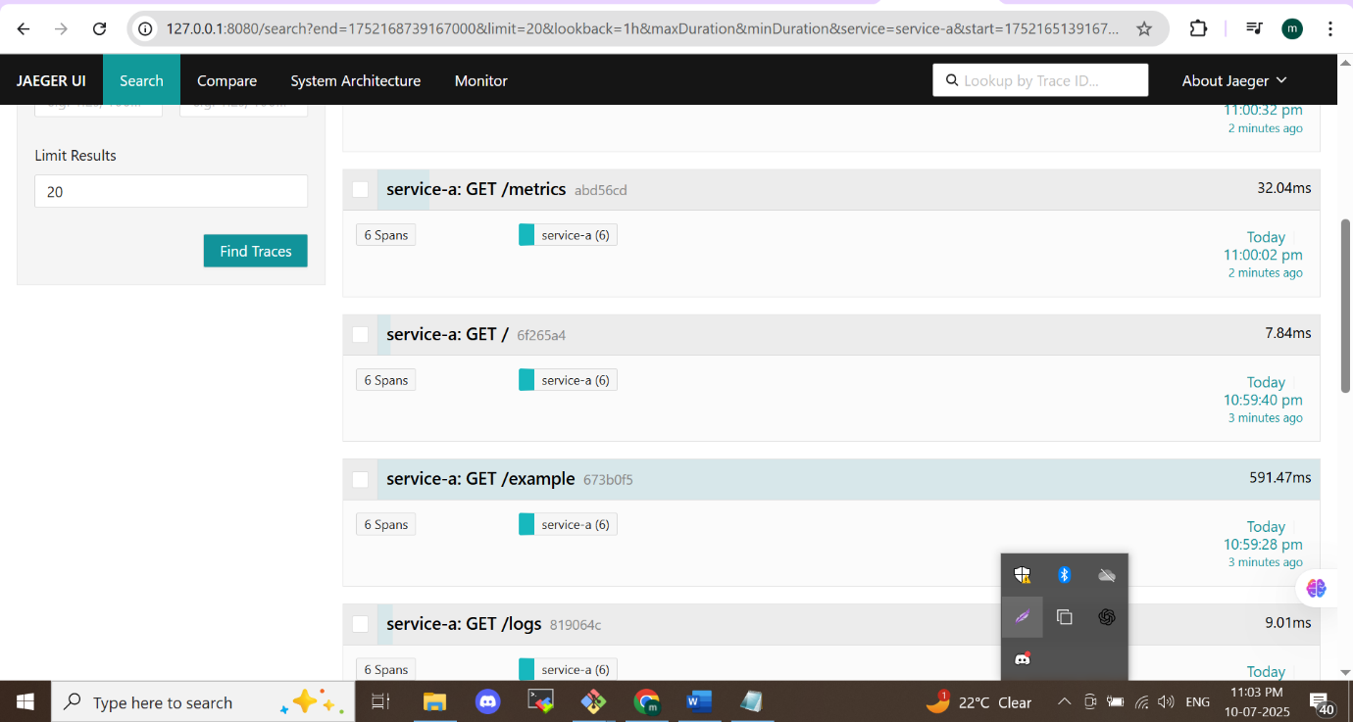

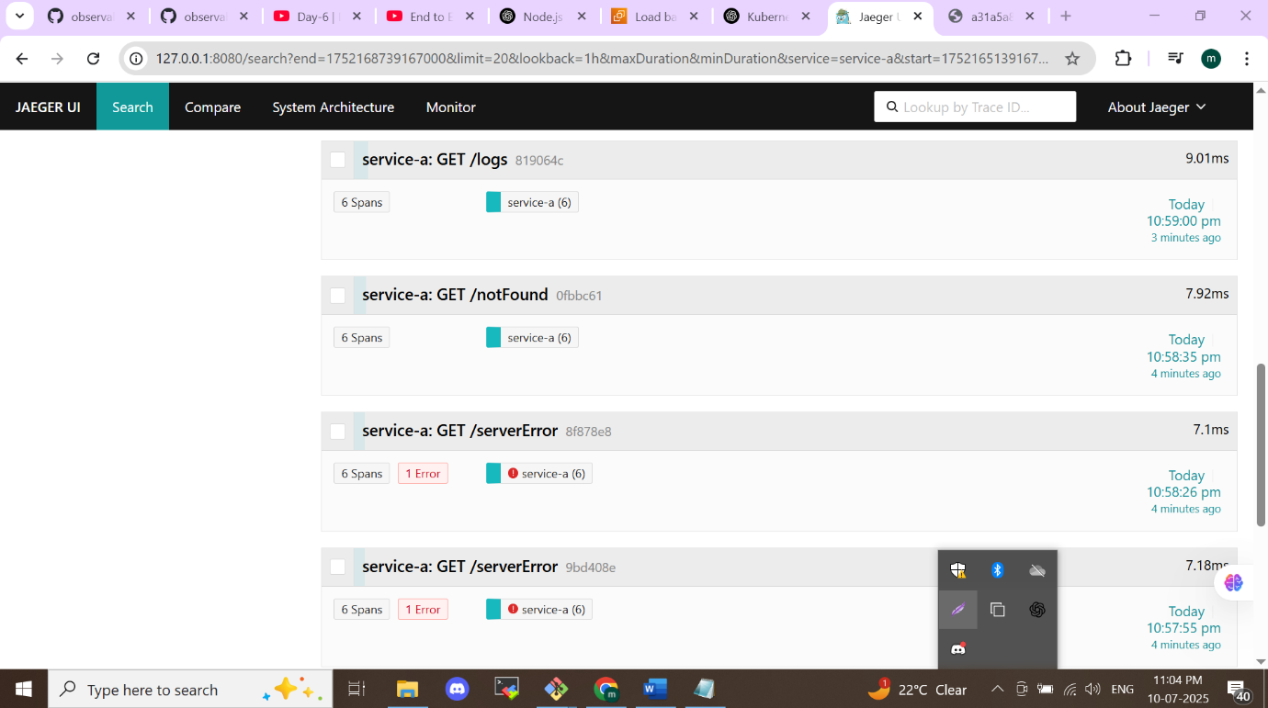

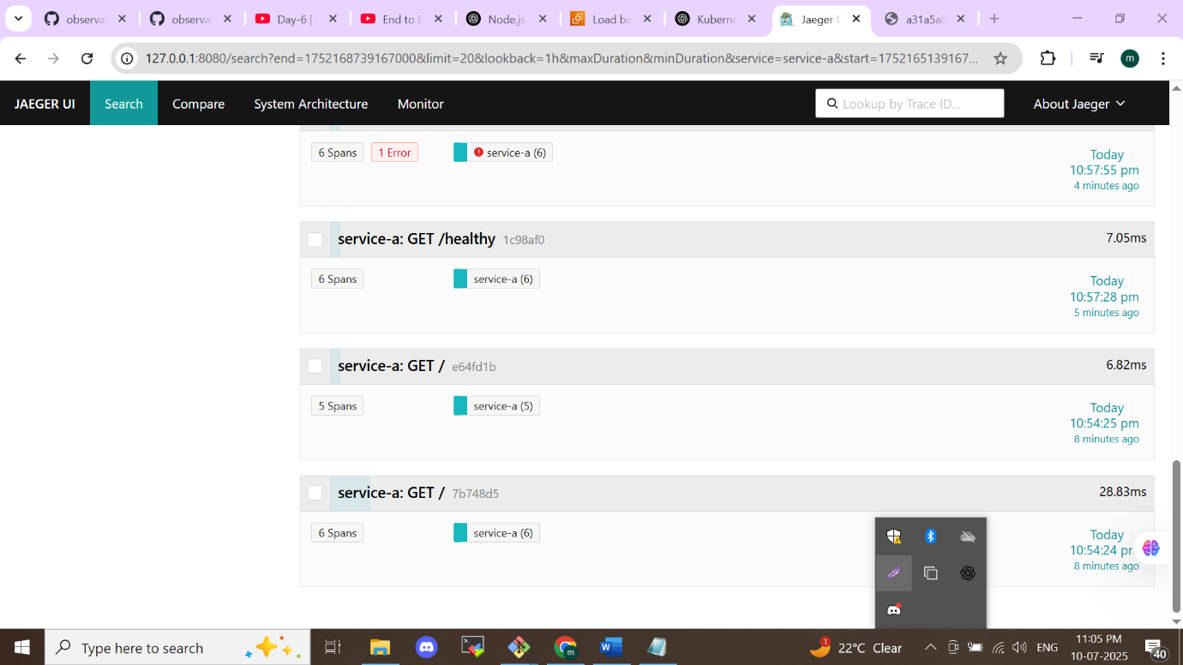

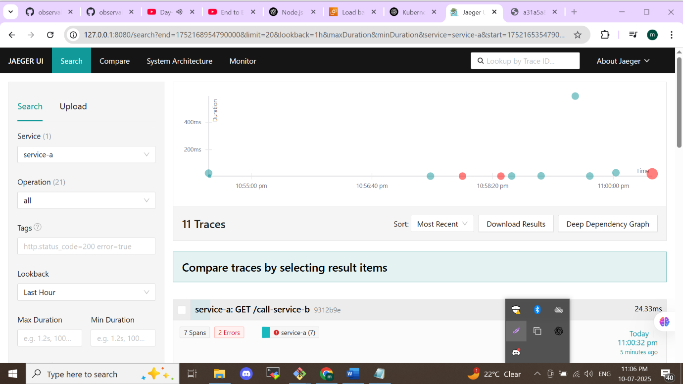

**Application span can be seen**

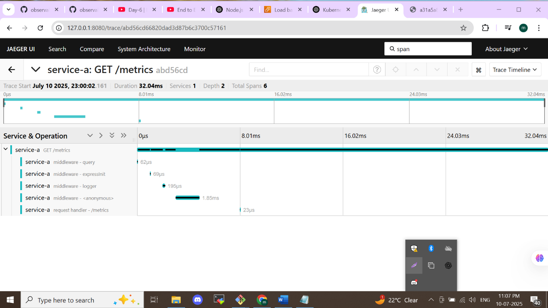

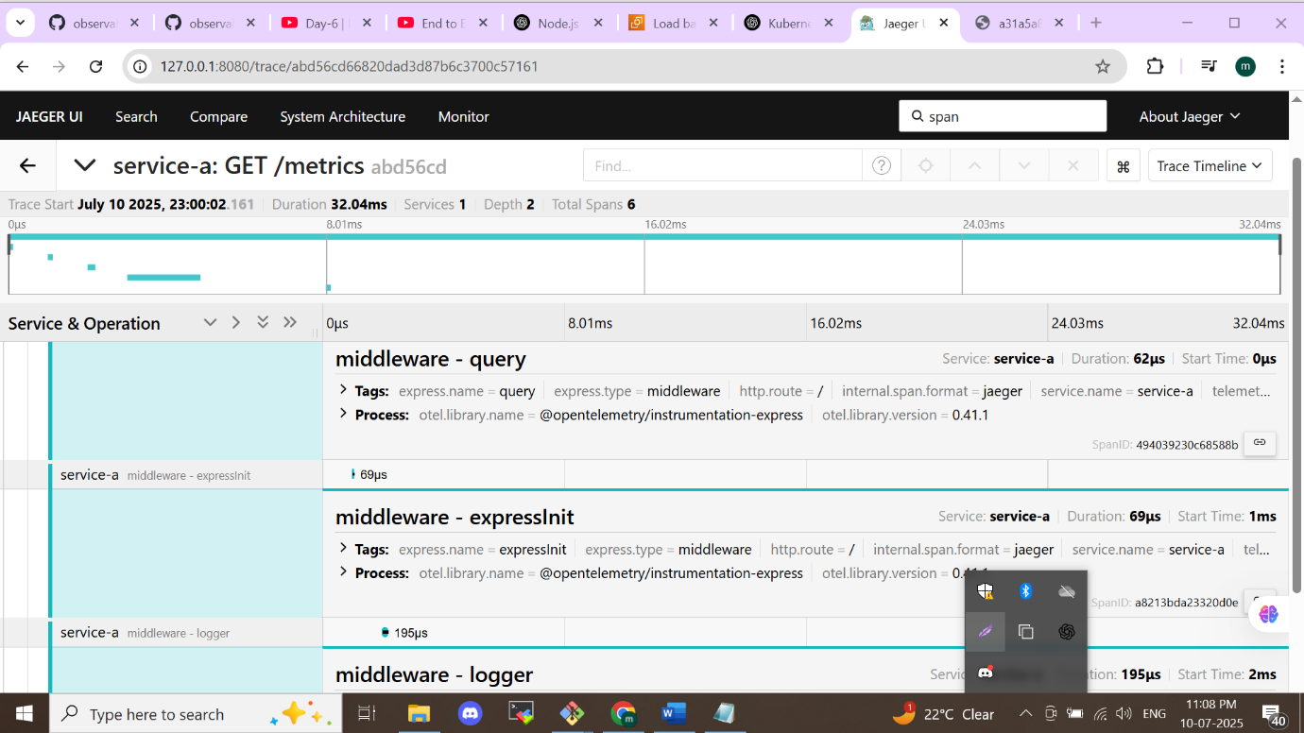

**Trace**

A **trace** represents the complete journey of a request as it moves through various services in a system.

**Example**: A user clicks "Buy" on your app → request goes to frontend → backend → payment service → database → then response returns. This entire journey is a **trace**.

**Span**

A **span** is a single operation or step within that trace. It includes information like:

* Start & end time
* Operation name (e.g., "call to payment API")
* Status (success/failure)
* Metadata (tags, logs, etc.)

**Example**: A span could be "process payment" or "query product database". A trace is made up of **multiple spans**.

**Middleware in Tracing**

In tracing, **middleware** refers to code that **automatically injects tracing logic** (start/end spans) into your services.

**Example**: In a Node.js Express app, middleware can create a span for each incoming HTTP request, so you don't have to manually trace every function.

**Visual Summary:**

* **Trace** = full request path (user to DB and back)
* **Span** = individual steps in that path (e.g., "call auth service")
* **Middleware** = helper that instruments spans automatically

**References**

<https://github.com/muhannadpv786/observability-zero-to-hero>

<https://youtube.com/playlist?list=PLdpzxOOAlwvJUIfwmmVDoPYqXXUNbdBmb&feature=shared>

**Logging**

Logs are textual records of events that help with debugging, auditing, and understanding system behavior.

* EFK Stack (Elasticsearch, Fluent Bit, Kibana) Overview

<https://www.elastic.co/what-is/efk-stack>

* Fluent Bit Documentation

<https://docs.fluentbit.io/manual/>

* Kibana Documentation (Log visualization tool)

<https://www.elastic.co/guide/en/kibana/current/index.html>

**Tracing**

Tracing tracks end-to-end request flow through microservices, useful for debugging latency

and dependency issues.

* Jaeger Documentation (Distributed tracing system)

<https://www.jaegertracing.io/docs/>

* OpenTelemetry Tracing Concepts

<https://opentelemetry.io/docs/concepts/traces/>

**Introduction to Distributed Tracing (CNCF)**

<https://www.cncf.io/blog/2021/06/16/understanding-distributed-tracing-in-cloud-native-systems/>